US Secures Trade Victory as China Retreats under Tariff Pressure
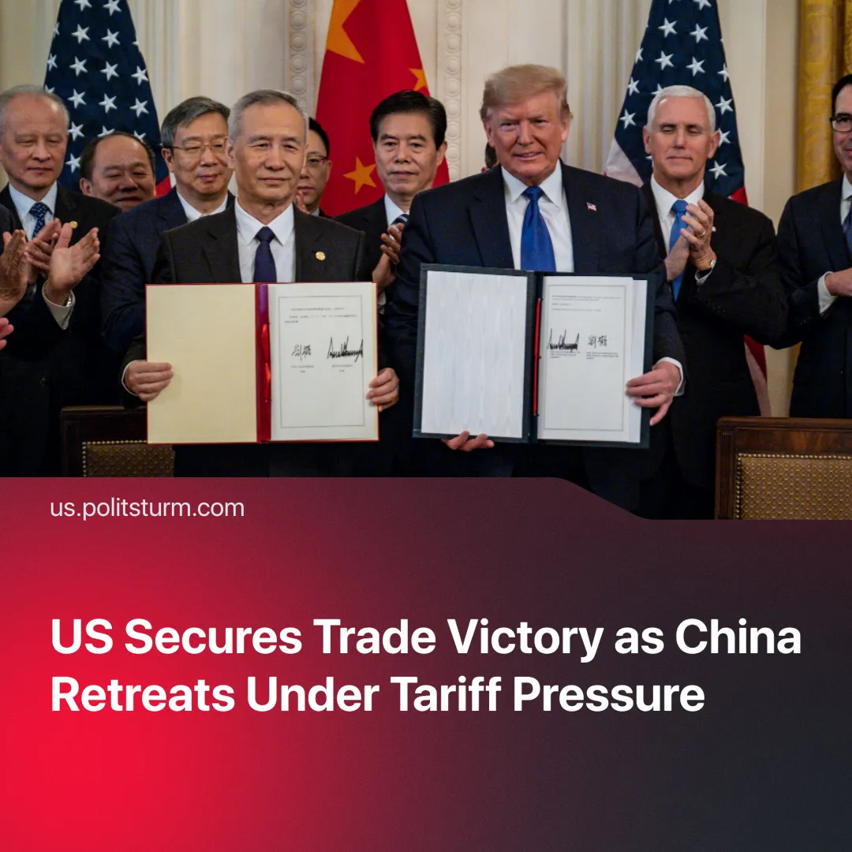

Original article
2025-06-20
2 min read

The ongoing trade conflict between the US and China has highlighted the interdependence of the world’s largest economies. The last agreement appears to be a temporary tactical victory for the US, forcing China to make concessions.
Details. Following talks in London, Trump announced that the US would reduce tariffs to 55% tariff on Chinese products, whilst China agreed to reduce tariffs to 10% tariff on US exports. Trump emphasised the significance of the agreement, saying it would be "the biggest deal ever made," adding that "we’re totally on the right track."
► China has issued a limited number of licenses to export rare earths and magnets, at least for the next six-months. The agreement to resume supplies is only temporary, and the Chinese leadership maintains its right to restrict new licences.
► Tariff revenues aim to be a significant source of funding. It is estimated that the US budget could receive about $156.4 billion, or about 0.5% of GDP, from tariffs imposed by the Trump administration in 2025.
Context. Trump urgently needs federal funds to strengthen the military, finance defense projects, and counter China. This is the main reason for the deficit tariff strategy.
►Trump had a disagreement with his biggest donor, Elon Musk over the "Big, Beautiful Bill." This law strengthens tax breaks, increases defence and border protection spending, and drives government spending deep into deficit. The Central Bank estimates the addition to the national debt at about $3.8 trillion by 2034.
► American companies are still heavily dependent on China. About 17-18% of US imports are critical components and equipment from China. Meanwhile, China exports nearly 60% of the world's rare earth minerals, and also concentrates approximately 90% of its processing. These minerals are crucial for the electronics and defense industries.
► Trump transformed tariffs from a mere protectionist measure to an imperial strategy. He successfully imposed a worldwide "tariff discourse", using them as key bargaining chips and fiscal instruments in international negotiations.
► Whilst the US had previously raised tariffs to 145% on Chinese goods, China responded just as harshly, with tariffs of 125%, and despite these measures, the two economies still need each other and settled to negotiate.
Important to Know. Trump's main goal of achieving "economic decoupling" has failed for now. The deal reflects mutual dependency. The negative impact of tariffs on the American economy was too strong, which is why an agreement had to be reached.
► The 150% tariffs imposed by the US sharply increased the risk of an overproduction crisis in China by cutting off access to key markets. Beijing has temporarily attempted to activate the domestic market by issuing 300 billion yuan worth of special treasury bonds to support recycling programmes for consumer goods and forming an alliance of Asian economies. Nonetheless, it was still forced to accept the 55% tariff, which shows that the US market remains a key target for China, and essential to avoid an economic crisis.
► The US legislative body is siding with small businesses that have been negatively affected by tariffs, whilst large businesses are evading them by, for example, shifting production to countries with low tariffs. This could further compel fascisation to overcome these courts with executive power.
► In the US, price increases due to tariffs act as a hidden consumption tax, costing households between $3,800-$5,200.
► In China, wages are squeezed and industry is slowed down to avoid triggering a crisis. In May 2025, its industrial production grew by only 5,8% year-on-year — the lowest in six months — due to weaker demand and US tariffs. Prices fell and the Consumer Price Index (CPI) decreased by 0,1%, which signals the risk of deflation. Chinese leadership has tried to offset the downturn by launching domestic stimulus programmes, but structural problems remain.

Original article

