US Threatens to Take Greenland by Force
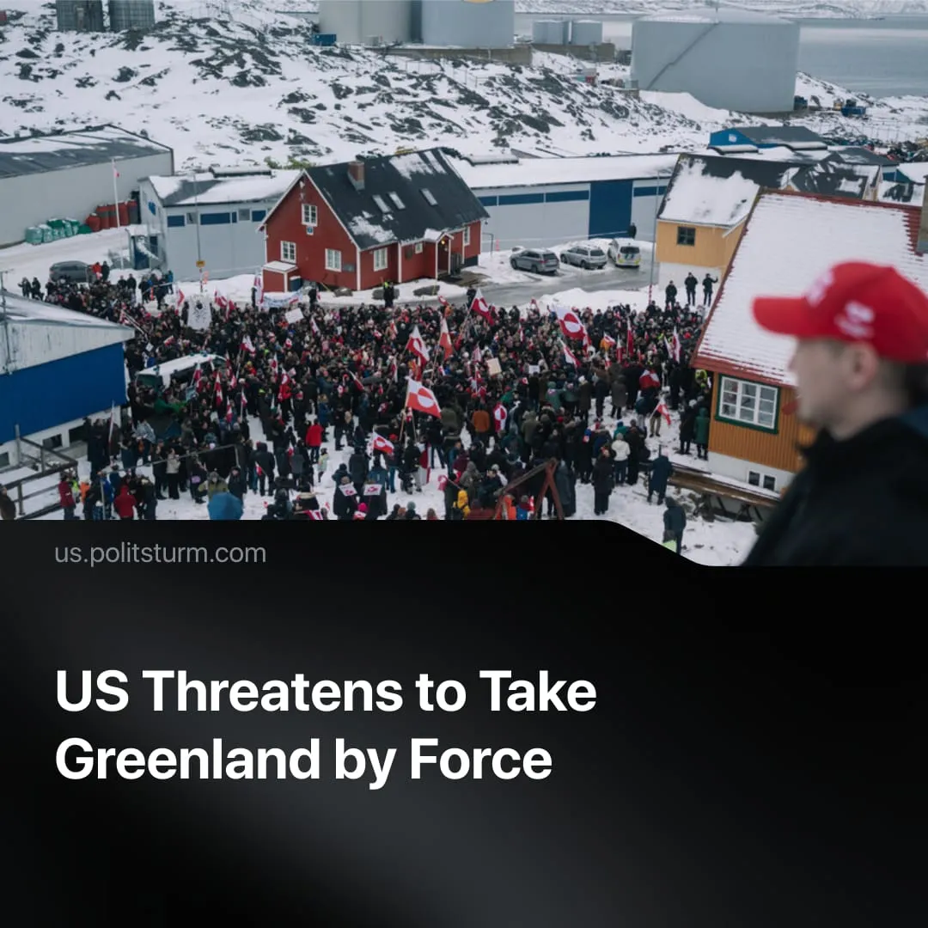

Original article
2026-01-19
2 min read

Renewed threats of US annexation of Greenland have thrown the NATO alliance into disarray.
Details. At the start of 2026, US imperialism renewed its focus on acquiring Greenland. Denmark announced an increased military presence on the island, while Trump stated Greenland is needed for defence and Arctic security. The island is also rich in mineral resources.
► The US has explored ways to acquire Greenland, including an offer to purchase the island for $500–700 billion. Officials have repeatedly refused to rule out military force.
► Danish Prime Minister Mette Fredrikesen warned that “everything would stop – that includes NATO” should an invasion take place. US diplomats emphasised that an attack on Greenland would be considered an “attack on NATO,” to which Trump responded, “If it affects NATO, then it affects NATO.”
► Denmark has instructed its troops to “shoot first, ask questions later” if the US attempts an invasion. NATO allies sent a minimal force of 29 troops for joint exercises in Greenland after Trump insulted its defences.
► After an initial diplomatic meeting on January 14 ended in a “fundamental disagreement” and US claims of progress were rejected by Denmark, the US imposed a 10% tariff on multiple European allies opposing the plan, threatening to raise it to 25% by June 1 if no agreement is reached.
► In response to Trump’s tariffs, the affected countries met on January 18. The eight nations reaffirmed their commitment to a united response, warning that Trump’s actions risk a “dangerous spiral.” They also emphasised their shared transatlantic interests and willingness to engage in dialogue that respects territorial integrity.
Context. Trump’s renewed threats of annexing Greenland came after the US successfully kidnapped the president of Venezuela and secured control over Venezuela’s exports.
► The emboldened US then threatened to use similar measures on a number of other countries, including Cuba, Mexico, and Colombia, and then threatened to launch new strikes on Iran, although he was allegedly “talked out of this.”
► The United States has been pursuing its capitalist interests more assertively, increasingly clashing with European capitalists – for example, disagreements over negotiations related to the “SMO,” covert influence campaigns in Greenland, and recent withdrawals from key international organisations.
► Where contradictions arose among these imperialists, the US supported far-right parties, forced the purchase of American weapons, and imposed tariffs to push the bloc toward closer alignment. Meanwhile, the EU made certain foreign policy decisions contrary to US wishes and amplified calls for “strategic autonomy,” including through a significant increase in military spending.
► Greenlanders themselves, although in favour of independence from Denmark, continue to oppose annexation, with 85% not wanting to join the US as per a January 2025 poll, and with only 6% in favour and 9% undecided.

Original article

