US Threatens Tariffs on Brazil to Protect Political Ally
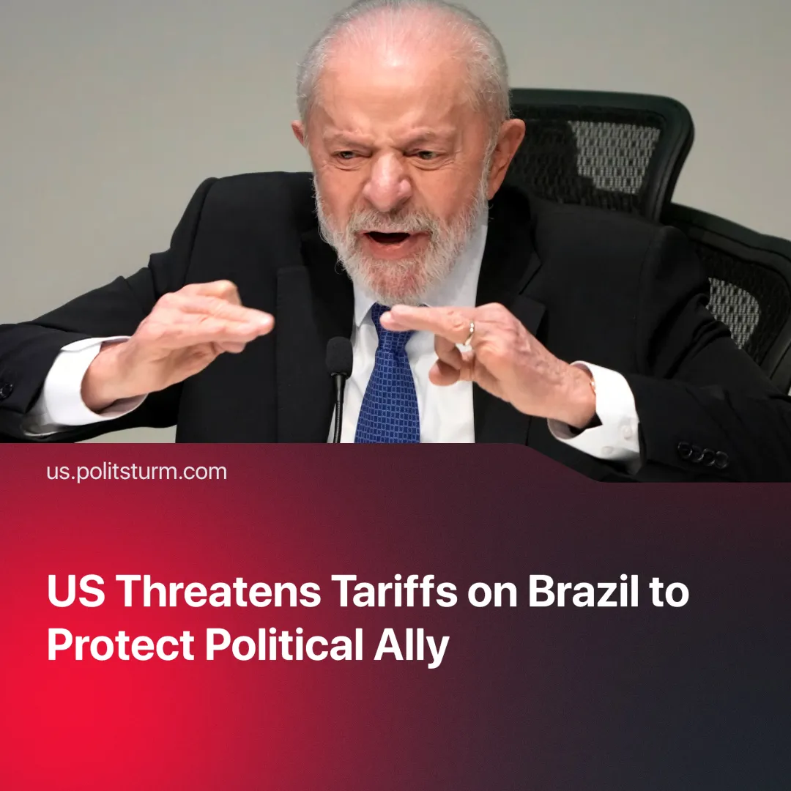

Original article
2025-07-18
2 min read

The US has threatened to impose 50% tariffs on Brazilian goods as ex-President Jair Bolsonaro faces prosecution.
Details. New tariffs, scheduled for August 1, will apply to all Brazilian exports. These include agricultural products (orange juice, beef, coffee), energy and minerals (oil, aluminium) and manufactured goods, such as drone components and aircrafts.
►The Supreme Court of Brazil took measures against social media companies that failed to ban specific accounts — mostly those spreading misinformation about the 2022 presidential elections — leading to Trump accusing Brazil of attacking US tech companies and “witch-hunting” Jair Bolsonaro.
► President Lula plans to use a recently passed law of reciprocity, which grants the presidency the power to respond to trade barriers if negotiations fail, by implementing a 50% counter-tariff on US imports.
Context. Despite Trump’s claims, the US had a trade surplus with Brazil last year, selling more goods than it purchases — remaining Brazil's second-largest trading partner.
► Bolsonaro has been a close ally of Trump, not only in economic policy but also in political positions regarding Israel and Venezuela.
► He and several associates are facing trial over attempts to overturn the 2022 election results, including plotting to assassinate Lula and install a military dictatorship.
► President Lula has been seeking closer ties with China, recently agreeing to a currency swap deal. Amid the ongoing tariff war between the US and the EU, Mercosur — the major South American economic bloc — has signed a trade agreement with several EU countries.
Important to Know. Trump’s tariffs are an attempt to help Bolsonaro regain eligibility for the 2026 elections. If Bolsonaro were to return to power, Brazil would shift back into the American sphere of influence and become a strong ally for the upcoming imperialist conflict.
► The US still holds significant economic leverage over Brazil. Lula would have to speed up trade negotiations with alternative partners to minimise the tariff damage. But if Brazil responds with reciprocal tariffs, these would also harm US exports.
► Lula will attempt to use these tariffs to galvanise the population and increase his own popularity. The tariffs are also immediately harmful to Brazil’s largest capitalists, who might move away from Bolsonaro because of them.

Original article

