US Strikes Venezuela. Position
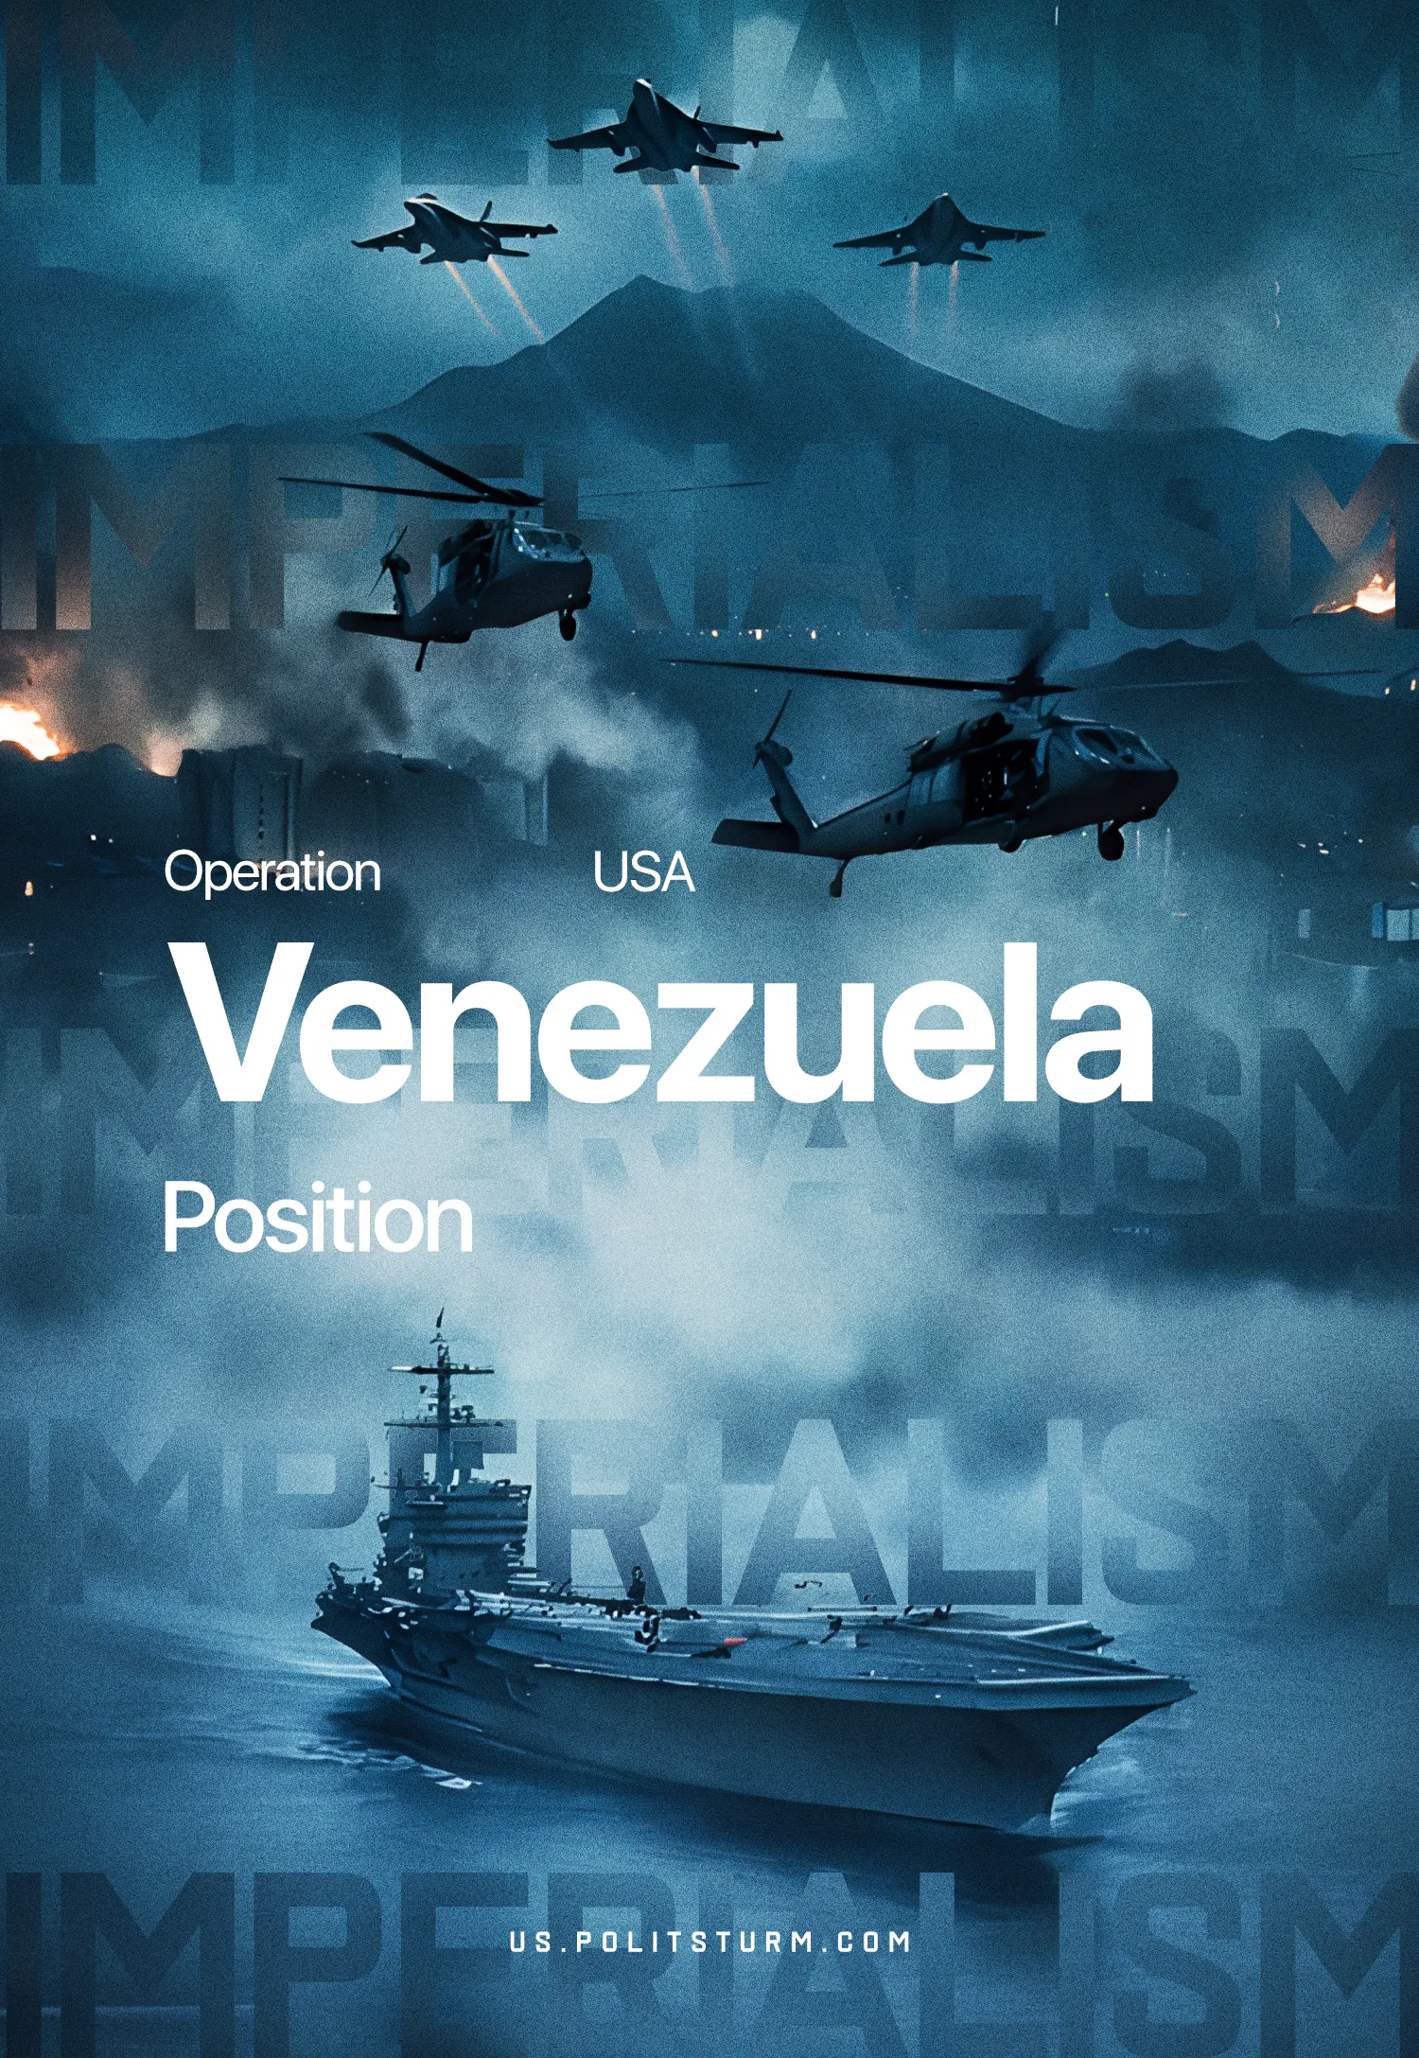

Original article
2026-01-04
6 min read

I. Timeline
On the morning of January 3, the United States launched an open invasion of Venezuelan territory. Venezuelan President Nicolás Maduro declared a state of emergency, but the US government refrained from making any public statements in the first hours.
American forces launched strikes on military and industrial targets. Reports emerged of a US force landing in Caracas and the seizure of the capital's airport.
Following this, the first official statements from US government officials were released. Donald Trump announced the capture of President Maduro and his wife by the US Delta Force. US Deputy Secretary of State Christopher Landau stated that Maduro would face trial for "crimes". Washington characterized the invasion itself as "executing the arrest warrant".
Venezuelan government officials have issued statements declaring continued resistance. Power has formally transferred to Vice President Delcy Rodriguez. However, the Western bloc is counting on the rise of María Machado, a far-right opponent of Maduro and Nobel Peace Prize laureate who has repeatedly spoken out in support of the American intervention in Venezuela. Trump subsequently announced he was working with the vice president and described Machado as unfit to lead Venezuela.
In essence, the January 3 operation represents a violent bourgeois coup: the replacement of one bourgeois group with another, completely controlled by the United States and ensuring the interests of American capital.

II. The Context of the Imperialist Conflict
The invasion unfolds against the backdrop of an intensifying struggle between American imperialism and rising Chinese imperialism. Throughout 2025, the Trump administration pursued a hardline policy toward China and its allies. To this end, the US imposed trade tariffs, pressured Russia, and launched strikes against Iran.
Venezuela is part of the Chinese bloc, representing its interests in South America. The signing of a strategic agreement with China's CCRC in 2024 has created the threat of Washington completely losing control over Venezuelan oil.
The conflict was preceded by months of secret negotiations between the Venezuelan and US leadership. From 2017 to 2025, the governments of both countries maintained regular contact.
In the fall of 2025, information about possible agreement options emerged. Maduro considered signing oil supply contracts with American corporations and gradually stepping down from power over the next few years. Maduro's willingness to make a deal with the US exposed the hypocrisy of the Venezuelan bourgeoisie, for whom maintaining power and profits is more important than any supposedly "anti-imperialist" rhetoric.
In early September, the United States strengthened its military presence in the Caribbean. In November and December, the American fleet began a blockade of the Venezuelan coast. After the invasion began, information emerged about plans to strike Venezuela in late December.
On the eve of the escalation, on January 2, 2026, Maduro met with China's special representative. During the meeting, hundreds of bilateral agreements were discussed, cementing military and economic cooperation between Venezuela and China.

III. The Goals of American Imperialism
The lightning strike, which Trump called "well-planned", has three specific objectives:
1. Moving Venezuela out of Chinese and Russian influence, ensuring monopoly access to oil for US corporations such as Chevron and ExxonMobil.
2. Diverting the American working class's attention from rising unemployment, inflation, rising prices, and the crisis. Through a "small victorious war", American capitalists led by Trump are attempting to instill social chauvinism in the working class and create the image of America returning to its "traditional" role – an aggressive imperialist, capable of defending its interests by force anywhere on the planet.
3. Internationally, the American bourgeoisie and Trump are sending a signal to rising imperialist China and all its weaker opponents in the region and globally. Now the bourgeoisie of dependent and semi-dependent states will be forced to reckon with the possibility of a repeat of the "Venezuela scenario".
Almost simultaneously with the attack on China's ally in South America, protests are unfolding in Iran. Trump has already declared his readiness to "come to the aid" of the protesters.
The justification for the invasion, citing "execution of an arrest warrant", contrasts with the US administration's actions regarding the International Criminal Court. After issuing an arrest warrant for the leader of US-ally Israel for aggression in the Gaza Strip, Trump imposed sanctions against the ICC. This confirms that "international law" is a fiction, valid only when it benefits a major imperialist.

IV. The Collapse of the Maduro Regime
Beginning in 2026 with a military strike against part of the Chinese imperialist bloc, the United States demonstrates the main trend of the current moment: the crisis of capitalism leads to an escalation of contradictions between blocs. This escalation manifests itself in an increasing number of wars and targeted military actions.
The swift operation by American troops will set an example for other capitalists. The normalization of attacks on the leadership of hostile bloc states leads to further escalation of tensions, new escalations, and wars.
The speed of the January 3 operation was due not only to the US military and technical superiority but also to the lack of mass support for the Maduro regime among the Venezuelan proletariat. The bourgeois regime pursued anti-labor policies, eroded workers' real incomes through hyperinflation, and suppressed independent trade unions and communists.
Maduro couldn't count on popular resistance. The Venezuelan bourgeoisie, including the upper echelons of the ‘United Socialist Party of Venezuela’ and the military, created the conditions for a successful foreign invasion through corruption and economic sabotage.
It is necessary to decisively expose the illusions about the "socialist nature" of the Maduro government. The petty-bourgeois concept of "21st-century socialism" has proven in practice to be a cover for classic state-monopoly capitalism.
The key means of production were controlled either by private capital or by the bourgeoisie, fused with the state apparatus. Nationalization, without changing production relations, merely transferred exploitation to the state as the collective capitalist.
It's noteworthy that the theory and practice of "Chavismo" received support from a number of Trotskyist movements. Nicolás Maduro himself published materials in support of Trotsky and called him "one of the great Marxists of the 20th century".
In an attempt to cling to power, the regime resorted to bourgeois nationalism, threatening to annex parts of Guyana. This adventurism was necessary both to distract Venezuelan workers from domestic problems and rally them around the flag of the bourgeois state, and to strengthen the position of the Venezuelan bourgeoisie.
The Maduro regime's entire "anti-imperialist" rhetoric boiled down to bargaining and maneuvering between major imperialists, handing over oil contracts first to the American Chevron, then to the Chinese CCRC. The class essence of capitalism remained unchanged.

V. The Position of the Communists
1. Condemnation of US imperialist aggression and support for Venezuelan workers.
2. No support for the bourgeois regime of Venezuela, which exploits the working class, bans strikes and suppresses communists, nor for the bourgeois “opposition” and other pro-capitalist forces.
3. The only way out for Venezuelan workers is to create a real communist party and fight for socialism, together with workers of all countries.

Original article

