US Department of State Backs Europe’s Far-Right
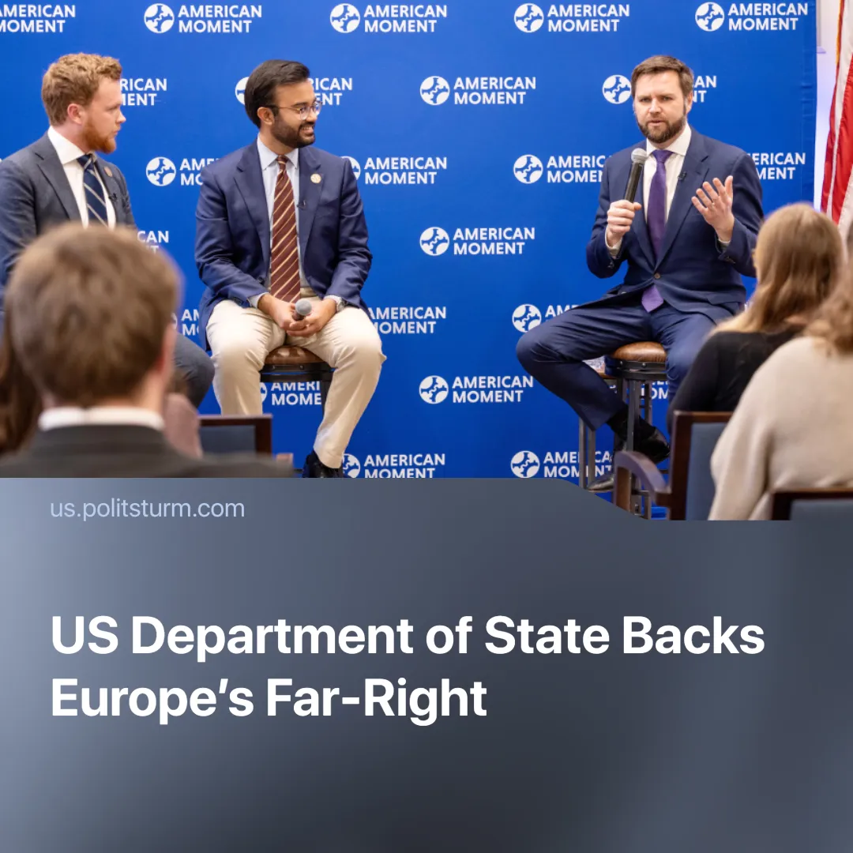

Original article
2025-07-21
1 min read

A US Department of State publication advocates bringing far-right leaders to power in Europe, framing them as Christian "civilizational allies. "
Details. On May 27, 2025, the US Department of State published an article titled "The Need for Civilizational Allies in Europe." Samuel D. Samson, a young author known for promoting religious "post-liberal" politics, has authored this piece.
► Samson was recently appointed Senior Advisor to the Bureau of Democracy, Human Rights, and Labor (DRL). The DRL is responsible for promoting "political liberalism", "human rights", and "labor advocacy" worldwide. It employs diplomacy and funding to influence foreign politics in accordance with American objectives.
► The article begins by framing Euro-American relations as "a shared Western civilizational heritage" but calls the EU the “greatest innovation of political life” that sought to overcome the “anchors of nationhood, culture, and tradition.”
► Later, however, Samson refers to the EU's efforts to suppress pro-American opposition as a "campaign against Western civilisation" that threatens "the transatlantic partnership." According to him, this global liberal project is trampling “democracy” and “western heritage” in the name of a “decadent governing class afraid of its own people.”
Context. Economic stagnation and austerity measures to protect profits have resulted in the rise of far-right parties all over Europe, which have expressed anti-EU views and threaten the bloc's ability to assert itself as an independent imperialist power amid growing tensions between the major powers.
► The EU has taken steps to suppress or control anti-EU parties that conflict with its interests. It has barred individuals from elections, overturned results in Romania, and signaled a readiness to do the same in Germany in the case of AfD.
► The US leadership, wishing to keep the EU semi-dependent, has repeatedly expressed strong disapproval of any EU measures against these groups. Secretary of State Marco Rubio criticised such moves as “tyranny in disguise.” J.D. Vance described them as a new Berlin Wall.

Original article

