US Seized Two Venezuela‑Linked Oil Tankers
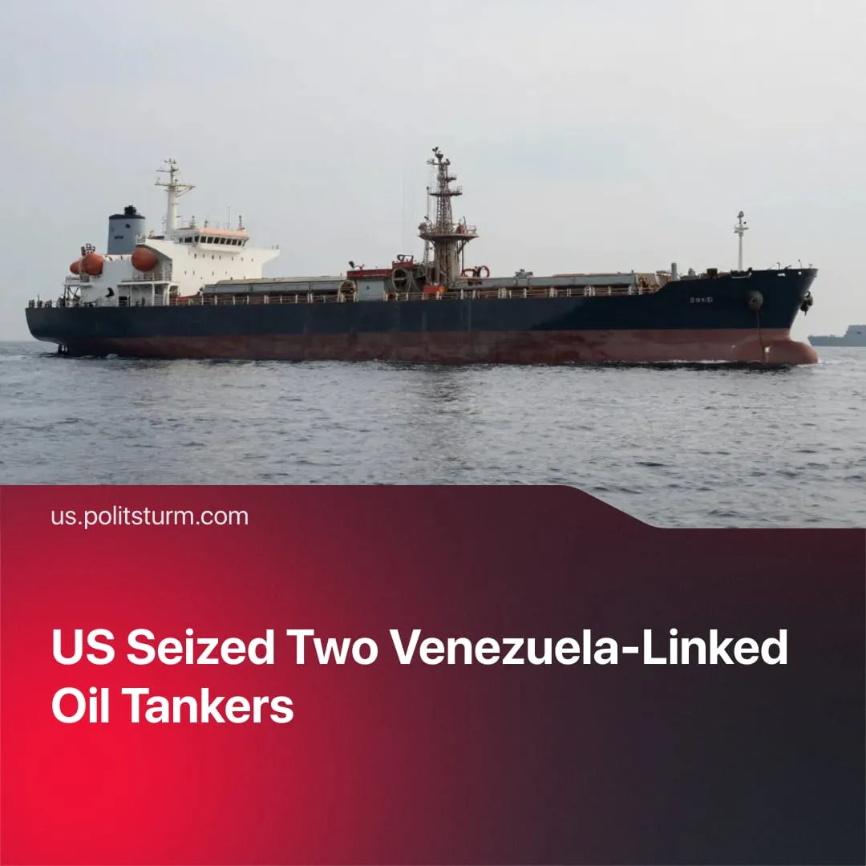

Original article
2026-01-10
2 min read

US seizure of two Venezuela‑linked oil tankers, including a Russian vessel, marks a direct assertion of control over the Western Hemisphere.
Details. On January 7, US military and Coast Guard forces seized two “shadow fleet” tankers linked to US-sanctioned Venezuelan oil exports, including a Russian-flagged vessel, in operations in the North Atlantic and the Caribbean.
► One of the vessels, the Marinera (formerly Bella 1), was pursued across thousands of miles after attempting to evade a US blockade. It was renamed and reflagged to Russia before US forces – with UK operational support – boarded and seized it in the North Atlantic. The second “stateless” tanker, Sophia/M Sophia, was intercepted and taken in the Caribbean during the same campaign.
► The Russian Transport Ministry stated that the vessel had been granted “temporary permission” to sail under the Russian flag and insisted that no foreign state has the right to use force against ships legally registered under another nation’s jurisdiction.
► By seizing a Russian vessel, Washington has sent a clear signal that Russian-associated shipping will no longer enjoy any presumed immunity in the Western Hemisphere.
Context. The tanker seizures follow the January 3 invasion that overthrew the Maduro capitalist regime and aims to install a more US-aligned government.
► Venezuela is aligned with the Chinese bloc through strategic agreements, including oil and military cooperation, making it a focal point in the confrontation between US and Chinese imperialism.
► Trump’s administration has been pushing for an end to the “SMO” since the start of his term, aiming to neutralise secondary fronts and concentrate pressure against rival imperialist China. As part of this strategy, the US recently imposed sanctions on Russia’s major oil firms – Rosneft and Lukoil.
Important to Know. The US seizure of these tankers represents a continuation and escalation of Washington’s renewed aggressive foreign policy and its drive to assert exclusive control over the Western Hemisphere, as set out in the latest US Security Strategy.
► Washington is sending a clear message to Russia and China that any attempt by rival powers to maintain influence in Venezuela’s oil sector will be met with direct coercive action, and that Venezuela is exclusively its “colony,” with active control exercised over its resources.

Original article

