US Secures Paraguay as Military Foothold
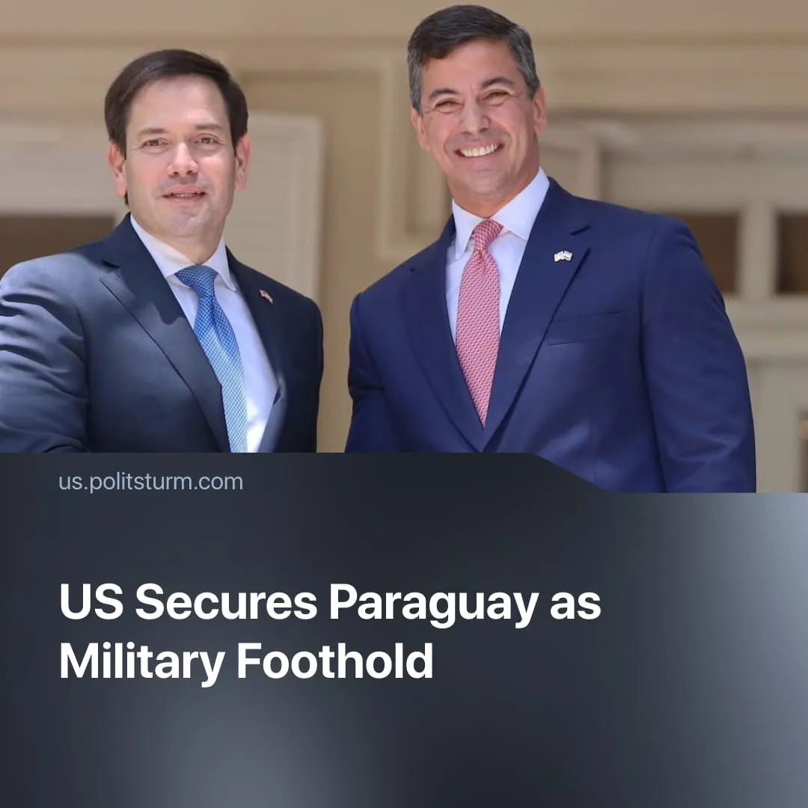

Original article
2026-04-09
1 min read

Trump secures a deal with Paraguay, allowing US military forces to operate within the country to combat “narcoterrorism”.
Details. Paraguayan lawmakers have approved a Status of Forces Agreement (SOFA) with the United States, signed in December 2025, which now awaits the final signature of President Santiago Peña. The agreement formally aims to combat terrorism and organised crime, strengthen military cooperation, and support humanitarian and disaster-response operations.
► SOFA grants US military personnel and contractors extensive privileges, including freedom of movement, the right to carry weapons, and the ability to import equipment. These forces operate under US jurisdiction, with broad immunity from Paraguayan law and exemptions from local taxes.
► Although officially described as temporary, the agreement has no fixed end date and can only be terminated with one year’s notice.
► US officials have hailed the SOFA as a historic step in strengthening security cooperation, claiming it will advance “mutual interests”. The Paraguayan government presents it as a tool to combat crime and trafficking, insisting that national sovereignty is not compromised and that no permanent US bases will be established.
Context. As part of its broader strategy of imperialist projection, the US has instrumentalised the fight against “narcoterrorism” to expand its influence in Latin America. This approach, most evident in Venezuela and being applied in Mexico and Colombia, is aimed at countering the growing foothold of Chinese capital, which challenges long-standing US dominance in the region.
► Furthering this campaign, the US recently launched the Shield of the Americas initiative, coordinating Latin American allies under US leadership through joint military operations, intelligence sharing, regional patrols, and training programmes, alongside financial monitoring and coordinated anti-cartel measures.
► Brazil has raised concerns about SOFA and US military activity near the tri-border region. Simultaneously, the US is looking at classifying two Brazilian syndicates as terrorist organisations after lobbying from two sons of the far-right ex-President Bolsonaro.
► Paraguay’s president, Santiago Peña, is a close ally of the United States. Paraguay has supported the so-called “Donroe Doctrine” by aligning itself politically with Washington's regional agenda. The country has further reinforced this partnership by signing a migration cooperation deal with the US, which coordinates asylum and migrant transfers.

Original article

