US Responds to China’s Tech Catch-Up
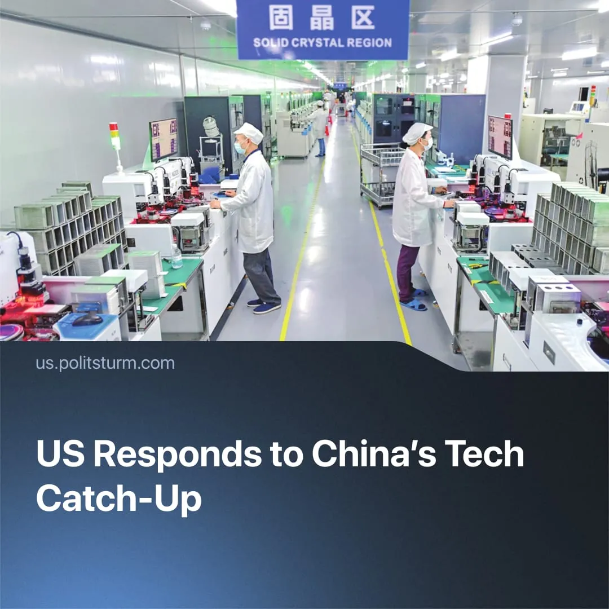

Original article
2025-10-25
1 min read

The US has acknowledged China's technological catch-up. Its response includes a giant AI centre, an autonomous drone factory, and hypersonic missiles.
Details. 4 months ago, in response to the release of DeepSeek AI, White House AI, and crypto czar David Sacks acknowledged that China is about 3 to 6 months away from reaching the US technological level in artificial intelligence.
► Major American tech companies – such as Meta, Microsoft, Amazon and Google – have collectively invested $166 billion in domestic AI projects. One project outlines plans to build a 500-acre self-powered data centre called “Horizon” in West Texas.
► The autonomous drone market is receiving heavy investment, with the industry projected to reach $54.6 billion in 2025. Californian company Anduril has announced plans to build a $900 million production complex for autonomous, weaponised drones in Central Ohio, employing over 4,000 workers.
► The US continues to develop and test hypersonic missiles. Budgets for programs – such as HASTE (Hypersonic Accelerator Suborbital Test Electron) under Rocket Lab – are increasing by 8.8% annually. The program aims to match Russia’s Avangard – Mach 20 hypersonic missiles capable of carrying nuclear warheads.
Context. As US–China imperialist rivalry has intensified, both states have sought to reduce mutual dependencies. China relies on export markets and high technologies dominated by Washington, while the US depends on Chinese rare earths, 92% of which are processed in China. This structural interdependence shaped the recent tariff truce.
► China is rapidly expanding AI chip and semiconductor production. In 2025, total AI investment is projected at $98 billion, with government support accounting for more than half. Semiconductor investment reached $63.3 billion in the first half of 2025, helping China expand its control over 27% of global chip output.

Original article

