US Requests $350 Billion to Fight "Communism on Our Own Shores"
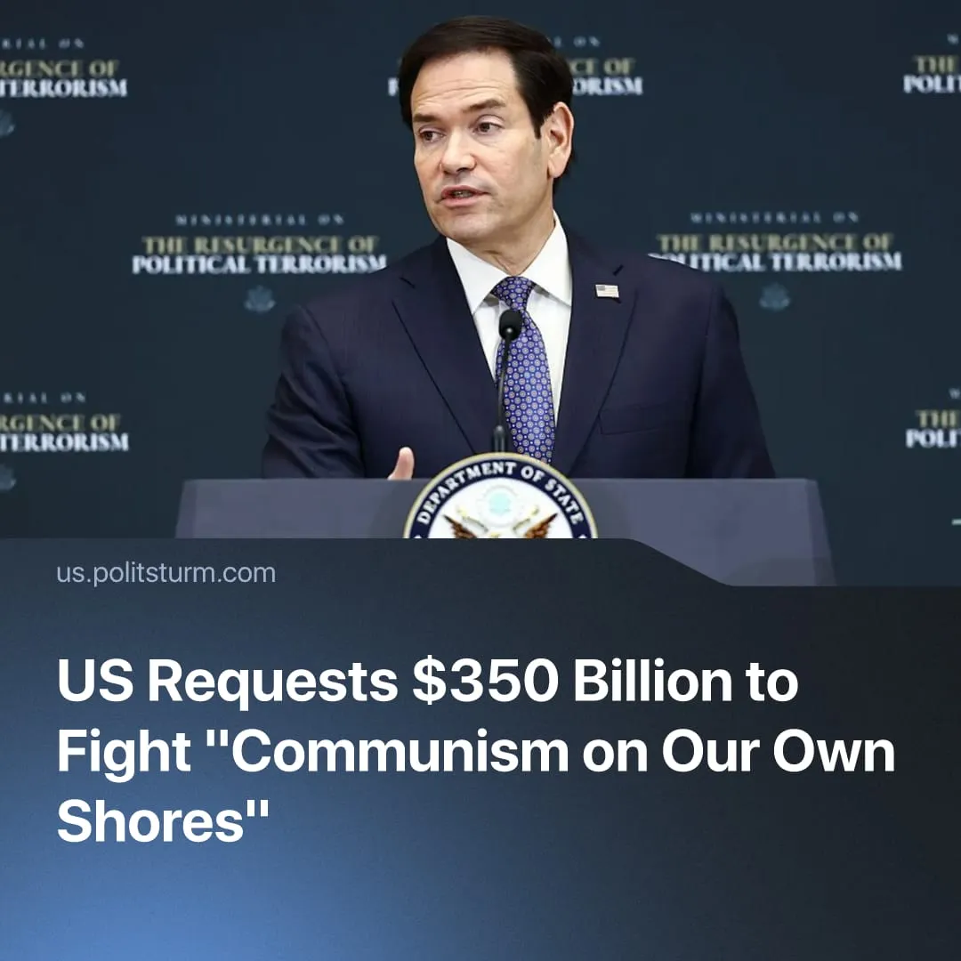

Original article
2026-07-25
1 min read

The left is labelled a “scourge” as US officials request an extra $350 billion defense investment to fight “communism on our own shores”.
Details. Last week, US Secretary of State Marco Rubio convened representatives from more than 60 countries to coordinate action against what he described as "far-left political terrorism". He claimed that recent political violence, including assassination attempts against Donald Trump, demonstrates a growing international threat requiring closer cooperation between governments.
► During the meeting, Rubio and political advisor Stephen Miller repeatedly described the left as a "scourge", "cancer", and "deformed", arguing that left-wing movements are incapable of creating anything and only spread destruction. He also promoted measures including visa restrictions, financial deplatforming ("debanking"), and broader international cooperation against left-wing organisations, pointing to Germany's recent debanking of left-wing activists as an example.
► Earlier, House Speaker Mike Johnson defended proposals to increase Pentagon spending by an additional $350 billion, claiming the United States must prepare to fight "communism on our own shores". If approved, total US defence spending would exceed $1.5 trillion annually, marking another major expansion of military expenditure.
Context. The campaign forms part of the broader fascisisation of the American state. Alongside anti-communist rhetoric, the federal government has expanded the role of ICE, strengthened executive authority, increased militarisation, and intensified surveillance of political opposition.
► The narrative of a growing communist threat follows earlier initiatives such as "Anti-Communism Week", the designation of Antifa as a terrorist threat, and Donald Trump's recent speeches warning that communism is spreading within the United States.
► Rubio and Stephen Miller's portrayal of the left as "fundamentally motivated by envy, by hatred, by jealousy" and incapable of creating anything closely resembles the dehumanising language of fascism. Nazi propaganda described its perceived enemies as "subhuman" who "hates all that is created by man" and "always sought to bring about his downfall”.
► Despite official claims, available data consistently show that far-right extremists commit significantly more politically motivated violent attacks than organised left-wing groups, yet government campaigns overwhelmingly focus on the latter.

Original article

