US Reinforces Military Occupation of Yemen
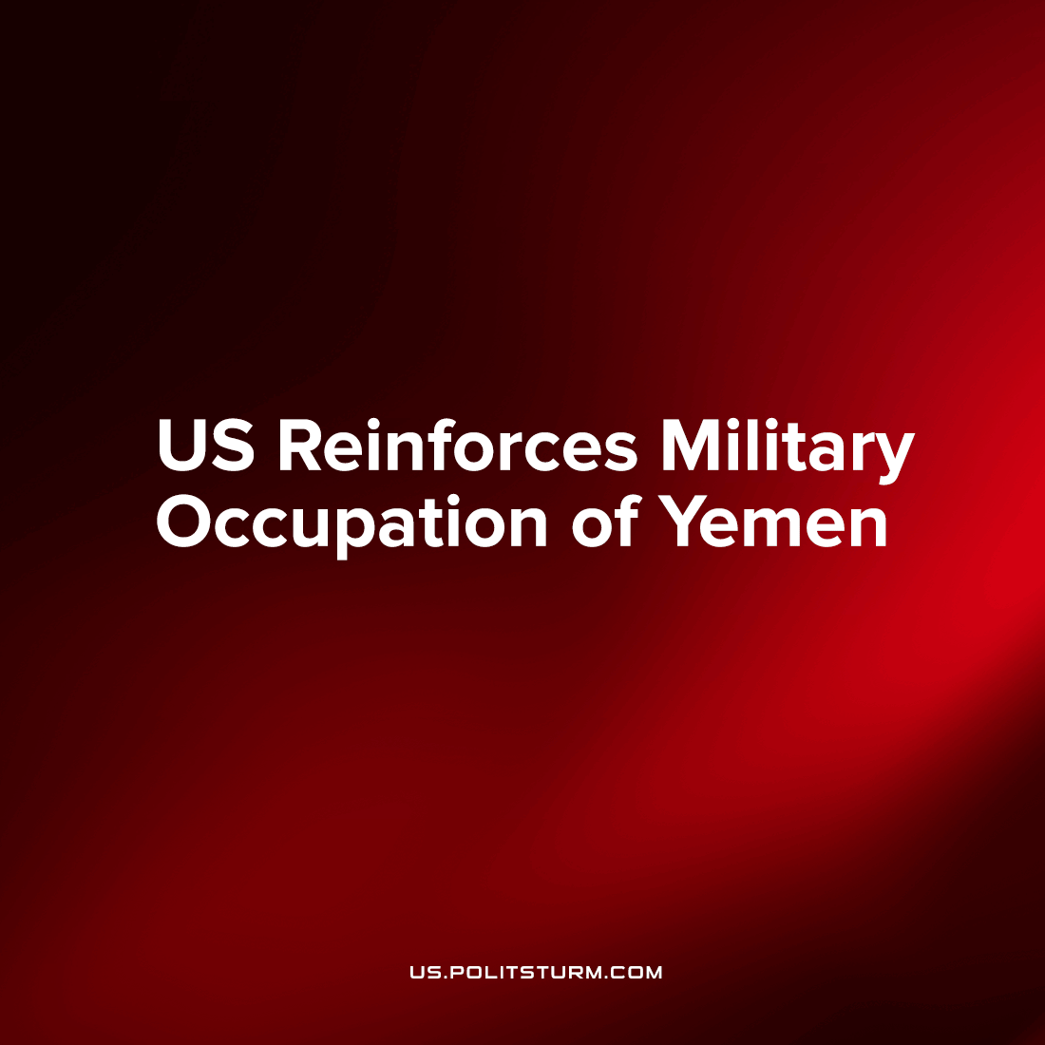

Original article
2022-08-01
2 min read

Using the truce as cover for the safe movement of personnel, the US is reinforcing its occupation of southeastern Yemen with more guns, more supplies, and more troops.
For years, the US has discretely operated the war against the ​​Ansar Allah (‘Houthi’ rebel) government of Yemen on behalf of its most important imperial asset, Saudi Arabia. The Saudi military is entirely inadequate to the job: their ground forces rely on foreign mercenaries, while their airforce bombs Yemen only as often as the US and British engineers and instructors enable them. This war has brought horrible famine and disease to the Yemeni people, misery which is central to the US-Saudi strategy of attrition.
But after years of failure for the Saudis, and meaningful victories for the Yemenis (striking vulnerable Saudi oil facilities and holding their northern territory), the US is looking to press its thumb on the issue. Since the war started as an offensive by Saudi Arabia and its allies, this current truce is a real indication of weakness on their part.
US and British military trainers were shipped in to the eastern province of the country on July 28th, hoping to finally teach their local allies how to defeat the guerilla-style tactics of the Houthis. In previous weeks, huge arm shipments were unloaded in the same region, while the province’s governor was quoted by Saba saying that the occupying Saudi-coalition is enabling crime in order to weaken local resistance within the coalition’s base area.
Reinforcement of US and allies’ imperial presence was also seen in Somalia in the past few months, where the Biden administration reversed Trump’s tepid ‘pull-out’ by sending hundreds of Special Forces troops to act as bodyguards for proxies there.
Conspicuously, these two countries border the strategic waterway juncture in the Gulf of Aden, through which millions of tons of oil and shipping pass through to-and-from the Suez Canal, the main route between Europe and Asia. Clearly, the United States seeks to maintain its grip on the most important areas of the ‘Middle East’ region in which it has seen a gradual retreat from regional competitors; Iran in Iraq, Russia in Syria and China in Afghanistan.
It is too soon to celebrate the end of US military presence in the region, and we must keep a sharp eye out for the inevitable escalation of war in places like Yemen by a hungry imperial state.
Sources: 1, 2

Original article

