US Regains Initiative in Imperialist Rivalry with China
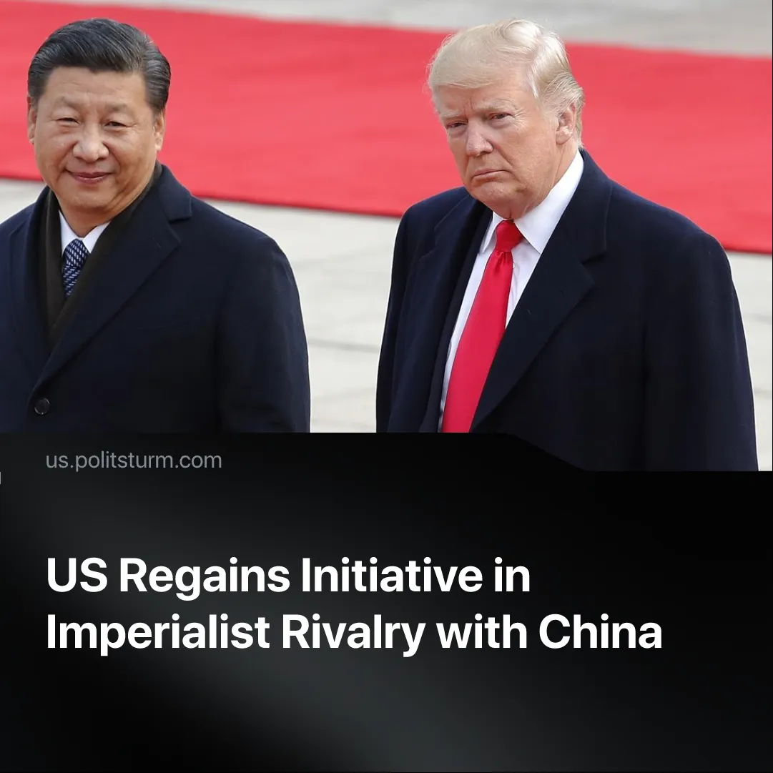

Original article
2025-08-24
2 min read

The US currently holds the advantage in its struggle with China.
Details. A number of facts indicate that the United States is gaining the upper hand in the confrontation with China.
► Chinese monopolies have agreed to Trump's tariffs and are forced to pay money for the opportunity to import Chinese goods in America. After the US tariffs, the PRC has called on Chinese capitalists to exploit the domestic market more actively and has also attempted to form an economic alliance of Asian countries unhappy with the tariffs. However, these attempts have been unsuccessful. Facing overproduction, Beijing accepted a truce on US terms that kept 55% tariffs on Chinese goods, whilst only 10% on US goods.
► The Trump administration has successfully frozen several conflicts in ‘secondary’ points of interest, easing pressure on the Western bloc. This gives America a short period of stability to rearm and prepare for a potential future conflict with China.
► The US has gained control over some global trade routes. After his inauguration, Trump pressured Panama to leave the Belt & Road Initiative and expel Chinese firms from the Canal. A week ago he secured exclusive development rights to the Zangezur Corridor in the Caucasus, valued at up to $100 billion in trade when finished. Both moves undercut China’s push to build a new Eurasian “Silk Road.”
► The US secured rare earth deposits in dependent countries like Congo and Ukraine. This will potentially cut America's reliance on China, which mines 70% and processes 90% of global supply.
Context. The global standoff between the US and China has intensified with the rise to power of Donald Trump. The new president has taken radical measures to maintain America's position as a hegemon.
► The US holds entrenched financial hegemony, controlling the dollar as the global reserve currency and access to global commercial banking through SWIFT. The IMF and World Bank — dominated by the US, which holds an effective veto through its voting share — remain the biggest foreign loan institutions.
► China’s economy produces far more than its domestic market can absorb. Exports are 20% of GDP, with a $1 trillion surplus driving growth.
Important to Know. The ease with which the US imposed its tariffs, and the fact that Chinese capitalists accepted them, showed how deeply China is tied to international trade.
► Control over the arteries of international capitalism gives the US advantages in enforcing its interests, such as the sanctions used against Russia since 2022, or in the case against Iranian oil, in which exports dropped by over half.
► The US still holds the military advantage, spending more on defence each year than its ten largest competitors combined. In 2025, Donald Trump proposed a record $1.01 trillion military budget for the next fiscal year. Backed by NATO and a global network of bases, the US retains unmatched capacity for worldwide power projection.
► China is not a socialist state. It has all the elements of a capitalist system: the presence of opposing classes, monopolies, the struggle for markets, economic crises, and growing social stratification. China does not represent a qualitatively different alternative to the US. The few superficial elements of socialism that Chinese capitalists retain are used to deceive workers in China and elsewhere.
► As Stalin explained in “Foundations of Leninism”, such rivalries are “a struggle waged with particular fury by new financial groups and Powers seeking a 'place in the sun' against the old groups and Powers, which cling tenaciously to what they have seized.”

Original article

