US Pivots Focus To Cuba After Iran
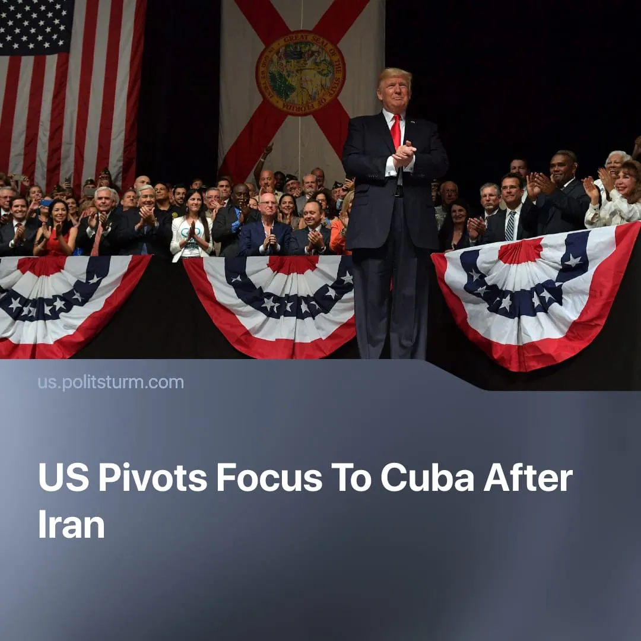

Original article
2026-05-14
1 min read

Trump plans to “take over” Cuba after having declared victory in Iran.
Details. On May 1, 2026, President Trump gave a speech at the Forum Club of the Palm Beaches Dinner in Florida, where he stated that the US Navy might use a show of force to pressure Cuba’s leadership into surrendering. He specified that this could happen right after the operation in Iran ends, when the navy returns home. Despite the joking tone of speech, such rhetoric echoes earlier US threats towards Cuba this year.
► This is likely to happen sooner rather than later, as Trump declared “victory" over Iran. According to the administration’s own statements – such as Marco Rubio’s claim that Operation Epic Fury is "over” – Trump’s government appears to be seeking a quick end of the conflict. For example, it already extended the ceasefire.
Context. US tensions with Cuba increased after the capture of Venezuelan President Maduro and the subsequent halt in oil supplies to the island from its main supplier. An energy crisis began in Cuba, with Trump additionally issuing an executive order, which threatened tariffs on anyone selling oil to the island.
► Trump himself labelled Cuba a "falling nation” and previously already made statements about a possible takeover, even during US–Cuba negotiations in March. A new round of negotiations is expected soon, with Trump claiming that Cuba “is asking for help”.
► The war with Iran proved too costly for the US in both financials and Trump's rating, as Iran adopted an economically draining tactic, retaining some military capabilities. In contrast, Cuba is militarily weak, geographically close, and facing an energy crisis, which the US views as a possible "easy win”.
► Nicaragua, Mexico, El Salvador, Colombia and several other countries have also received threats of invasion or “takeover" rhetoric from Trump. Some of these countries have ties to Russia or China, while the US is seeking to weaken China’s influence ahead of future confrontation and reinforce control over what it considers its own hemisphere.

Original article

