US Naval Force Deployed to Latin America
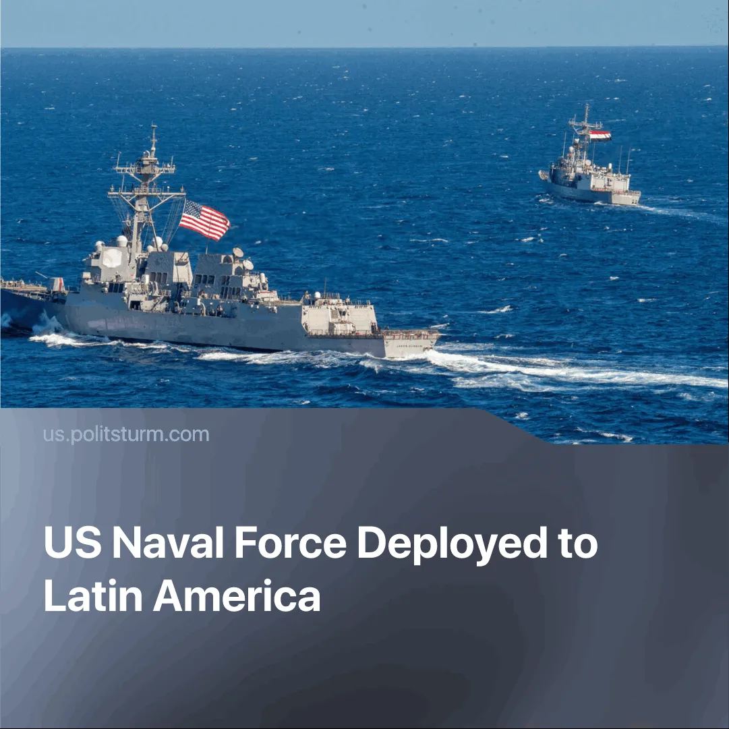

Original article
2025-09-01
2 min read

Venezuela may become a new focus of US pressure following strikes on Iran, as Washington seeks to weaken Chinese allies.
Details. The US has deployed a naval force to the southern Caribbean near Venezuela, consisting of seven warships, a nuclear-powered submarine, and over 4,500 personnel. Deputy White House Chief of Staff Stephen Miller said on Friday that the military buildup aims to “combat and dismantle drug trafficking organisations, criminal cartels, and foreign terrorist organisations in our hemisphere.”
▶In response, President Maduro has ordered the mobilisation of militia fighters, comprising more than 4.5 million members, to “ensure coverage of the entire national territory.” He has also conducted exercises and enlistment drives, along with new troop movements and enhanced border and coastal patrols.
▶ China’s Foreign Ministry spokesperson Mao Ning stated that China opposes any actions that violate the UN Charter or another country’s sovereignty. She rejected foreign interference in Venezuela’s affairs and urged the US to act in ways that promote peace and security in Latin America and the Caribbean.
Context. In June 2025, after diplomacy with Iran failed to halt uranium enrichment, Israel carried out strikes on Iranian officials and nuclear scientists. The US then launched Operation Midnight Hammer, bombing major nuclear sites at Fordow, Natanz, and Isfahan. Following the “12-day war,” 180 Iranian economists and high-profile officials issued a joint statement calling for renewed talks with Europe and the US.
▶ Historically, the US has maintained South America as a dependency through financial dominance via IMF and World Bank loans, reinforced by political pressure and military interventions. Today, that influence continues; the US recently pressured Panama to withdraw from China’s Belt and Road Initiative, end Huawei installations, and audit Chinese-run ports.
▶ Since 2005, China, as a rival imperialist power, has invested roughly $200 billion in Latin America, creating new dependencies in raw materials and infrastructure. Venezuela is its largest borrower, taking around $60 billion in loans alongside oil and infrastructure joint projects, challenging long-standing US primacy in the hemisphere.
▶ The US has long imposed sweeping sanctions on Venezuela, formally recognised Juan Guaidó as interim president in 2019, and supported pressure campaigns—including a controversial aid push at the Colombia border and backing a failed April 30, 2019, uprising. In August 2025, the US doubled the reward for Nicolás Maduro’s capture to $50 million, accusing him of leading a “narco-terrorist” cartel.

Original article

