US Moves Force, Withdraws People from Niger
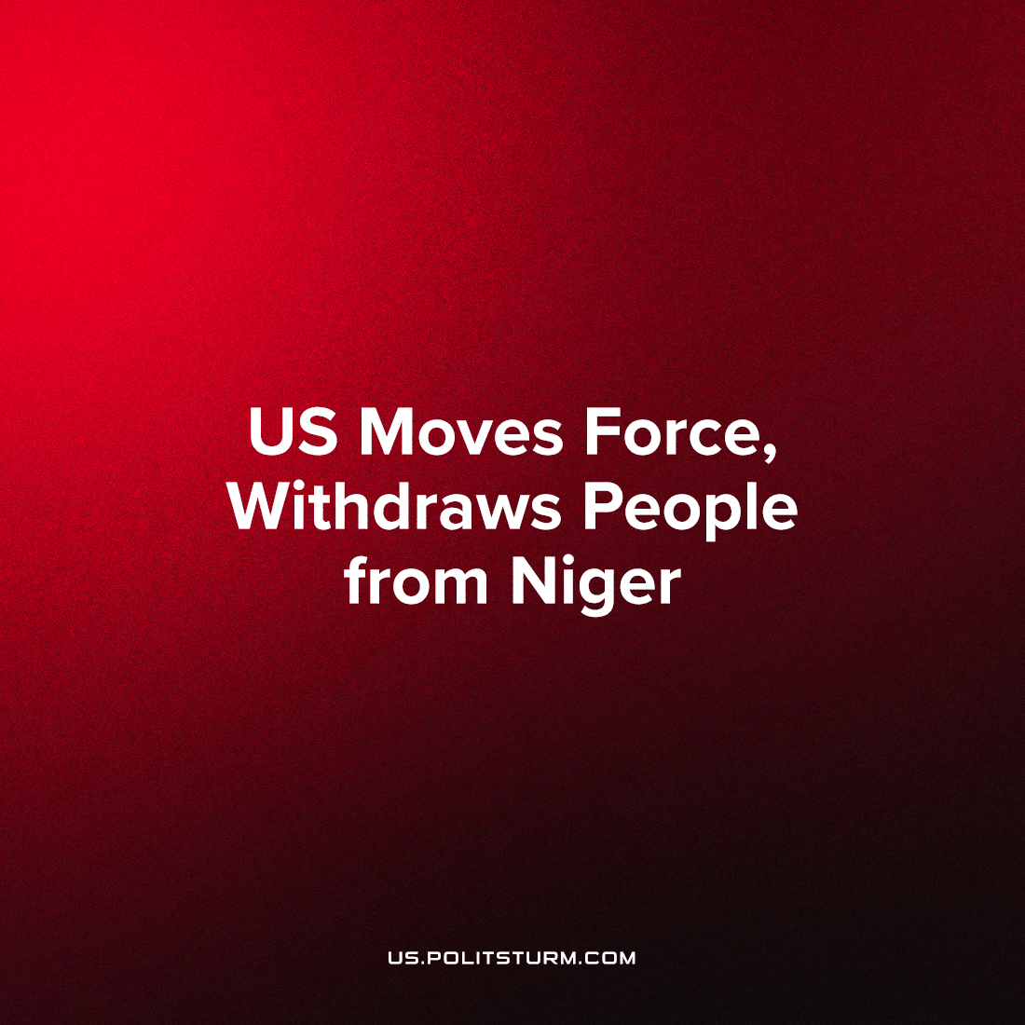

Original article
2023-09-08
1 min read

The U.S. has moved troops and military equipment from their major shared base with the French at the Nigerien capital, to another permanent base over 400 miles north in the center of the country
At the same time, they have withdrawn all "non-essential personnel". Most U.S. government personnel already left back in early August. Later that month, U.S. the military drafted an evacuation plan.
This move could suggest an increased state of war-readiness by U.S. AFRICOM forces in Niger as negotiations continue on the French withdrawal. Mobilization out of the Niamey-area Air Base 101 region, to the more isolated Air Base 201 in Agadez, de-entangle this unknown force, from a previous total troop number of 1,100, in a fight with the junta for the capital.
This move could be a sign to Niger's ruling military council that the U.S. is meeting demands and moving these troops as part of ongoing counter-terror agreements, in a position which doesn't threaten the junta. Alternatively, it places U.S. troops away from concentrations in the southwest, instead reinforcing a defensible, strategic position which could project force across the whole country.
"This consolidation represents prudent military planning to safeguard U.S. assets while continuing to address the threat of violent extremism in the region," US officials told Reuters.
Further, they stated "The movement of U.S. assets has been coordinated with and approved by the appropriate authorities,". Coordination for the move is in compliance with Biden's order for US forces to remain in place in support of the diplomatic negotiations.
Source: 1

Original article

