US Military Requests Massive Wall Street Investment
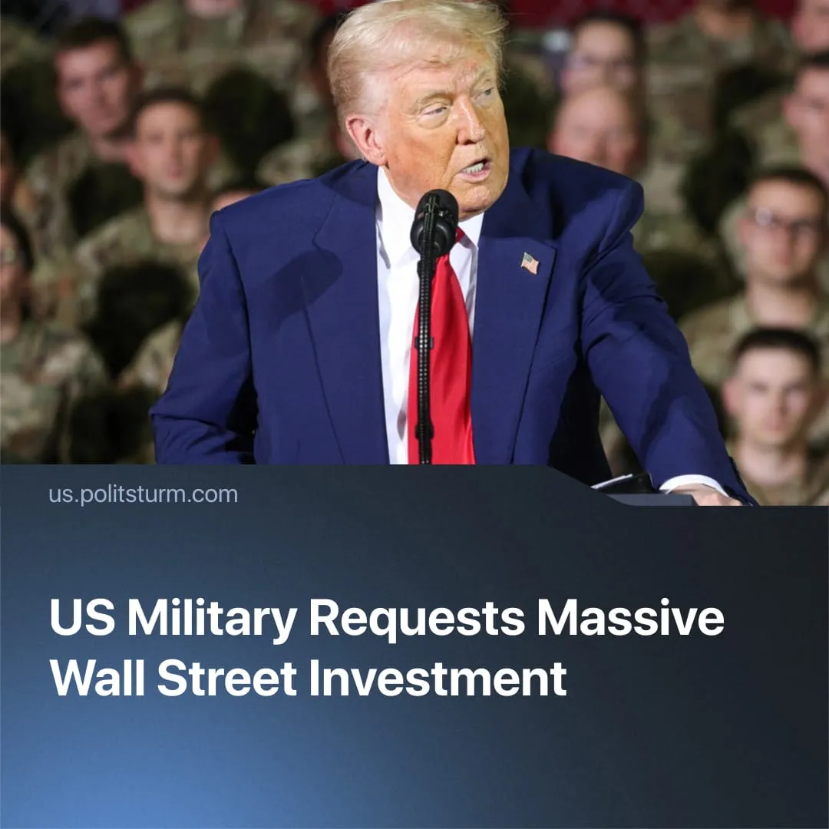

Original article
2025-10-30
2 min read

$150 billion is being raised from Wall Street private equity firms to rebuild US military infrastructure, marking an unprecedentedly open merger of finance and the Pentagon.
Details. Secretary of the Army Daniel Driscoll and Finance Minister Scott Bessent invited 15 top Wall Street firms to an investment forum for the US military. The federal officials, both former bankers, requested $150 billion in capital to fund US militarisation – claiming that the $15 billion Department of War overhaul budget was insufficient.
► This policy, part of the new Army Transformation Initiative, seeks to outsource construction and raise private funds for the modernisation of military infrastructure – such as bases, depots and distribution hubs. The $150 billion influx of capital would cover the upfront costs for consolidating the US Armed Forces’ global supply chain.
► Driscoll and Bessent envision joint US projects with Wall Street, such as leasing federal land to the private sector for the construction of new data centres and rare earth processing plants. The government would initially grant the land for free, in exchange for companies providing their output to the army once the facilities are operational.
Context. This move builds on an already entrenched merger between private capital and the federal government, which is now deepening and becoming increasingly open.
► The US Army has recently commissioned Big Tech executives from Palantir, Meta, and OpenAI as reserve officers.
► Billionaire tycoon Timothy Mellon gave the federal government a $130 million “donation” to pay American soldiers’ salaries during the shutdown. Such private funding of the US military is unprecedented and may even violate American law.
► The US Army’s new Janus Program plans to deploy small nuclear reactors on American military bases, which would be “commercially owned and operated.” NuScale and Oklo, the companies competing for this energy contract, saw a surge in their stock prices.
► The American military’s Defence Logistics Agency is migrating its cloud computing needs from old government-run systems to a new commercially-provided service, with Google winning the $48 million contract.
► The Pentagon has bought $400 million in stocks of the rare earth company MP Materials, becoming the largest shareholder. The Department of War also guaranteed the Pentagon would buy all magnets produced by MP Materials for the next 10 years at a minimum price.

Original article

