US Meets With Iran Amidst Tensions
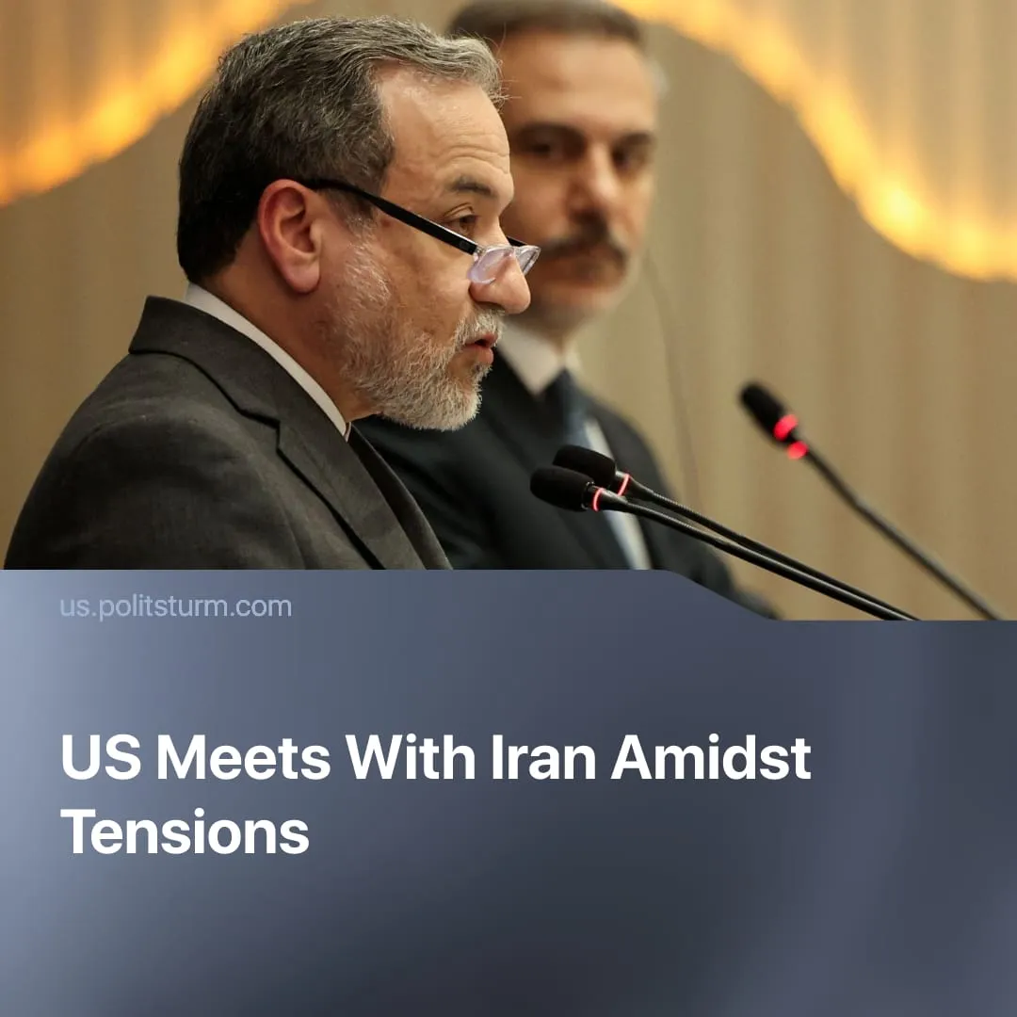

Original article
2026-02-07
1 min read

Iran makes concessions for ‘deal’ with USA, as Middle East war looms.
Details. Bilateral talks were held in neutral Oman on Friday to discuss Iran’s nuclear weapons program. Negotiations had nearly collapsed this week due to disagreements on the location and parameters. US officials were reportedly “very sceptical” of the meeting’s utility, but agreed to go ahead after allied requests.
► The negotiations are meant to stave off President Trump’s threatened “next attack” on Iran, forcing concessions. The US wants to impose “zero nuclear capability,” which Iran agreed to in principle. However, broader American demands to disarm Iran’s conventional missile arsenal and its imperialist proxies were refused.
► The US qualified the outcome of the Oman meeting as “very good,” and Iranian authorities stated it was “a good start.” Further talks are now being planned for next week. Nevertheless, Iranian concessions still fall short of President Trump’s maximalist demands, with the US issuing new sanctions against Iran just after the Oman talks concluded.
Context. In 2025, similar talks in Oman were previously interrupted by the Twelve-Day War, with US-Israeli attacks on Iranian cities, missile bases and nuclear facilities. The US claimed “obliteration” of Iran’s nuclear program, but remained concerned about the threat. In the aftermath of the attacks, parts of the Iranian bourgeoisie nonetheless publicly supported renewed engagement with the West.
► In December, after Israel presented a new “attack plan” to Washington, spontaneous worker-led protests erupted in Iran. In response, the capitalist regime massacred thousands of striking workers and demonstrators. The US is exploiting the crisis, using outrage over killings as a pretext for imperialist war.
► Since January, the US has built up large offensive forces near Iran, which President Trump termed an “armada,” including a Carrier Strike Group. In preparation, the US launched aerial military exercises in the region and deployed additional missile defence systems to protect American bases and allies. Maximising this pressure, Trump warned that Iranian leaders should be “very worried.”
► This week, the American fleet in the Gulf shot down an Iranian military drone that was flying nearby. The US claimed the aircraft was “acting aggressively.”

Original article

