US Lifts Some Belarusian Sanctions
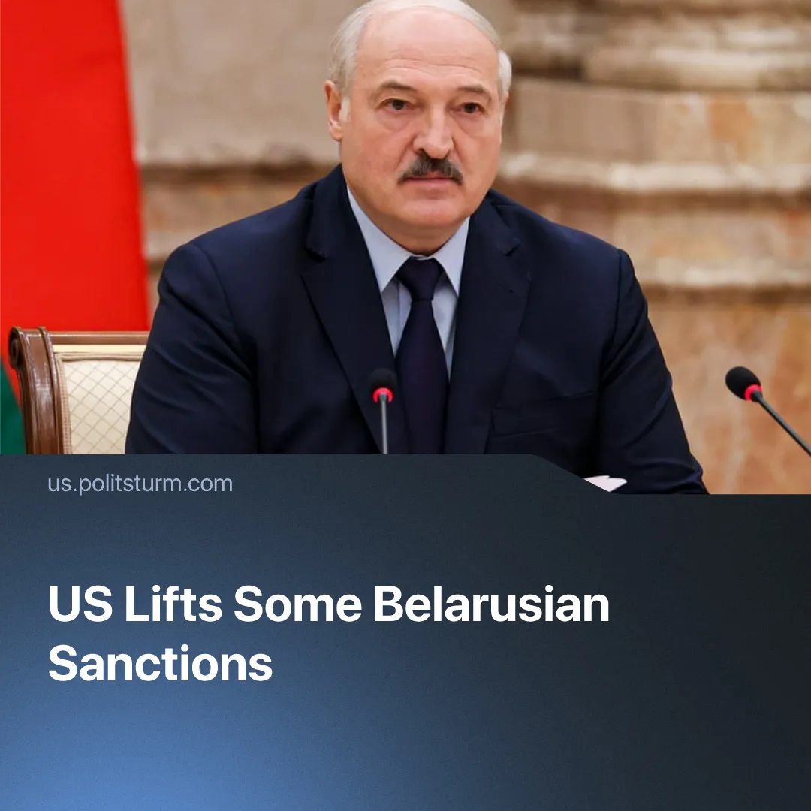

Original article
2026-03-28
1 min read

US sanctions relief for Belarus exposes an attempt by the US to pull Minsk – and indirectly Russia – away from China.
Details. The United States and Belarus reached a deal under which Belarus released 250 political prisoners in exchange for limited sanctions relief. The measures eased restrictions on major state-owned financial institutions, potash exports, and travel permits for selected officials.
► Talks began earlier in 2026. US officials presented the deal as a limited step tied to prisoner releases, while Belarusian President Lukashenko framed the agreement as a victory for his policy, stating, “we have defended our sovereignty and national dignity, forcing the West to recognize our interests without compromising our independence.”
► The European Union disagreed. EU High Representative Kaja Kallas stated that “while the release of 250 individuals is a long-awaited humanitarian relief, it does not signal systemic change,” explaining that their “restrictive measures will remain in place until all political prisoners are freed and democratic rights are restored.”
Context. A smaller release of 123 prisoners in late 2025 had already signaled possible negotiations, but without major changes in sanctions policy.
► After mass protests in 2020 against the government, which were met with violent repression, Belarus was forced to rely on Russia for political and security support, limiting its previous ability to balance between blocs.
► This deal gives Minsk some room to maneuver between blocs again. At the same time, Belarus remains tied to the China–Russia camp, relying on China, Russia, and particularly Iran for trade, energy, and investment.
► This deal reflects the broader US–China inter-imperialist rivalry, serving as a test case for easing sanctions on Russia after Donald Trump’s failed attempts to reset relations with Vladimir Putin. By weakening Russia’s alignment with China, the US aims to reduce the number of fronts it must confront.

Original article

