US Labels China as Currency Manipulator
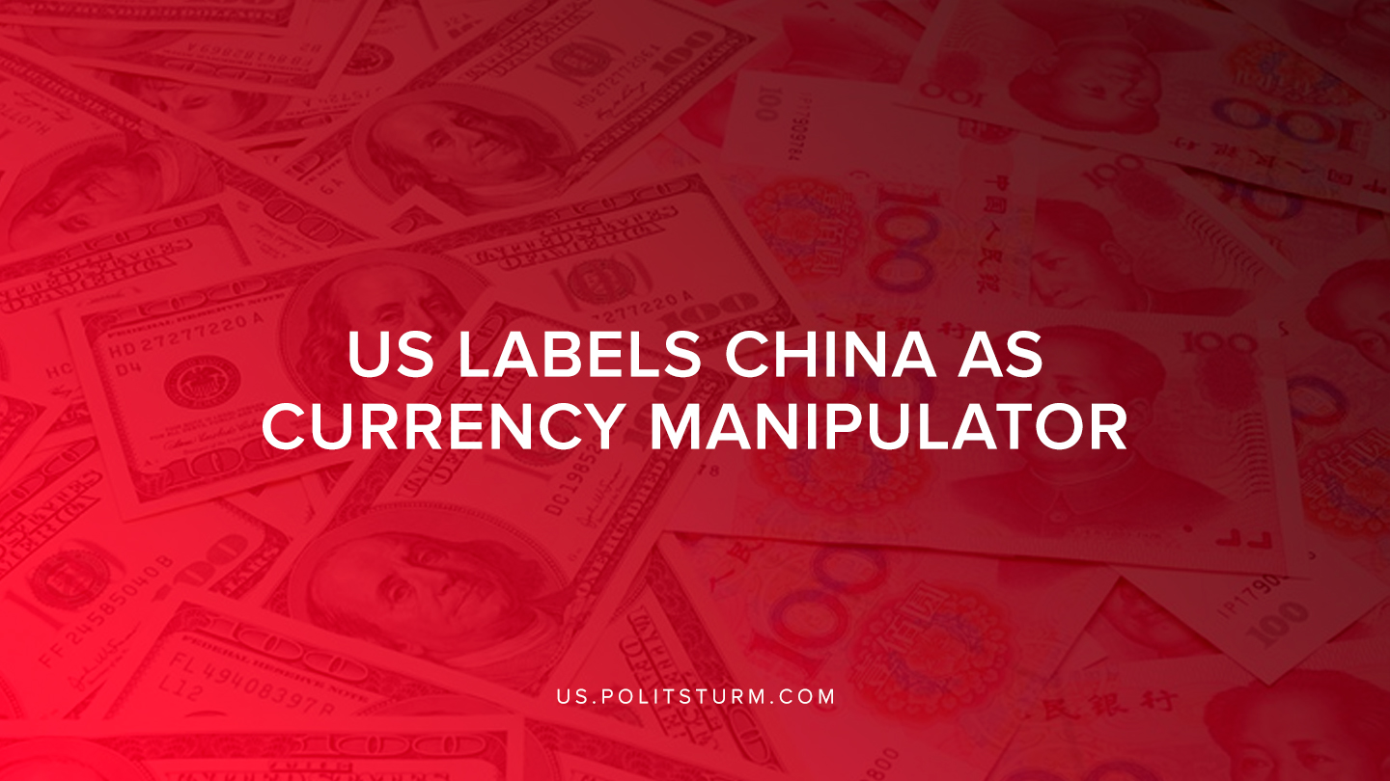

Original article
2019-08-07
1 min read

The U.S Treasury department determined that China is a “currency manipulator” and that the Treasury Department Secretary Mnuchin will work with the International Monetary Fund (IMF) to eliminate its alleged unfair competitive advantage.
The Treasury Department’s press release states that China has a long history of engaging in the foreign exchange markets with the intent of devaluing its currency.
Trump recently announced that the United States will also be imposing a 10% tariff on $300 billion of Chinese goods.
The trade war between the United States and China reflects the long-term trends that were created by uneven capitalist development. The United States has suffered massive deindustrialization as “services” encompass a large portion of the American employment as manufacturing has been on a prolonged decline.
As manufacturing has left the United States in search of greater profits, the Trump administration is utilizing protectionist policies to aid domestic capitalists and at least rhetorically attempt to revive American manufacturing.
The most recent Treasury Department Report to Congress states,
“China should make a concerted effort to enhance transparency of its exchange rate and reserve management operations and goals. It is also critical that China aggressively addresses market-distorting forces and pursues meaningful structural reforms to reduce the role of the state in the economy, permit a greater role for market forces, and rebalance the economy away from investment and exports towards household consumption and services. (p.23)”
The United States, as a chief imperialist state, is attempting to decelerate the economic growth of other capitalist competitors such as China. China is a largest creditor to the United States, and the statement reveals the intent of the U.S to “rebalance the economy away from investment and exports towards household consumption and services”.
However, the contradictions of capitalism including recurring crises of overproduction, are inherent to the capitalist economic system. No policy changes or experimenting with fiscal policies has been able to overcome the instability or crises of the capitalist system. The recent trade war is merely a reflection of the economic and political competition between nations and it reveals the imperialist nature of the U.S.
Sources: 1 ,2, 3

Original article

