US' Iran Rhetoric Mirrors Russia’s “Special Military Operation”
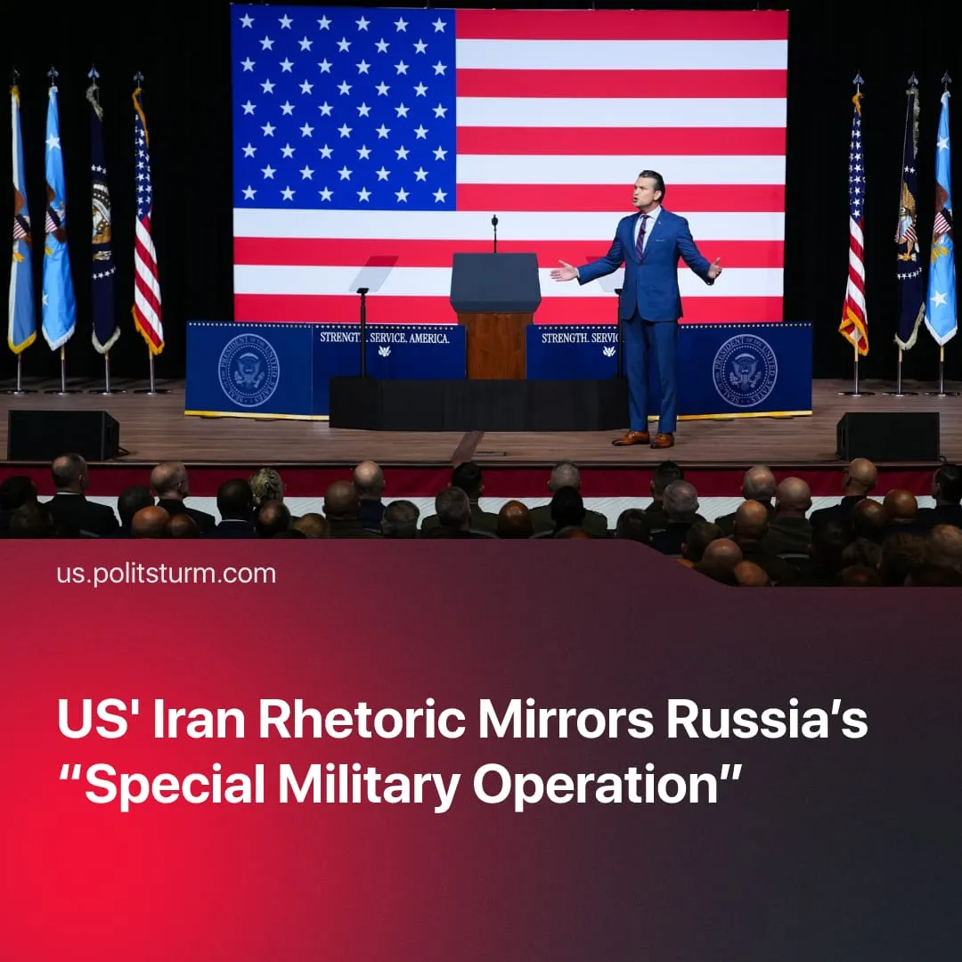

Original article
2026-03-30
2 min read

Strikes on Iran are framed as a short-term, limited military campaign by the US officials. This mirrors the rhetoric of the Russian leadership at the beginning of the “Special Military Operation”.
Details. From the outset of the Iran strikes, the Trump administration has consistently framed the operation as limited, targeted, and with definite “achievable” objectives. Trump initially stated the campaign was expected to last “four to five weeks,” while Secretary of War Pete Hegseth stressed that “This is not Iraq. This is not endless.” The administration has also repeatedly denied any intention to deploy ground troops, with Trump stating, “I’m not putting troops anywhere.”
► This narrative is contradicted by shifting timelines and escalation. Trump later admitted the campaign would continue for “whatever it takes,” while strike targets have expanded to leadership targets, military bases near key oil infrastructure, and threats against civilian energy facilities. Thousands of US troops have also been redeployed to the region, indicating preparation for ground involvement, as Iran denies US claims of ongoing negotiations.
► The framing mirrors rhetoric used by Vladimir Putin during Russia’s so-called “Special Military Operation.” It was described as a focused, time-limited effort designed to achieve specific objectives without full national mobilisation. In practice, the “SMO” has now lasted longer than the Great Patriotic War of the Soviet people (1941–1945), and has become extremely costly for the Russian economy.
► For Donald Trump, this “limited” framing aligns with longstanding rhetoric against “endless wars” and reflects low domestic support for extended overseas military involvement; only 27% of Americans approved of the strikes on Iran. It also allows the administration to act under executive authority without immediately requiring congressional approval, which would likely become necessary in the case of a sustained operation.
Context. In February 2022, Russia launched a large-scale “Special Military Operation” in Ukraine, officially aimed at the “demilitarisation and denazification” of the country and the “protection of populations in Donbas”.
► On 28 February 2026, the United States and Israel began “major combat operations” against Iran. Trump outlined the objectives: to destroy Iran’s missile and naval capabilities, disrupt proxy networks, and prevent a nuclear-armed Iran, framing the operation as pre‑emptive defence of the US and its allies. He also urged Iranians to “take over” their government following the operation.
For a deeper analysis of the US-Iran conflict, see the Marxist position on this subject: The Middle East: Architecture of War

Original article

