US Increasingly Drops “Democratic” Rhetoric Internationally
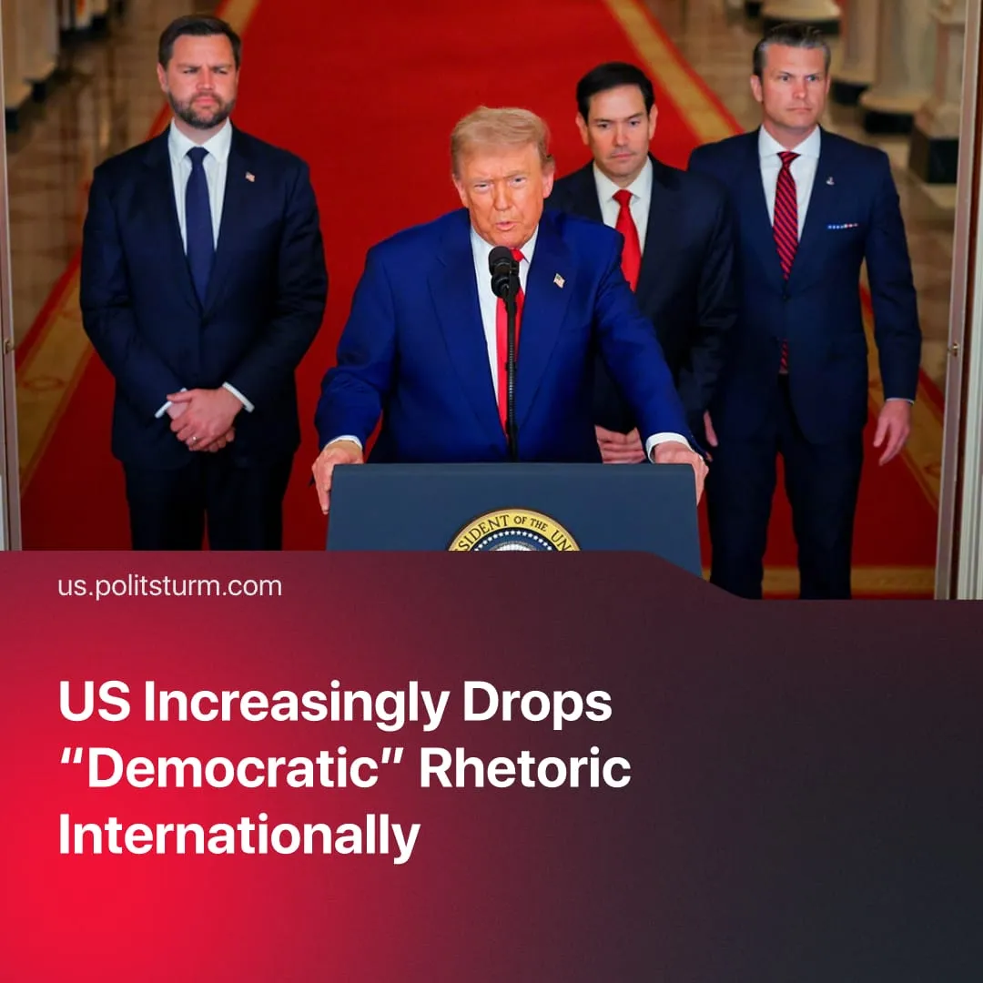

Original article
2026-06-20
2 min read

Has Trump abandoned the liberal “democratic values” that the US once stood for?
Details. Dating back to the Cold War against the Soviet Union, American leaders actively claimed to fight for “freedom” and liberal “democratic values”. The United States continued justifying its heavy global involvement in the 2000s and 2010s by preaching international cooperation, framing its local military interventions as humanitarian peacekeeping operations – during a period where no wars broke out amongst the “great powers”.
► Today, the US administration has almost entirely abandoned this diplomatic facade for open imperialism. In May 2026 the newly renamed Department of War explicitly announced a strategic doctrine to aggressively project military power across the Pacific. Additionally, the administration openly frames its goals around resource extraction, with President Trump declaring his desire to take the oil from foreign nations by force.
► Washington is abandoning its old multilateral commitments. In 2026, the USA withdrew from 66 international organizations simultaneously, and launched aggressive economic attacks against its closest allies. This year, the administration threatened to annex Greenland while successfully forcing European nations to accept extortionate fifty percent tariffs and purchase $100s of billions in American fossil fuels.
► Domestically, the state is accelerating its internal fascisation. The administration now officially labels left wing activists as domestic terrorists, weaponizing the justice system against dissent, while simultaneously securing a massive $70 billion budget increase to transform ICE into a highly militarized domestic enforcement arm with “federal immunity”.
Context. During the Cold War, capitalist countries positioned themselves as champions of freedom and liberal democracy, with propaganda contrasting their systems against the socialist bloc, which they universally framed as authoritarian dictatorships – often equalised with fascism.
► Despite American “democracy” achieving ideological “victory,” the collapse of the Soviet Union in 1991 only accelerated US imperialism. Emerging as the sole unipolar hegemon, the United States allowed American finance capital to expand globally into newly opened markets almost completely unopposed, prioritizing the unrestricted extraction of massive super profits.
► The rhetoric of freedom and liberal democracy simply served as an ideological weapon to justify invading or overthrowing any nation that didn't align with American capital. The international institutions established during the 20th century – World Bank, IMF, WTO – were deliberately designed to serve and maintain this global American rule.
Important to Know. Nowadays in the 2020s, the objective global situation has completely changed as rival capitalist powers have grown stronger, leading to the highest number of armed conflicts since WWII, and effectively ending American hegemony.
► All competing imperialist powers are constantly intensifying their military activity and spending. The United States must similarly keep escalating not only to defend its increasingly shaky sphere of influence, but also to reinforce profit extraction from foreign markets.
► The international institutions the US once helped create, now simply get in the way. Once used to maintain American control, they are now unilaterally dismantled because they restrict corporate interests.
► This US imperialist aggression is a bipartisan necessity dictated by the American ruling class. Building on established policies, the previous Biden administration continued this shift, aggressively framing China as the primary economic enemy and heavily expanding military infrastructure in the Pacific to manage this new competition.

Original article

