US Income Inequality Worsens
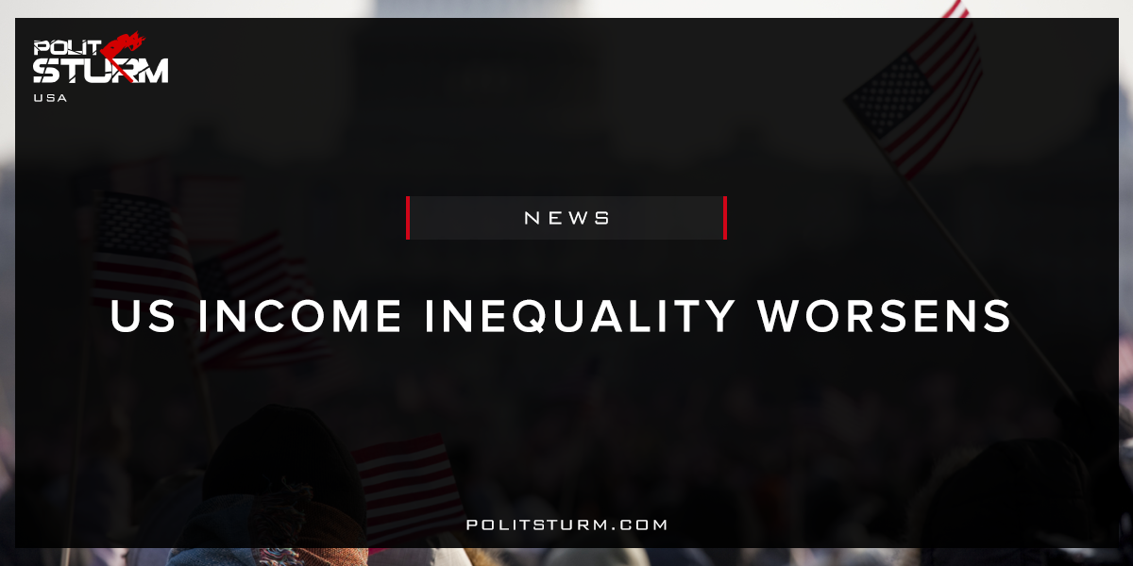

Original article
2017-12-21
2 min read

15 December 2017 – The number of Americans living in poverty and the already high income inequality could worsen further in the days to come, making the United States the most unequal society in the world, the United Nations expert on extreme poverty and human rights warned Friday.
“The American Dream is rapidly becoming the American Illusion, as the US now has the lowest rate of social mobility of any of the rich countries,” said the UN Special Rapporteur on extreme poverty and human rights, Philip Alston, Friday, at the end of a fact finding mission to the country.
“Instead of realizing its founders’ admirable commitments, today’s United States has proved itself to be exceptional in far more problematic ways that are shockingly at odds with its immense wealth and its founding commitment to human rights,” he added.
In his statement, the Mr. Alston also stated that the assumption that poor came from ethnic minority groups is not correct and in fact there are eight million more white people than African-Americans living in poverty.
“The face of poverty in America is not only black or Hispanic, but also white, Asian and many other colours,” he said.
Politsturm: The recent report by the United Nations detailing the growth of income inequality in the country should come as no surprise to those paying attention. The capitalist class is becoming wealthier because they take advantage of the appreciation of their stocks, bonds, properties, etc. The working class has not recovered from the most recent crisis because they are continually exploited by the capitalists. Workers only have their own labor power to sell, while the capitalists are able to enrich themselves at the expense of the working class.
If you think about it, there are two types of income a person can get. There is earned income from labor and unearned income from not working. Earned income is obtained through working and selling your labor power. Unearned income is obtained through owning property. If you own stocks you can get dividends and capital gains but you do not do any work to get them. If you own “fixed income” products or have a large bank deposit you get interest payments on a regular basis for doing no work. If you have substantial land ownership that you can commercially or residentially rent you collect ground rent. If you own a private company you get the profits that are produced by the workers. What all of these scenarios have in common is that there is a form of private legal ownership of the means of production by the capitalist class.
The wealthiest Americans represent the capitalist class who exploit workers and control the political current. That inequality and capitalism are related is an inexorable truth. Capitalists use their money to get a share in the socially produced surplus. Dividends, interest, and ground rent are all a part of the profit over and above the costs of production. They can re-invest their profits into the stock market, money market, and real estate markets to expropriate even larger sums of unpaid labor. Over time this leads to inequality as wealth consolidates into the hands of a small group of individuals. As long as you have capitalist production, you will have an unequal, crisis ridden society in which the parasitic elites suck the blood of the working class. The riches of the bourgeoisie are merely the spoils of the world’s largest social theft. Inequality reflects the fact that the American working class has allowed this theft, among others, for far too long.
Sources: 1, 2

Original article

