US Government Intelligence Officially Targets Russia
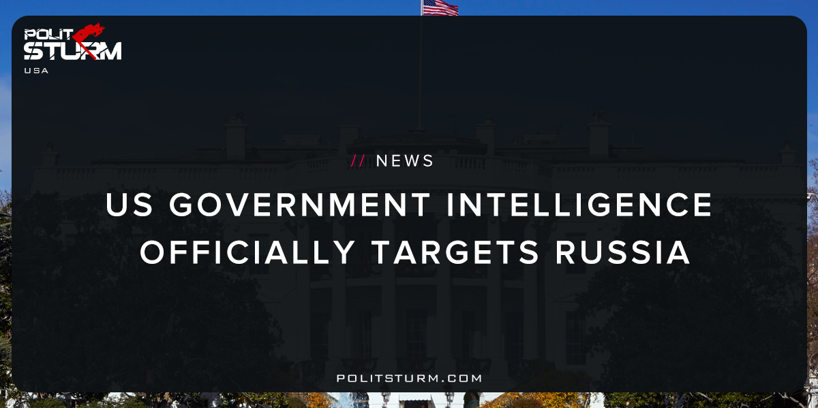

Original article
2017-11-01
1 min read

Russian efforts to influence the 2016 US presidential election represent the most recent expression of Moscow’s longstanding desire to undermine the US-led liberal democratic order, but these activities demonstrated a significant escalation in directness, level of activity, and scope of effort compared to previous operations. We assess Russian President Vladimir Putin ordered an influence campaign in 2016 aimed at the US presidential election. Russia’s goals were to undermine public faith in the US democratic process, denigrate Secretary Clinton, and harm her electability and potential presidency. We further assess Putin and the Russian Government developed a clear preference for President-elect Trump. We have high confidence in these judgments.
Polistrurm: This recent report issued by the Office of The Director of National Intelligence clearly demonstrates the re-emergence of McCarthyism in America. The recently declassified document is claiming that the Russian government used state propaganda to shift the election in favor of Donald Trump. Russia allegedly undermined US “liberal democratic order” by “denigrating” the character of Secretary of State Hillary Clinton. The release even states that “Russia, like its Soviet predecessor, has a history of conducting covert influence campaigns focused on US presidential elections that have used intelligence officers and agents and press placements to disparage candidates perceived as hostile to the Kremlin”.
This is clearly just an attempt by US National Intelligence to manufacture an explanation for the political instability within the US. The actual evidence to support the claims of direct Russian involvement in the previous election is speculative and unsubstantiated. The US elites are actually just trying to deflect the growing dissatisfaction with internal political affairs in a xenophobic and nationalistic way. US political instability is the direct result of the internal contradictions of capitalism. As these contradictions intensify and the political situation becomes more unstable the US needs to search for an external cause of the crisis. US “liberal democracy” is not failing because of an external power, but rather because the economic system fails to provide jobs, opportunities, and stability. The enemy of the US working class is not the Russian government, but the capitalist economic system and those who try and defend it.
Source

Original article

