US Government Enters Shutdown
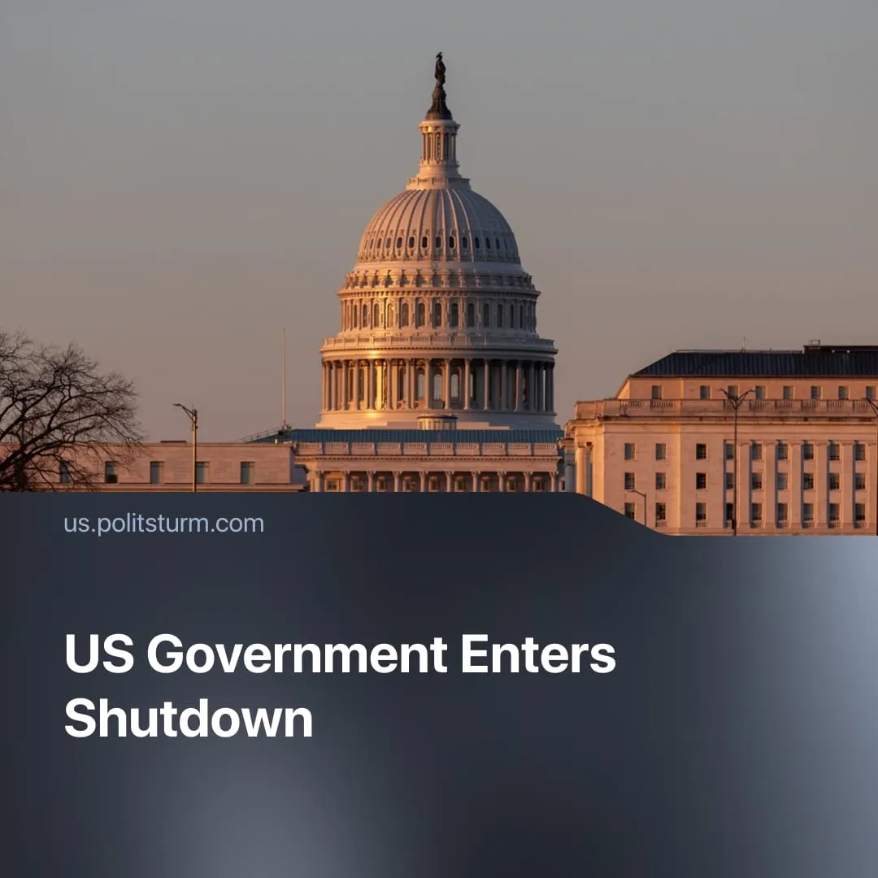

Original article
2025-10-09
2 min read

The US has entered a federal shutdown, costing $7 billion per week. Trump threatens mass layoffs and has frozen funds to Democratic states.
Details. The US government shut down on October 1 after Congress failed to pass a funding bill. Agencies were ordered to suspend non-essential operations, with up to 750,000 federal employees furloughed daily. Essential government functions, including those relating to national security, defence, border control, and transport, are continuing.
► The funding lapse is projected to cost the US economy around $7 billion per week, potentially reducing GDP growth by 0.1 percentage points weekly, though some effects may rebound once funding resumes. The travel sector alone is reporting a loss of $1 billion weekly due to delays and airport disruptions.
► The shutdown occurred due to a failure to reach an agreement on the budget or a “continuing resolution,” which extends temporary funding. Democrats demand continued subsidies and protection for Medicaid and other social programs. In contrast, Republicans and the Trump administration favour a "tough" budget, spending cuts, and no new commitments.
► Trump’s administration has responded by blaming Democrats and freezing $26 billion in federal funds to Democratic-leaning states. It is also preparing broad workforce reductions for non-priority programs, and Trump has threatened that furloughed employees will not be paid.
► Democrats, in turn, have refused to approve a funding bill that simply extends the budget without policy conditions, warning that proposed healthcare and Medicaid cuts would affect millions.
Context. Trump’s first term was marked by the longest government shutdown in US history, lasting 35 days between December 2018 and January 2019. During that period, he refused to sign a budget without funding for the border wall, leading to a prolonged standoff with Congress.
► At that time, presidential tools were more limited. Trump could delay or block funding, but lacked both the mechanisms and the necessary support in the House, the Senate, or the Supreme Court to restructure agencies, reduce the workforce, or freeze state funds during the shutdown.
► In his current term, Trump has pushed for broad workforce reductions and agency reorganisations. While lower courts have issued injunctions, the Republican-dominated Supreme Court has repeatedly ruled in favour of executive authority, giving the administration greater leverage during the current shutdown.
► The Democratic Party’s defence of healthcare funding is opportunistic. Having itself revoked pandemic-era insurance expansions and allowed millions to lose coverage, it now uses the shutdown to posture as a defender of public welfare.

Original article

