US Fascisation Advances With Supreme Court Opening Door to Birthright Citizenship Ban
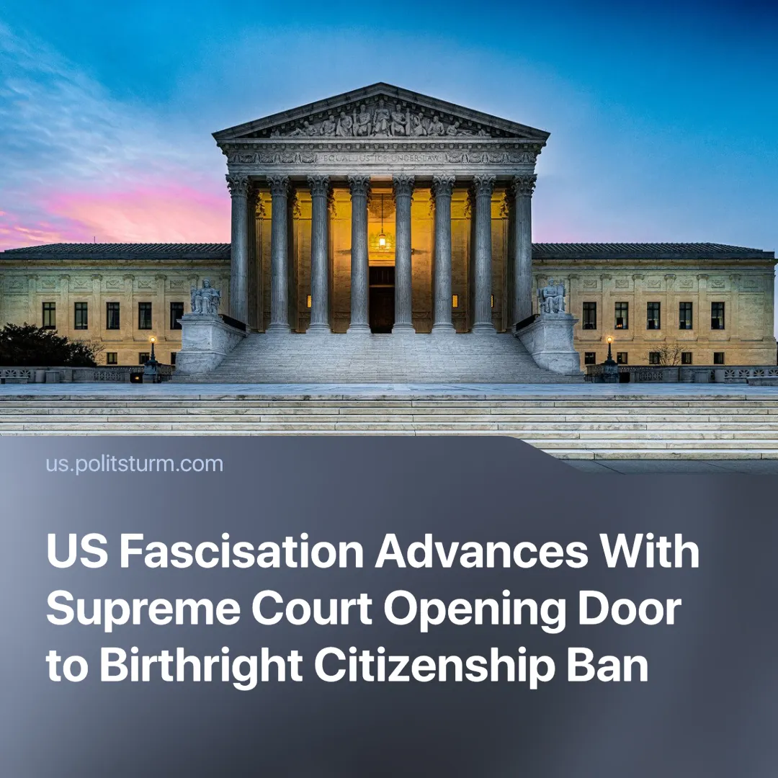

Original article
2025-07-03
1 min read

US fascisation has overcome a major hurdle. The Supreme Court ruled that lower courts cannot use injunctions to block presidential orders.
Details. Trump claimed a “big win” after the Supreme Court, in a 6-3 decision, lifted an injunction blocking his order to end birthright citizenship.
► The ruling prevents lower courts from issuing nationwide injunctions against presidential orders. It did not directly address the constitutionality of Trump’s birthright citizenship order.
► The Supreme Court claimed the ruling restored judicial remedies to those “traditionally accorded by courts of equity at our country’s inception.”
► Trump hailed this as a victory against “radical left” judges.
► Instead of injunctions, federal courts must now rely on alternatives such as class action lawsuits to stop or slow executive orders from affecting individuals.
Context. Since the start of his term, Trump has sought to centralise power around the presidency and executive powers to crack down on migration, bypassing other government powers.
► We have previously covered how Trump’s actions are shattering the myth that democracy is inherent to the US, and the difficulties US fascisation has encountered.
Important to Know. The Supreme Court’s ruling marks another step along the path of fascisation. The further concentration of power around the executive body, increased militarisation, the expansion of the police force, etc, lay the groundwork for the eventual open terroristic dictatorship of capital, where capitalists discard liberal democracy to protect profits and their class rule.

Original article

