USA Exploits “Solidarity” Rhetoric By Sending Aid To Cuba
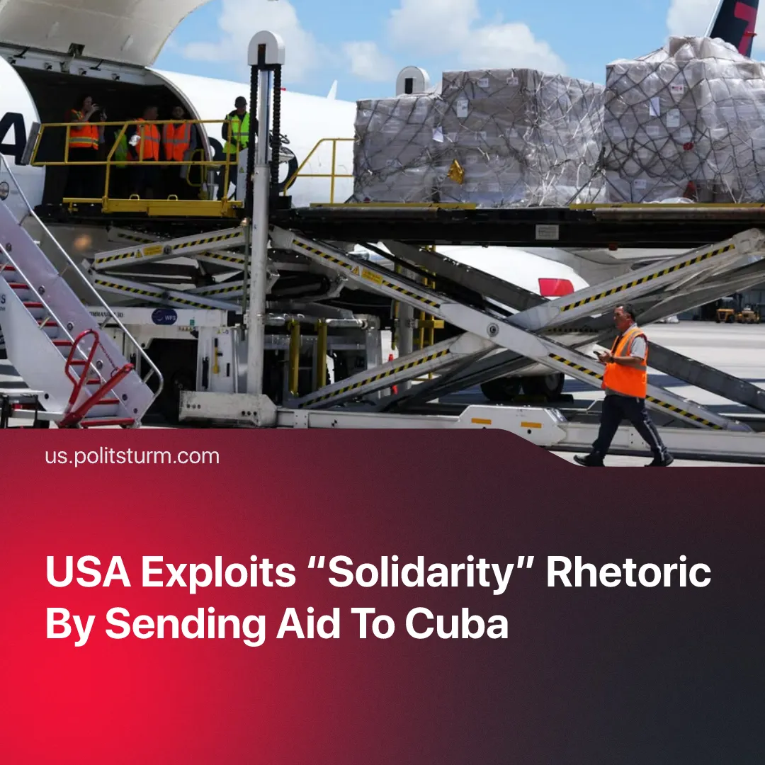

Original article
2026-08-03
1 min read

The US sends humanitarian aid to Cuba to exploit the “solidarity with the Cuban people” narrative. Meanwhile, Solidnet is unable to express solidarity without defending the capitalist Cuban government.
Details. On July 21, the US State Department announced a humanitarian flight to Cuba. The aid, worth about $100 million, includes food and hygiene kits for up to 700 families.
► The department specified that the aid should “help the people, not the Cuban government”, arriving directly through local Catholic groups. However, Cuban residents note that the ongoing fuel blockade causes a gasoline shortage, complicating delivery. Moreover, the State Department itself admits that accepting the aid depends on the government.
► The Communist Party of Greece (KKE) – the leading party in Solidnet – was quick to declare solidarity with the Cuban people following the formal completion of capitalist restoration. However, its solidarity is contradictory: it extends to the Cuban state while failing to address the government as a capitalist dictatorship and avoiding any mention of the state capitalist corporation GAESA.
► One of the latest examples of this contradictory solidarity with the Cuban Revolution and the people is a statement by the Communist Party of the USA calling for the US working class to defend “Cuba”. Meanwhile, Solidnet still plans to hold the 24th International Meeting of Communist and Workers' Parties (IMCWP) in Havana.
Context. In January, Trump escalated sanctions against Cuba by blocking Venezuelan oil shipments and issuing an executive order authorizing tariffs on any country supplying oil to the island. By June, the Cuban parliament passed a reform package opening the market to foreign capital, formalizing a decades-long process of capitalist restoration on the island.
► The State Department recently released a major report that framed communists and the left-wing as “spies of the Cuban government". The report accuses new communists of prioritizing “anti-imperialism” and “national liberation” over classic class struggle. Washington conveniently exploits the stance of organisations like Solidnet as a pretext to justify state repression.

Original article

