US Elites Exploit Iran Conflict for Insider Trading
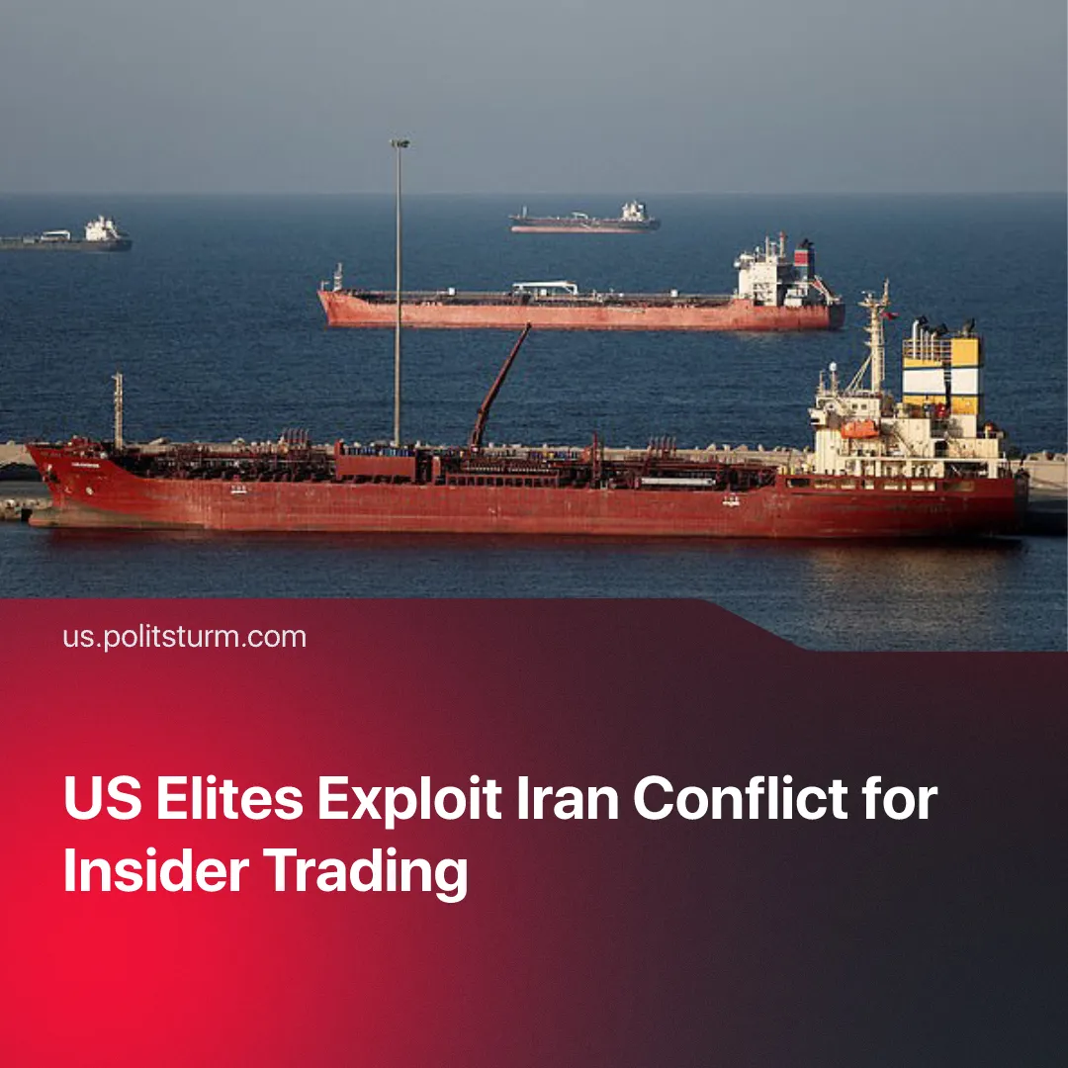

Original article
2026-04-13
1 min read

A $950 Million Oil Bet Placed Hours Before Trump Ceasefire Announcement, Triggering 15% Price Drop and Major Profits.
Details. In several cases, US President Trump’s statements have directly moved oil markets, with prices surging above $110 per barrel following escalation threats, and dropping sharply when he signals peace talks or US withdrawal.
► Large insider trades have been placed immediately before such announcements, including a $500 million oil bet ordered just minutes before Trump signalled a delay in US attacks on Iran, triggering a price drop and generating multi-million-dollar profits for traders.
► A similar pattern occurred around the ceasefire, where a $950 million bet on falling oil prices was placed hours before Trump’s announcement, after which crude dropped by around 15% to below $100 per barrel.
► Secretary of War Hegseth was reported to have invested multiple millions into arms firms’ stocks through a broker shortly before the US launched the war on Iran. The defence monopolies he invested in receive most of their business from the Department of War.
Context. The conflict has generated broad profiteering across capitalist blocs, with European oil monopolies recording $80 million in excess daily profits, US defence firms securing major new military contracts, and Chinese capital benefiting from its special rights to continue crossing the Strait of Hormuz, alongside the rise in yuan-based energy trade.
► American state officials already regularly engage in insider trading, with US Congress representatives making over 13,000 trades worth more than $600 million in 2025.
► These forms of insider trading have also been evident under the Trump administration, including a Kalshi bet on the exact timing of a press event that ended precisely as predicted, suggesting access to non-public information. An Israeli army officer was also arrested for using classified information to profit on Polymarket, likely one of many such cases.

Original article

