US Coronavirus Death Toll Surpasses 100,000
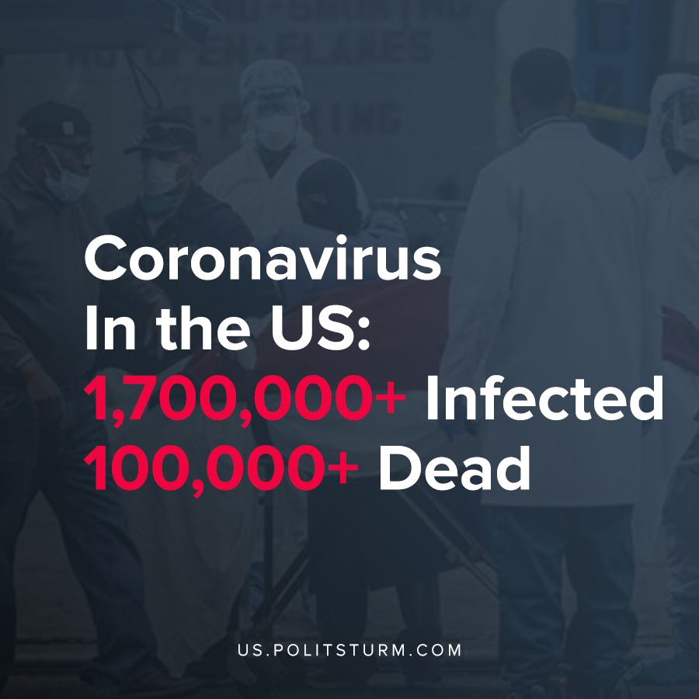

Original article
2020-05-29
1 min read

The official number of deaths related to the coronavirus now exceeds 100,000 in the United States. The number of Americans infected with the coronavirus now stands over 1.7 million confirmed cases.
The state of New York has the highest number of coronavirus deaths with 29,653. New Jersey and Massachusetts follow with 11,412 deaths and 6,640 deaths, respectively.
In a discussion about healthcare for seniors, President Trump tried to downplay the severity of the coronavirus pandemic by comparing it to hypothetical scenarios.
“If we didn’t act quickly and smartly, we would have had, in my opinion and in the opinion of others, anywhere from 10 to 20 and maybe even 25 times the number of deaths”, said Trump.
While Trump can shirk personal responsibility for the catastrophic death toll, the fact remains that over 100,000 people have died and the figure continues to grow. While the most vulnerable in American society are perishing in droves, the sycophants of capital push for the resumption of capitalist production at all costs. If production is deterred, the production and extraction of surplus value is also curtailed. Thus, the capitalist economic system which prioritizes profit over all else has failed the American people miserably.
Sources: 1 , 2

Original article

