US Congress Passes Denunciation of the Horrors of Socialism
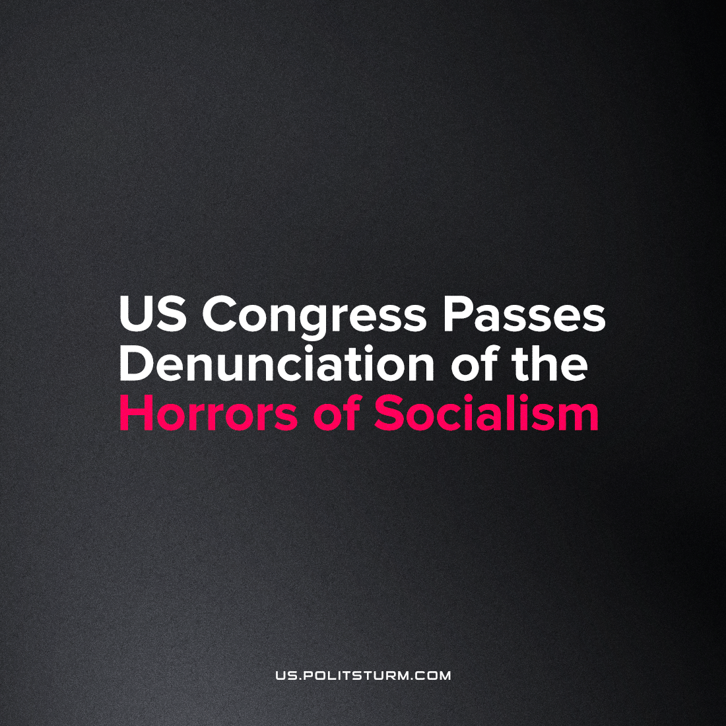

Original article
2023-02-06
3 min read

The February 2nd resolution Denouncing the horrors of socialism was passed in Congress this year. The text of the resolution clearly demonstrates how the imperialistic class openly lies in crafting modern-day fables for the purpose of protecting the position of the ruling class. The passing of this vote merely serves to signal loyalty to a certain ideal and a certain basis for bipartisanship, and is overall entirely meaningless except as the establishment of a formal reponse to growing pro-communist sentiment among the youth, which they often cite, and which this may support the legal program for future repression and banning of Communist symbols and demonstrations. One must wonder why this isn't redundant with the past 70 years of anti-communist laws in this country.
Opportunist social democrats, leading the right wing of the Democratic Socialists of America, have praised the outcome of this resolution vote! They point to the fact that some 100 ruling class representatives refused to sign on, which supposedly shows something positive in America's political growth in the decade after Bernie Sanders' 2016 presidential campaign.
We cannot read too much into this, since it is simply reflective of a political battle waged by Republicans against Democrats, where one side merely uses this question as a cudgel, and the other chiefly rejects it to deny power and the passage of their bill- certainly not because they fear a pro-socialist outcry from their constituency, or support any of the figures mentioned in the bill.
The social democrats are desperate to show their followers some positive development, and so intentionally mislead them here, in the context of the consistent failure of their advance of 'socialism' through this legislative body.
Using simple tricks imperialistic government of USA combine communists and representatives of the pro-bourgeois political left movements. Much like the age-old equation of fascism and socialism, the various enemies of the American state, namely, Daniel Ortega and Nicolas Maduro) are all treated alike with figures like Pol Pot, whom the US supported, and others who actively used socialistic rhetoric but had nothing similar with communism ideas and policy. To speak of the Left's reaction in the US, they have entirely taken the bait, and a large section will support any leader or trend which the Republicans choose to list as their boogeyman.
The imperialist class lies about Great October Revolution which is without a doubt freed Russian people and was reason why greatest economy boom of USSR and of history of humanity became possible. Congress is not interested in the reasons behind hunger and terror in USSR in the first moments of that new state. Greater explanation for the hardships in the early USSR are found not in a revolution but in the First World War, which was started by capitalistic empires, like that of the Americans, with the purpose of plundering of weak and dependent countries, and in the aftermath of which tried to subject the same to Russia, Ukraine and the other nations of the union through an imperialist invasion.
After applying the policy of collective farms people of USSR have never experienced hunger. Revolution in Russia stopped the crises and hunger which plagued the Tsarist era endlessly – it was the resurrection of capitalism in 1991 which brought back the regime of hunger.
Error loading image
Error loading image
This is exactly the reason the Congressional resolution claims the opposite.
Deception with the legitimacy of the state is a powerful weapon of the imperialist class. Socialism and communism are true horrors for the capitalists. Socialism can stop wars and hunger, from which the class of capitalist will no more be able to enrich themselves. They must lie constantly because it is capitalism which today leads to famine and mass murder all around the world.
Source: 1, 2

Original article

