U.S.-China Trade War Temporarily Cools Down As Deal Is Reached
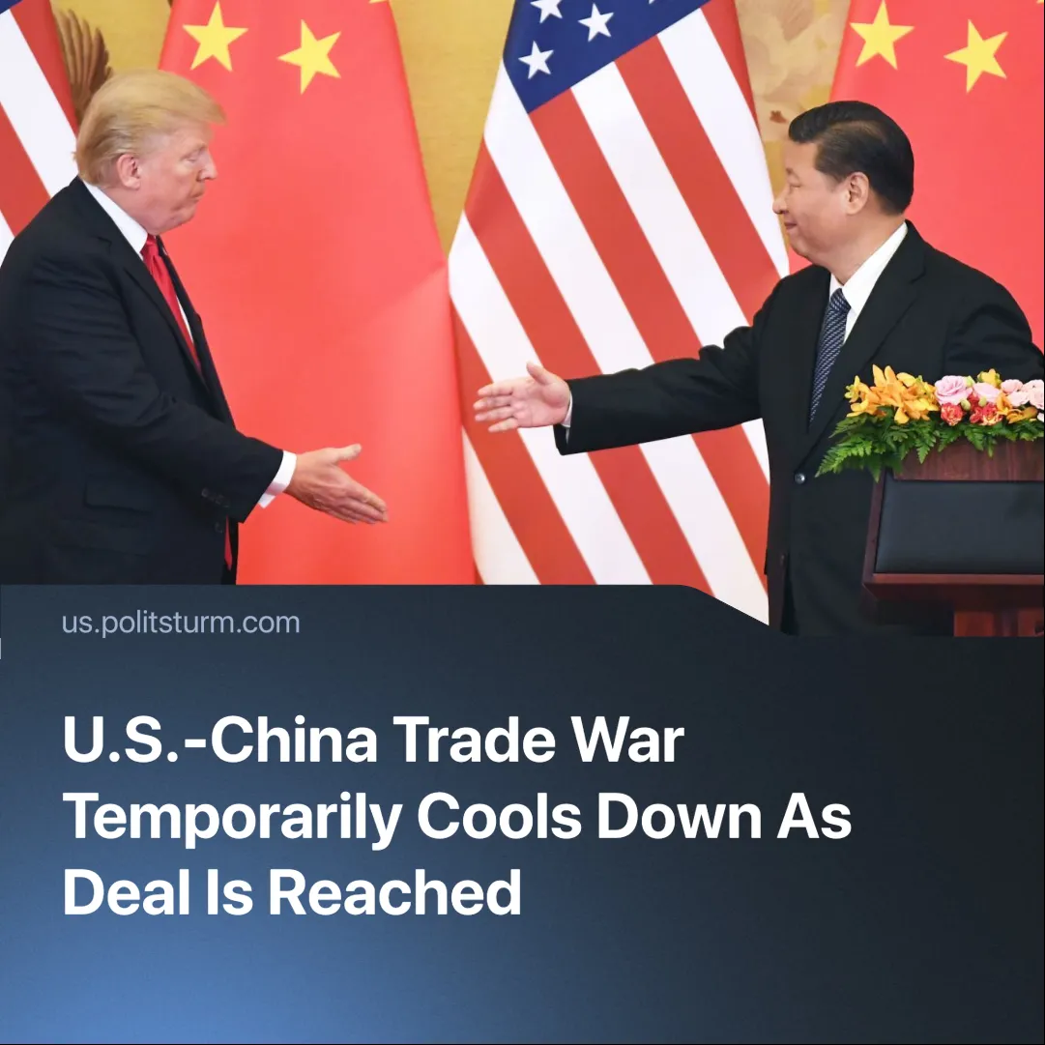

Original article
2025-05-23
2 min read

Neither the US nor China were able to immediately sever economic ties and were forced to cancel a number of "tariff war" measures.
Details. Officials from both the United States and China concluded trade talks in Geneva, leading to a pause in the ongoing trade war between the two. The U.S. officials have claimed to have reached a “deal” that would reduce America’s trade deficit, and Chinese officials have said that an “important consensus” has been reached. Both countries have agreed to set up a new consultation platform for trade and economic issues.
►To allow for further negotiation, both countries are reducing their tariffs by 115% for 90 days. This means the US’s 145% tariffs are reduced to 30% and China’s 125% tariffs are reduced to 10%. China also agreed to suspend its non-tariff retaliatory measures, such as restrictions on rare-earth mineral exports.
Context. Despite strong rhetoric during the period of escalating tariffs, with Beijing saying it would “fight till the end”, both countries are deeply enmeshed in the global market and incapable of full self-sufficiency without major sacrifices.
► Even during the height of the reciprocal tariffs, the U.S. rolled back some tariffs on goods such as phones and computers, and didn’t apply them to semiconductors. Similarly, China discreetly created a list of products that would be exempt from its 125% tariff, such as pharmaceuticals and aircraft parts. All of these are essential goods which neither economy can do without.
► We have previously covered the rapidly escalating trade war between China and the United States following Trump’s “Liberation Day” tariffs, as well as the ongoing negotiations between the U.S. and Iran.
►The temporary cooling down of the trade war does not mean imperialist contradictions have disappeared. Maintaining the high tariffs would’ve been too costly for both economies and would’ve led to a risky, faster escalation. The deal serves as a pause that allows them to regroup and prepare for the inevitable re-escalation.
► Both countries used the trade war as an opportunity to expand their spheres of influence and isolate their rival. The U.S. gained access to 50% of Ukraine’s rare-earth minerals — reducing its dependence on Chinese exports — and is now seeking to improve relations with Russia. It has also begun negotiations with Iran, focusing on enriched uranium stockpiles and the lifting of sanctions. Meanwhile, China has been deepening economic ties with its partners and leveraging Trump’s tariffs to expand its influence over traditional U.S. allies such as Japan, Korea, and the EU.

Original article

