US Buys Brazilian Rare Earth Mine
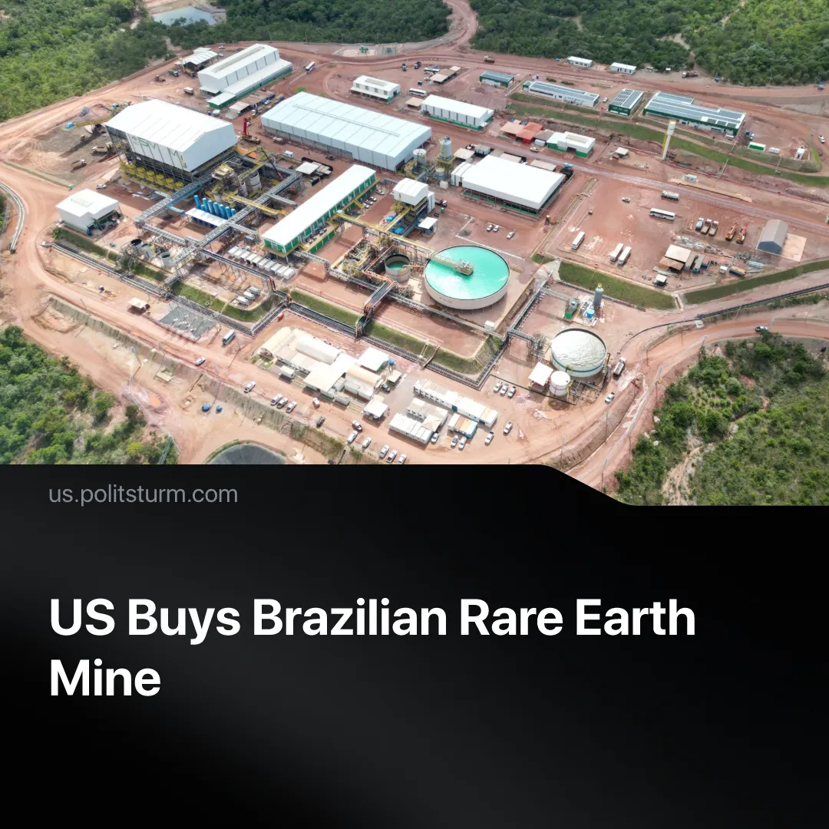

Original article
2026-05-10
2 min read

The only large rare earth mining and processing plant outside Asia is acquired by Washington as it continues its hunt for rare earth minerals.
Details. USA Rare Earth has announced a $2.8bn acquisition of the Brazilian rare earth mining company Serra Verde, continuing a series of purchases. The deal gives it access to a site producing heavy rare earth elements, used mainly for permanent magnets with significant military applications.
► USA Rare Earth CEO Barbara Humpton explained that "Serra Verde's Pela Ema mine is a one-of-a-kind asset and the only producer outside Asia capable of supplying all four magnetic rare earths at scale.”
► For the next 15 years, Serra Verde will send 100% of its production to a separate company set up for this purpose. This company is funded by a mix of US government bodies and private investors. In January, USA Rare Earth agreed to a $1.6 billion debt-and-equity funding package with the US government, while privately held Serra Verde agreed to a loan worth $565 million from Washington in February.
► Some reformist members of parliament have submitted a formal complaint to the Attorney General’s Office to annul the sale, appealing to legality and pointing to a “possible extrapolation of constitutional competences.” Current President Luiz Inácio Lula da Silva gave his usual populist verbal opposition, saying "[...] we will not allow them to take the critical minerals”, but not offering anything material to impede the deal.
Context. The US is heavily interested in securing access to these crucial minerals to minimise its dependence on China – which controls 60–70% of mining and more than 80% of global refining capacity – and to prepare for a possible confrontation by securing influence over nations and their resources.
► China’s monopoly creates a stranglehold over the US, which had to halt its trade war with Beijing last year after China imposed restrictions on the export of rare earth minerals.
► Pro-US figures are attempting to gain Trump’s favour in this context. Flavio Bolsonaro, the son of former Brazilian President Jair Bolsonaro and a presidential candidate himself, stated at a Conservative Conference that Brazil is “the solution for the United States to break its dependence on China for critical minerals, especially rare earths.”
► Lula’s government, specifically through Industry Minister Marcio Elias Rosa, recently rejected the creation of the national mining company "TerraBras", stating "there is no need whatsoever to create a state-owned company to carry out the exploration or processing of critical minerals."

Original article

