US Billionaire Forges New Media Empire
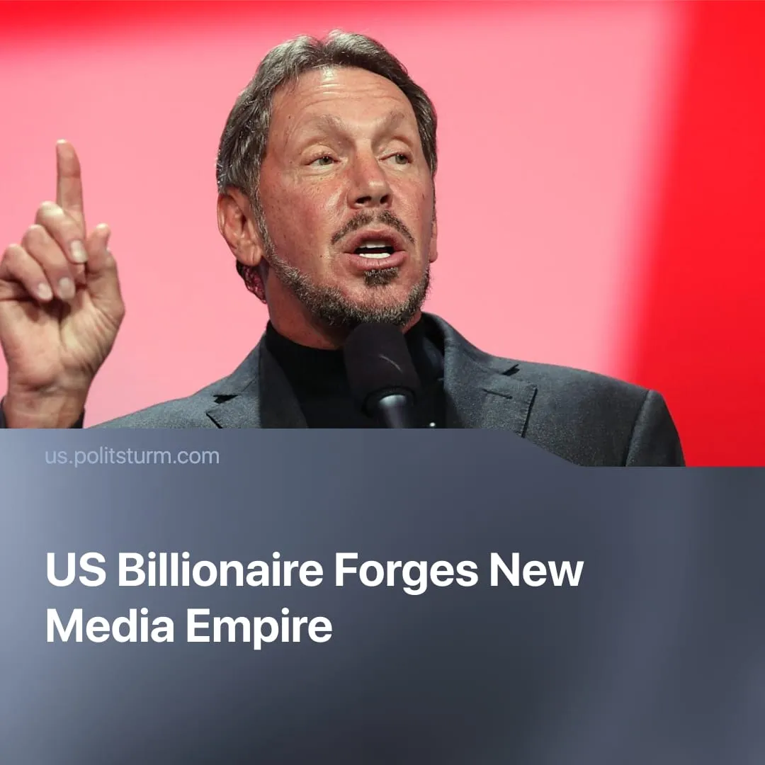

Original article
2025-10-02
1 min read

The largest US media empire is about to be formed, with immense power to influence national and international politics.
Details. Ellison, co-founder of Oracle, is one of the richest individuals in the US and a major donor to the Republican Party.
► Reports indicate Ellison is preparing to take full control of Paramount Global, which owns CBS, MTV, Comedy Central, Showtime, Nickelodeon, and streaming service Paramount+ (which now has about 79 million global subscribers).
► At the same time, he has expressed interest in merging Paramount with Warner Bros. Discovery (WBD), the media giant that owns CNN, HBO, and DC Studios. This would consolidate two of the largest US entertainment and news conglomerates.
► Ellison has also been linked to efforts to buy TikTok’s US operations, after Trump signed legislation forcing its Chinese parent company, ByteDance, to divest. TikTok has over 170 million US users.
Context. Under capitalism, control of the press has long been concentrated in the hands of large capitalists, who use it to shape politics and ideology according to their interests.
► Rupert Murdoch’s News Corp has long been the dominant right-wing media empire, shaping US and global politics through outlets like Fox News, the Wall Street Journal, and the New York Post. Murdoch has repeatedly intervened directly in coverage, from instructing Fox to support Trump’s campaign in 2016 to steering editorial lines across his outlets.
► Jeff Bezos, founder of Amazon, owns the Washington Post, a key outlet of the liberal establishment. Since his acquisition, it has become more docile toward Amazon and shifted its editorial line to defend “almost exclusively personal liberties and free markets.”
► Elon Musk, owner of Tesla and SpaceX, purchased Twitter in 2022, presenting the move as a push for “free speech.” In practice, he has boosted far-right accounts, had his own posts artificially amplified, and used the platform’s GrokAI to push far-right propaganda.
► As Lenin correctly observed, “All over the world, wherever there are capitalists, freedom of the press means freedom to buy up newspapers, to buy writers, to bribe, buy and fake ‘public opinion’ for the benefit of the bourgeoisie.”

Original article

