US Passes $3.4 Trillion Bill Slashing Social Spending and Expanding Militarism
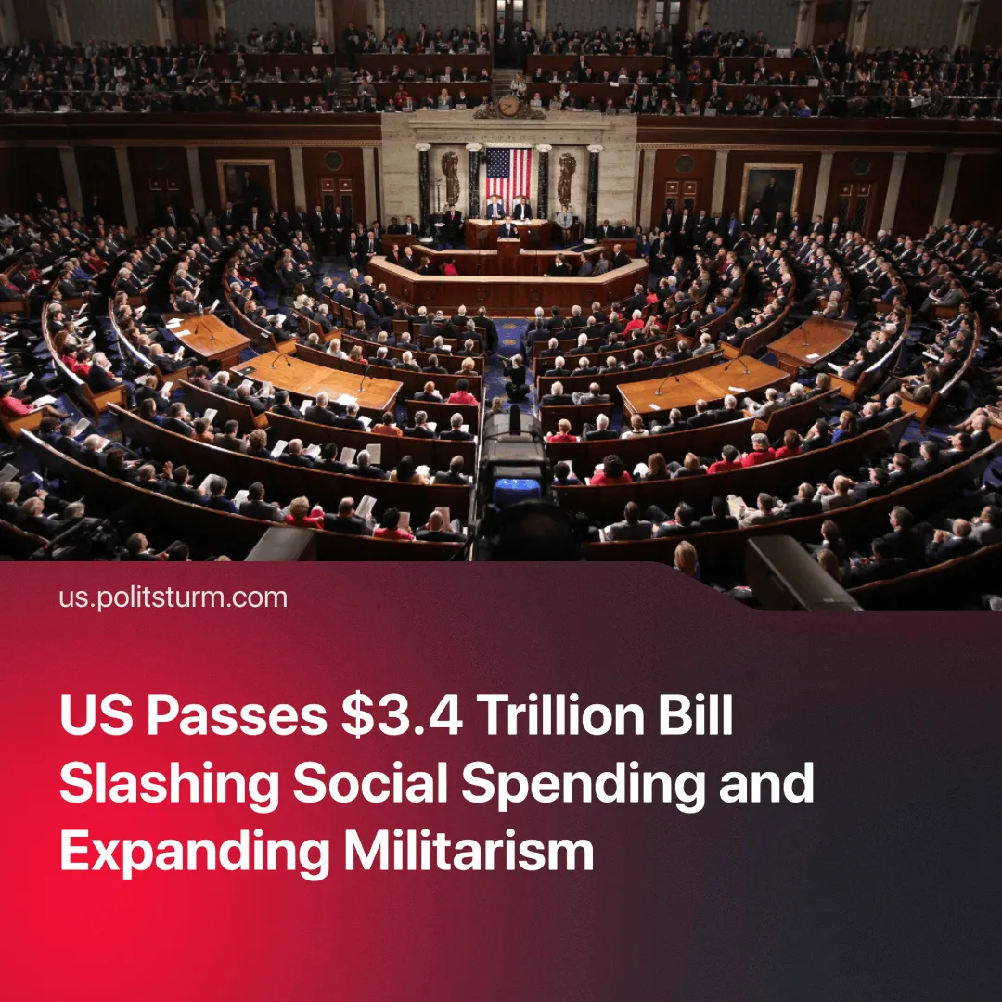

Original article
2025-07-07
1 min read

Tax cuts for the rich, deep cuts to social spending, and a $150 billion budget boost for the military and ICE – the US Congress has finally passed the “Big Beautiful Bill” (BBB).
Details. The bill cuts $120 billion from Medicaid and the Supplemental Nutrition Assistance Program (SNAP), affecting access to healthcare and food assistance for low-income individuals.
► The Consumer Financial Protection Bureau — a federal agency tasked with investigating predatory lending and corporate fraud — will see its budget halved.
► The Trump-era tax cuts, worth an estimated $1.5 trillion over ten years, are kept in place. They will continue to benefit corporations and the wealthiest households disproportionately.
► All renewable energy subsidies and “green” programs introduced under previous administrations have been eliminated.
► The debt ceiling is raised by $5 trillion — the single largest increase in U.S. history — enabling further state borrowing.
► The bill grants the largest US military budget in history, increasing military spending by $100 billion. ICE also receives a $45 billion boost, making it the 16th most funded armed force in the world.
Context. This continues a long US pattern of cutting social programmes while expanding military budgets and protecting corporate wealth, as seen in the 2011 Budget Control Act, 2017 tax cuts, and the 2018 budget deal.
► The bill reflects a broader bipartisan consensus to prioritise capitalist interests over social needs. Under Biden, the Trump-era tax cuts passed in 2017 were maintained.
Important to Know. The bill’s narrow passage by just one vote reveals contradictions within the US capitalist class and sharpening political conflict.
► Some capitalists, especially in tech and renewables, opposed the subsidy cuts and rising debt. Elon Musk, for example, criticised the EV cuts under the banner of “fiscal responsibility” and claimed he has formed a party in response.
► The growing use of state power to enforce austerity, suppress dissent, and expand militarism shows the maturation of US monopoly capitalism into state-monopoly capitalism – where the state directly enforces the interests of dominant capital factions, preparing for intensifying class struggle and imperialist war.

Original article

