Did the US and Israel Strike Iran “for the People”?
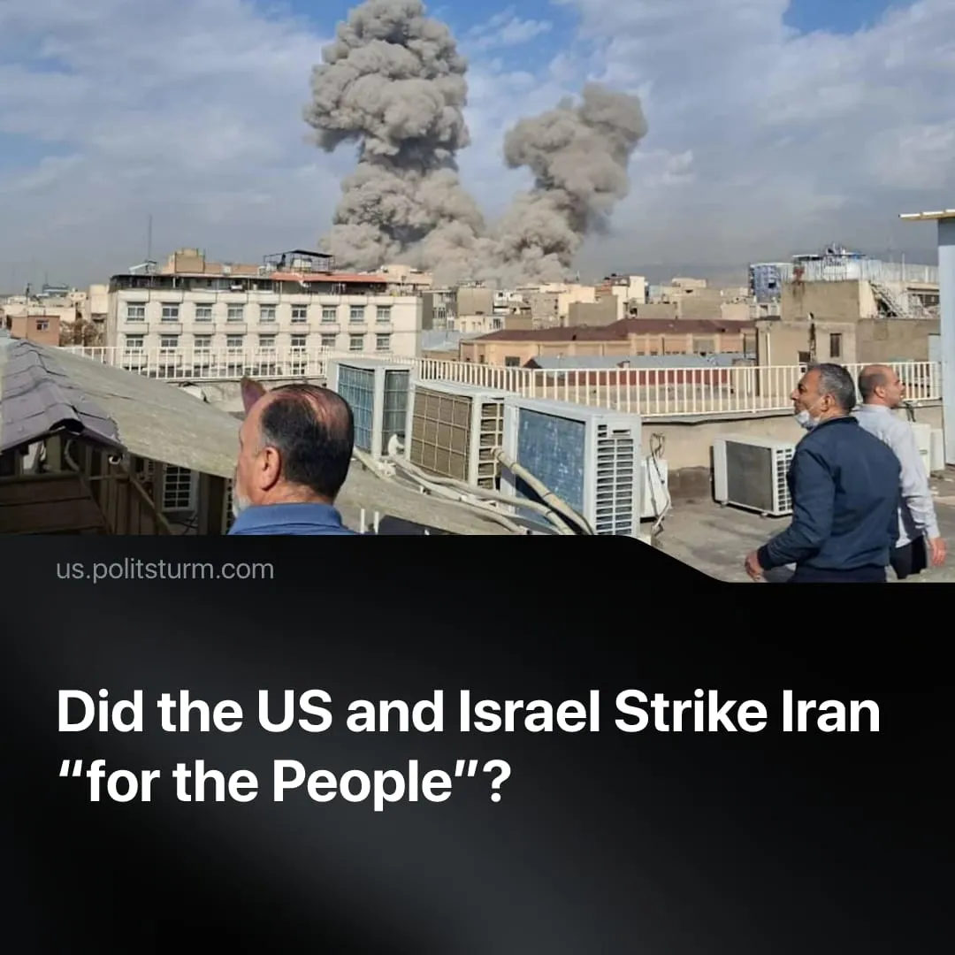

Original article
2026-03-04
1 min read

The US and Israel claim their strikes on Iran are “for the Iranian people” – recent history proves otherwise.
Details. On February 28, the United States and Israel launched a “major military campaign,” publicly presenting it as an opportunity for Iranians to achieve “freedom.” Trump moralised the operation, denouncing the Iranian regime as “evil” and telling Iranians, “When we are finished…it will be yours to take.”
► Prime Minister Benjamin Netanyahu echoed this narrative, stating the strikes are a chance for Iranians to “cast off the yoke of tyranny.”
► The strikes targeted Iran’s leadership, including the assassination of Supreme Leader Ayatollah Ali Khamenei, which Trump framed as “justice for the people of Iran.” Dozens of other senior figures, along with IRGC, police, and security installations, were also hit, destabilising the government and reinforcing the “liberation” rhetoric.
► Despite this rhetoric, the US–Israeli campaign has struck civilian areas, killing hundreds. A girls’ school in Minab was hit on February 28, with Iranian authorities reporting approximately 165–180 dead. Strikes across multiple cities have also impacted residential and other non‑military sites.
Context. Earlier this year, the US launched a military operation in Venezuela, capturing Nicolás Maduro and presenting it as liberating Venezuelans from a dictator. In reality, the US replaced one capitalist government with another US‑friendly one and gained control over the country’s oil trade and exports.
► In January, Trump publicly encouraged Iranian protestors, posting that “HELP IS ON ITS WAY” and opportunistically urging them to challenge the regime. Despite this, the US continued diplomatic engagement with Tehran, negotiating over nuclear and regional issues while the Iranian government violently suppressed protests, killing thousands.
► The “12‑day war” in June 2025 saw the US and Israel strike Iranian military, nuclear, and infrastructure targets, killing civilians. These attacks were publicly justified as security operations to neutralise threats to the US and allies, not as efforts to help Iranian civilians, as claimed under the current operation.

Original article

