US and Israel Launch Major Strikes on Iran Sparking Regional Retaliation
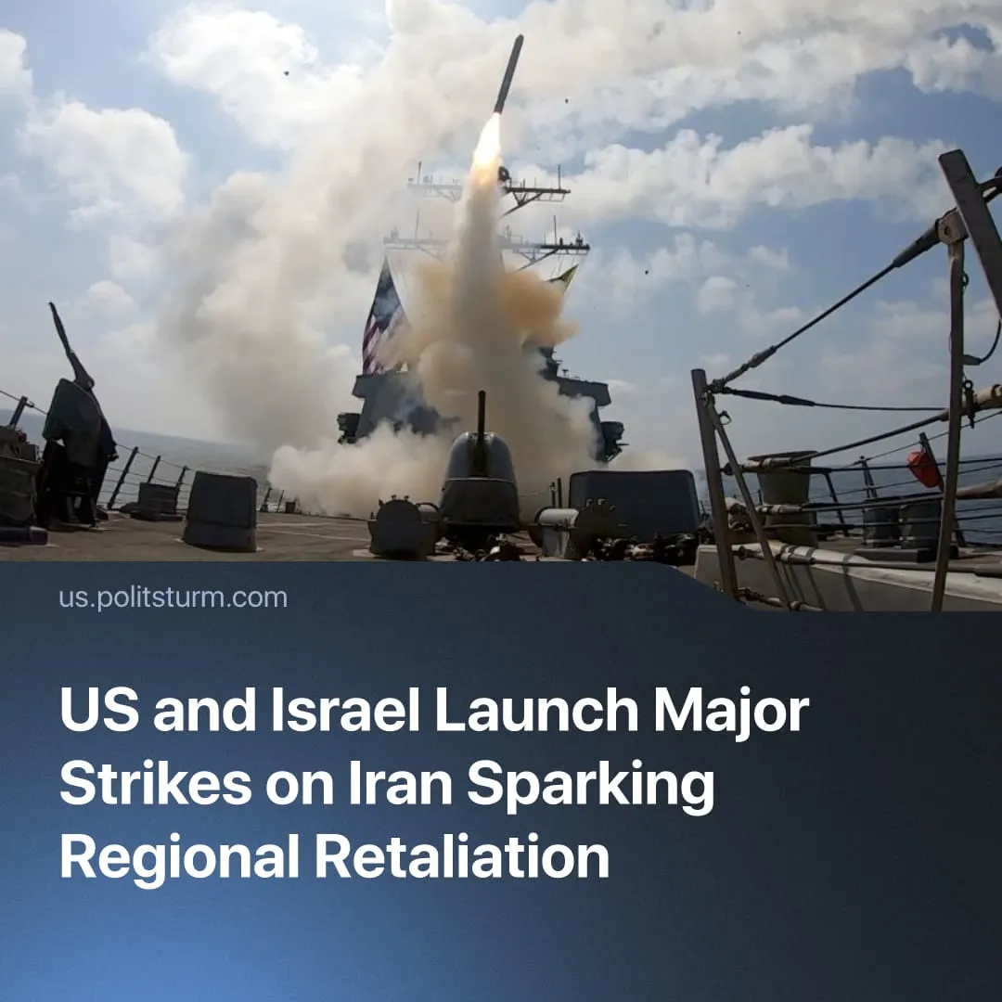

Original article
2026-03-02
2 min read

The first days of the US-Iran war were marked by the death of the Iranian leader, IRGC retaliatory strikes across the Middle East, and rising oil prices.
Details. On 28 February, the United States and Israel began “major combat operations” against Iran.
► Trump outlined the objectives: destroy Iran’s missile and naval capabilities, disrupt proxy networks, and prevent a nuclear‑armed Iran, framing it as pre‑emptive defence of the US and allies. Trump called for regime change, urging Iranians to “take over” their government after the operation.
► Initial targets included military infrastructure, air‑defence systems, IRGC command facilities, missile and drone sites, nuclear‑linked sites, and leadership-associated locations. Iran reported civilian hits, including an elementary girls’ school. By March 1, Israel claimed “air superiority,” enabling deeper strikes.
► In the opening wave, several senior Iranian officials and generals were targeted and reportedly killed, including Supreme Leader Ali Khamenei, whose death was later confirmed by Iranian state authorities.
► Iran has launched retaliatory missile and drone strikes – designated "Operation True Promise 4" – targeting Israel and US military bases in several Gulf states, including Bahrain, Qatar, the UAE, Kuwait, and Jordan. While Tehran stated the strikes were aimed at military‑strategic targets, some civilian infrastructure was hit.
► Iran has effectively halted shipping through the Strait of Hormuz by radio threats, leading to hundreds of oil tankers anchoring outside the strait. There are confirmed reports of tankers being struck near the strait.
► On March 1, Trump claimed that surviving Iranian leadership had reached out for talks and said he had agreed to them, but provided no further details.
Context. The USA has been intensifying pressure on rising imperialist China and its weaker rivals globally. The current Iran operation follows the US military intervention in Venezuela, in which American forces captured President Nicolás Maduro and installed a US‑aligned interim government. In the aftermath, President Trump and senior officials openly threatened further actions toward Cuba, Colombia, Mexico, Iran, and Greenland.
► The current attack followed three failed rounds of negotiations over Iran’s uranium enrichment; similar to the 12‑Day War. The US at the time claimed “obliteration” of Iran’s nuclear program but remained concerned about the threat. In the aftermath, sections of the Iranian bourgeoisie publicly supported concessions to the West.

Original article

