US Abandons Rojava Kurds
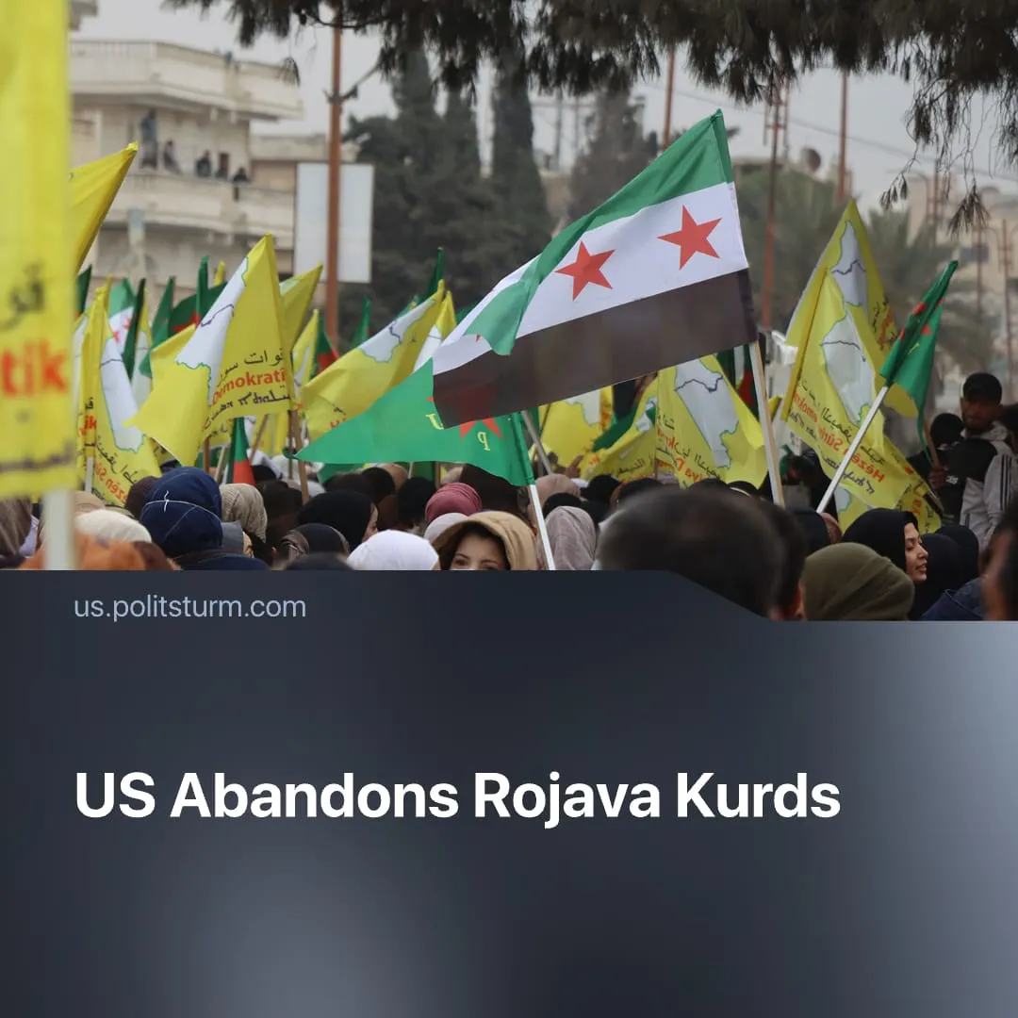

Original article
2026-02-04
1 min read

USA abandons the Kurds in Rojava after their utility has “largely expired.”
Details. The Syrian Transitional Government launched an offensive against Kurdish autonomous zones in the eastern third of the country. After negotiations to integrate the Kurdish-led Syrian Democratic Forces (SDF) stalled, the Syrian Army seized most of the territory by force, including key oil fields. Fighting has now ended, with a fragile ceasefire.
► SDF forces were quickly overwhelmed; Damascus-aligned sources count hundreds killed in the 2 weeks of combat. Government troops allegedly executed and abused Kurdish POWs. Civilians were cut off from services and infrastructure due to the fighting, with over 134,000 refugees fleeing the warzone.
► Syrian President al-Sharaa declared victory and compelled the SDF to sign an integration agreement on his terms. He issued a decree granting Syrian citizenship to Kurdish inhabitants and, on paper, recognising their national and language rights.
► US officials warned that further Syrian Army advances could result in mass violence against Kurdish civilians, similar to previous sectarian killings. Despite this, the United States limited its response to brokering a ceasefire and ruled out military intervention, effectively abandoning its long-standing Kurdish proxies – stating that their utility had “largely expired.”
► The dissolving Turkey-based Kurdistan Workers’ Party (PKK) pledged support for the Syrian Kurds and called for mobilisation to defend Rojava. Kurdish militias in neighbouring countries claimed Syria deployments to reinforce the SDF, but retreated amidst failed Kurdish border-crossing attempts.
Context. Historically, US imperialism used Kurdish insurgents as proxy forces. Exploiting chauvinistic oppression of Kurds by rival capitalists, the US promised support for Kurdistan’s autonomy and armed nationalist groups. Kurdish auxiliaries were deployed in the 2003 US invasion of Iraq, and the Kurdish-led SDF served as a US proxy in the Syrian Civil War (2011–2024).
► Last year, the US began withdrawing support for Kurdish groups, reducing military cooperation. After Assad’s fall, Trump reoriented US policy to favour NATO ally Turkey and its new Syrian dependency. In 2025, the leading Kurdish militia PKK, announced its surrender to Turkey, beginning with a disarmament process.

Original article

