UPS Workers Vote to Authorize Huge Strike
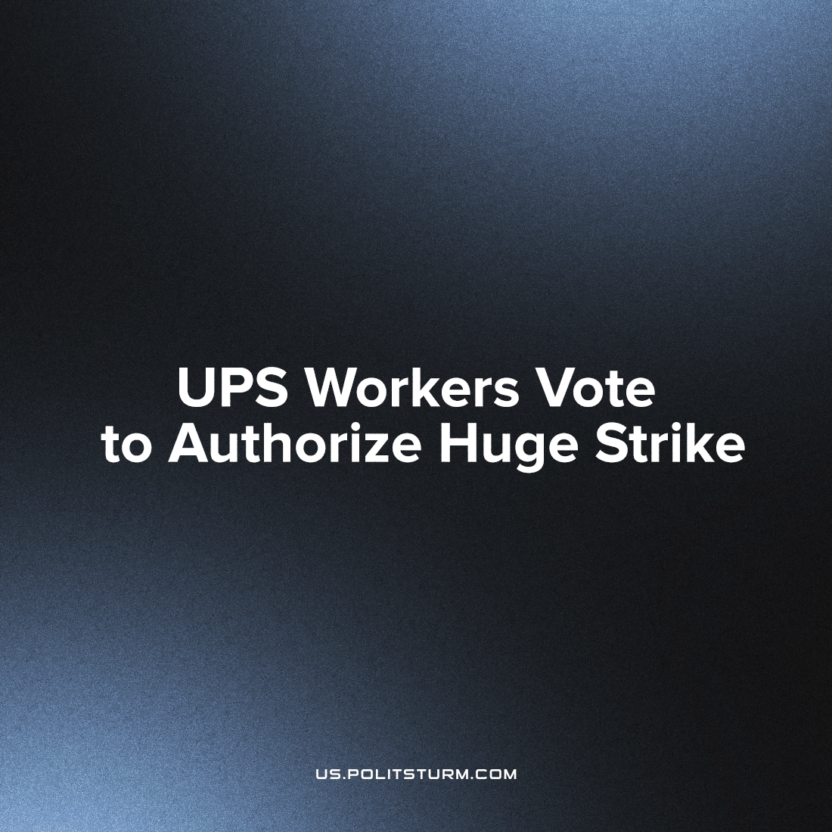

Original article
2023-06-29
1 min read

We wrote more about the possible UPS strike earlier. Voting for permission to strike is common during contract negotiations. So what's so special about this?
Employees of the American company United Parcel Service, which specializes in express delivery and logistics, voted to grant the union the right to strike. The work may be stopped if the organization and the company's management cannot come to an agreement before the contract expires in July. If the strike takes place, it could become one of the largest in U.S. history.
The union represents the interests of more than half of UPS employees. This is 340 thousand people, including drivers and parcel sorters.
The last time UPS workers went on strike was 25 years ago, when cargo transportation was stopped for 15 days, which led to significant damage. Since then, the company has begun to play a major role in the country's economy and today is engaged in the delivery of the equivalent of about 6% of US GDP.
The union is seeking higher pay; the elimination of so-called two-tier wages, where newer workers are paid less than older employees for the same job; the removal of surveillance cameras from delivery trucks; and more full-time jobs.[1]
Source: 1

Original article

