UPS Drivers' Strike
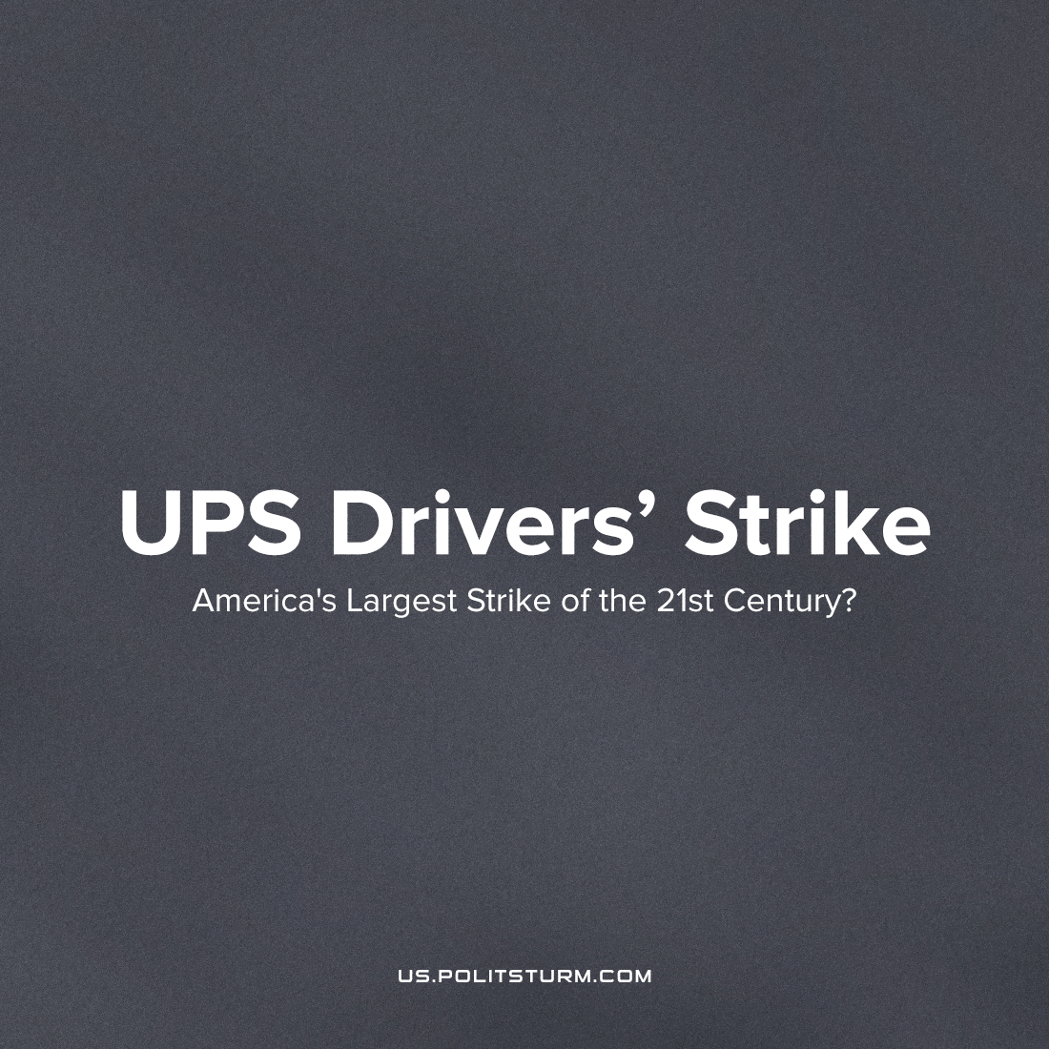

Original article
2023-03-13
3 min read

At least, it will become the biggest this summer if the employer doesn't make concessions[1] when the deadline arrives for a new union contract, in which the union demands improving working conditions, eliminating a special category of employees whom management can underpay and with whom it tries to replace the rest of the employees, and raising the minimum wage to $20 per hour, from $15.
The owners of the country’s largest logistics company have the opportunity to meet the demands of employees[2] as UPS’ profits have been growing rapidly in recent years due to market changes like increased deliveries from the pandemic. Now, however, due to projected stagnation in the economy, profits are in danger of falling, and the mass layoffs of workers that have already begun, making the struggle of workers for their rights more urgent.
“UPS’s opening position is crystal clear: all the company wants after a year with $101 billion in revenue is more money off your backs,”
said Local 804 president Vinnie Perrone, who began working at UPS nearly thirty years ago.
Local 804 represents roughly eight thousand United Parcel Service (UPS) workers in New York City, Westchester, and Long Island, making it one of the Teamsters’ largest UPS locals.
And the drivers' demands are quite reasonable, especially about improving working conditions: this summer, due to abnormal heat in the cabin, a driver died [3], and a few more drivers have ended up in the hospital.
UPS management is stalling for time and, apparently, is preparing to fight with workers to maintain UPS’s record profits. The contract with the union will end in July, and negotiations have not begun, although in previous years discussions began long before the termination of the contract.
CEO Tomé told investors that the company is “building contingency plans”; workers say that management has been warned not to plan any vacations for August.
Union leaders promise not to back down and seek to include workers' demands in the new contract. If this does not happen, a strike will begin, which has every chance of a successful end. The past confrontation between the trade union and the employer in 1997 ended with the victory of labor over capital[4]. Last time, 185 thousand people came out to fight, against 350 thousand that are going to come out this year.
O'Brien, newly elected head of the trade union, offered CEOs his forecast for the coming years: “It’s gonna get bloody, it’s gonna get painful. So ice up, because when you take one of us on, you take all of us on. If you are corporate America and you want to take us on, put your helmet on and buckle your chinstrap, because it’s a full-contact sport.”
The past few years have seen increased energy in the US labor movement, even if it has not yet translated into greater union density [5]. Starbucks[6] and Amazon[7] workers have grabbed headlines for their surprisingly successful union drives. A sea change is underway[8] in the United Auto Workers (UAW), whose contracts at the Big Three automakers, covering 150,000 workers, expire on September 1. Other potential strikes are in the works, too: the Writers Guild of America’s contract expires May 1, and another contract, covering some seventy-five thousand health care workers at Kaiser Permanente, expires on September 30 [9]. A UPS strike this summer would have political effects beyond its immediate economic impact — it would be a national sign of workers going on the offensive, refusing a status quo that has seen them get poorer as the rich accumulate more wealth than ever before.
The capitalist system does not need a worker who does not bring profit. Therefore, we are seeing more and more stories news on the dismissal situation of workers, of employers who stonewall concessions to unions. After all, the goal of capitalists is to maximize profits, not the well-being of working families. Only in a joint struggle can workers protect themselves.
But in the capitalist system, this struggle can only bring a temporary effect, in order to consolidate their gains, the workers must build a socialist state.
Only a socialist system based on the power of the working majority and the socialization of the means of production will provide all workers with decent working conditions.
Sources: 1, 2, 3, 4, 5, 6, 7, 8, 9

Original article

