Update on the Situation in Russia: DPR, LPR, and Mobilization
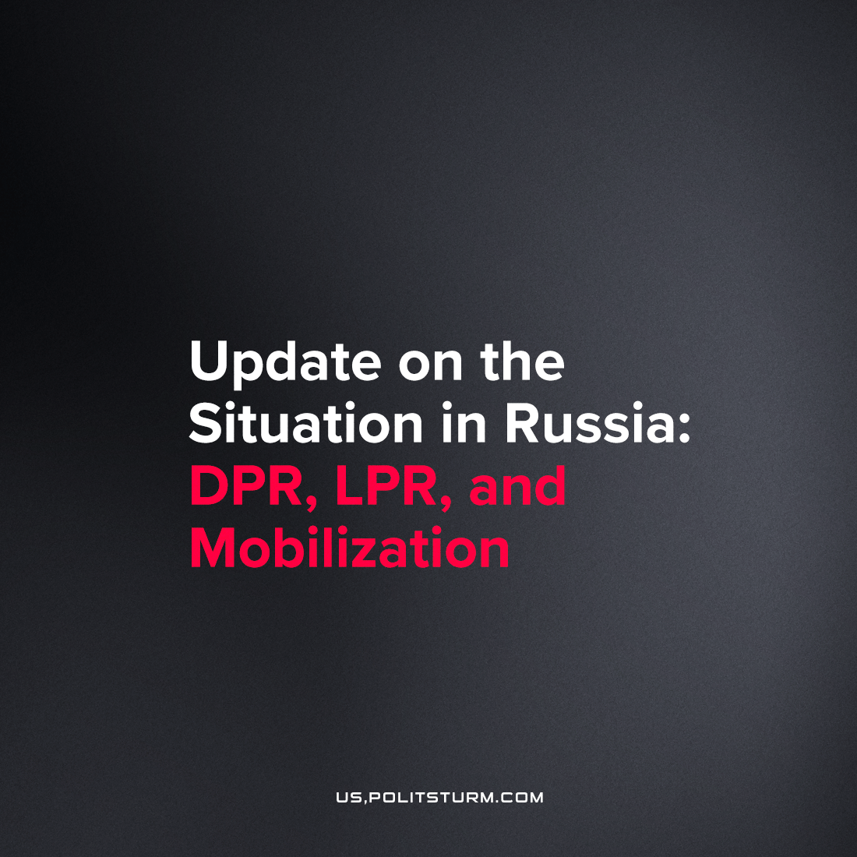

Original article
2022-09-20
2 min read

Yesterday, the 19th of September, the Public Chamber of the Luhansk People’s Republic called for an immediate hold of the referendum on the recognition of the LPR as a subject of the Russian Federation. Today, the referendum on reunification with Russia was scheduled this week for the 23rd of September to the 27th. A similar referendum in Donetsk People’s Republic (DNR) and the Kherson region will be held on the same dates.
At the same time, State Duma (Russian Parliament) is preparing a legal framework for mobilization and martial law. The deputies submitted to the State Duma a bill introducing the concepts of “mobilization” and “wartime” into the Criminal Code.
– In Art. 63 of the Criminal Code on aggravating circumstances, the concepts of “mobilization or martial law, wartime” may appear, and articles on voluntary surrender (Art. 352.1, imprisonment up to 10 years) and looting (Art. 356.1, up to 15 years in prison).
It also introduces a punishment of up to 10 years in prison for desertion or non-appearance of a contract soldier or conscript for service for more than a month “during the period of mobilization or martial law, in wartime or conditions of armed conflict or hostiles.”
Some other restrictions were tightened:
1) An aggravating circumstance for crimes against military service will be considered if they are committed not only in conditions of armed conflict or hostilities but also “during the period of mobilization or martial law, in wartime”;
2) Responsibility for non-execution of military orders, resistance to the chief of military service, unauthorized abandonment of the place of service, desertion, evasion from service, violation of the rules of service, loss of military property, if they were committed “during martial law, in wartime or conditions of armed conflict or conduct of hostilities”;
3) Those called up for military training from the reserve will be held criminally liable for failure to appear or unauthorized leaving of the place of service on an equal basis with contractors;
4) Introduces criminal liability for voluntary surrender (from 3 to 10 years) and criminal liability for looting (up to 15 years);
5) Criminal liability is introduced for repeated violation of the terms of the contract under the state defence order – from 4 to 8 years in prison, and if the task is not completed or the damage amounted to at least 5 million rubles – for a period of 5 to 10 years;
6) Criminal liability is introduced for repeated refusal to conclude a contract under the state defence order (from 4 to 8 years).
We remind the reader that, in Russia, military service is still obligatory for men aged 18 to 27. New restrictions not only tighten the laws concerning the currently-acting military units, which now mainly consist of army contractors, but also for the recruits and reservists who pass general service. All this shows that even if the Russian government has no plans to carry out a general mobilization right now, it has prepared for it in advance. The recognition of the DPR and LPR as the subjects of the Russian Federation is needed for the capitalistic government to recognize the current “special operation” as a “national war”. As always, the union of labour and capital will be imposed from above, but such a union will only serve the private interests of companies and businesses at the top. Ordinary people will have to pay with their lives in the hope of earning some money, by drugging themselves with the false ideas of nationalism or powerlessly obeying the orders of the government.

Original article

