Lenin on Finance Capital
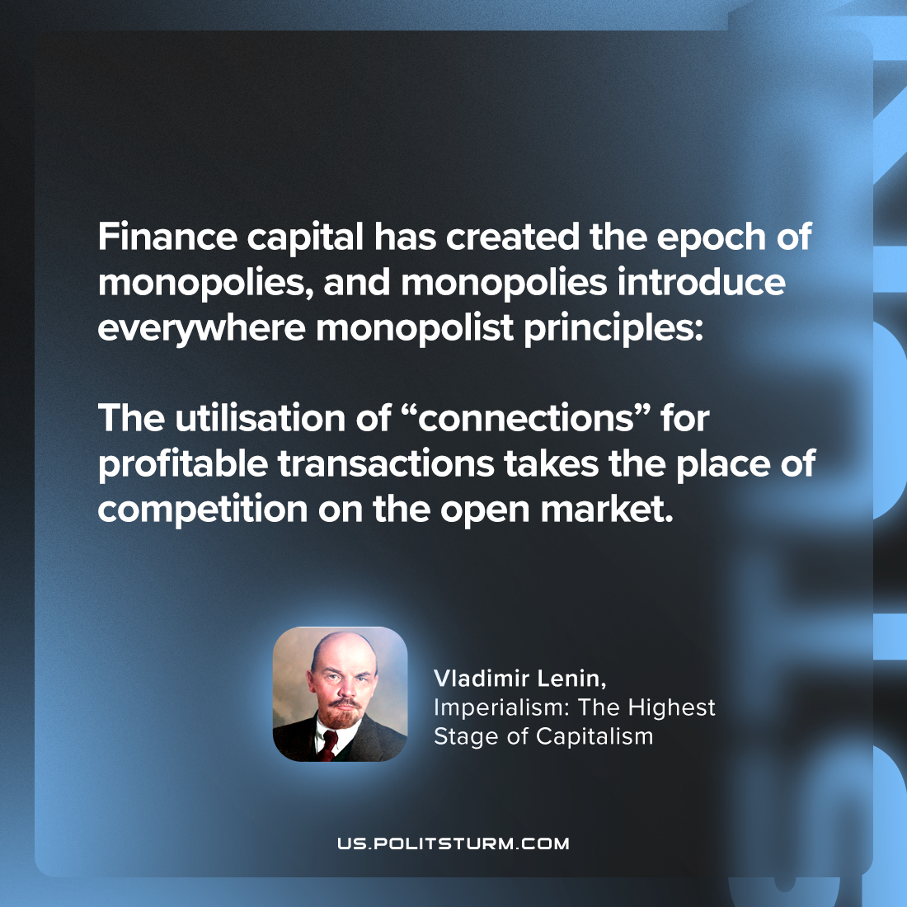

Original article
2023-09-16

"Finance capital has created the epoch of monopolies, and monopolies introduce everywhere monopolist principles: the utilisation of “connections” for profitable transactions takes the place of competition on the open market."
Vladimir Lenin, Imperialism: the Highest Stage of Capitalism

Original article

