Marx on the Exploitation of the Labor Process by the Capitalist
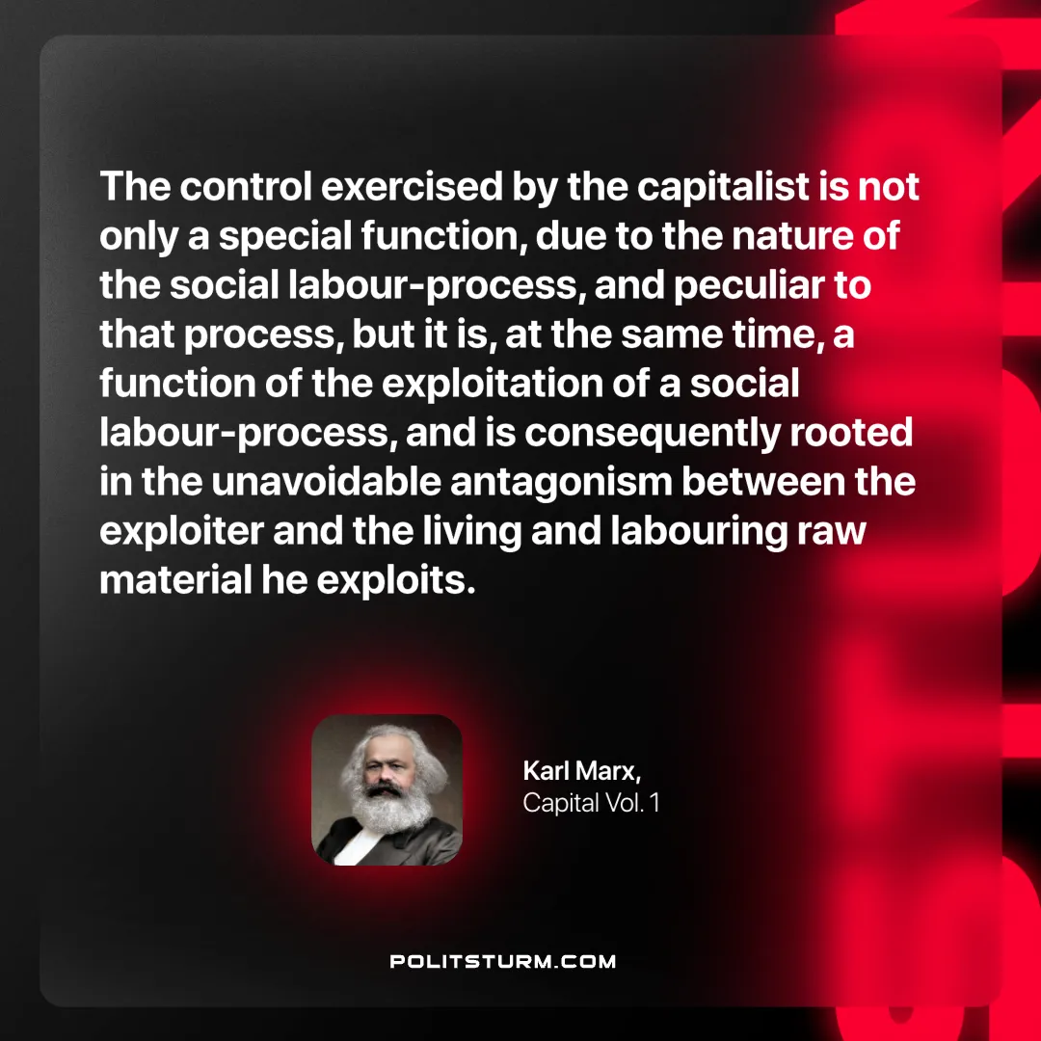

Original article
2025-02-06

“The control exercised by the capitalist is not only a special function, due to the nature of the social labour-process, and peculiar to that process, but it is, at the same time, a function of the exploitation of a social labour-process, and is consequently rooted in the unavoidable antagonism between the exploiter and the living and labouring raw material he exploits.”
Karl Marx, Capital Vol. 1

Original article

