Lenin on Advocating Democratic Centralism
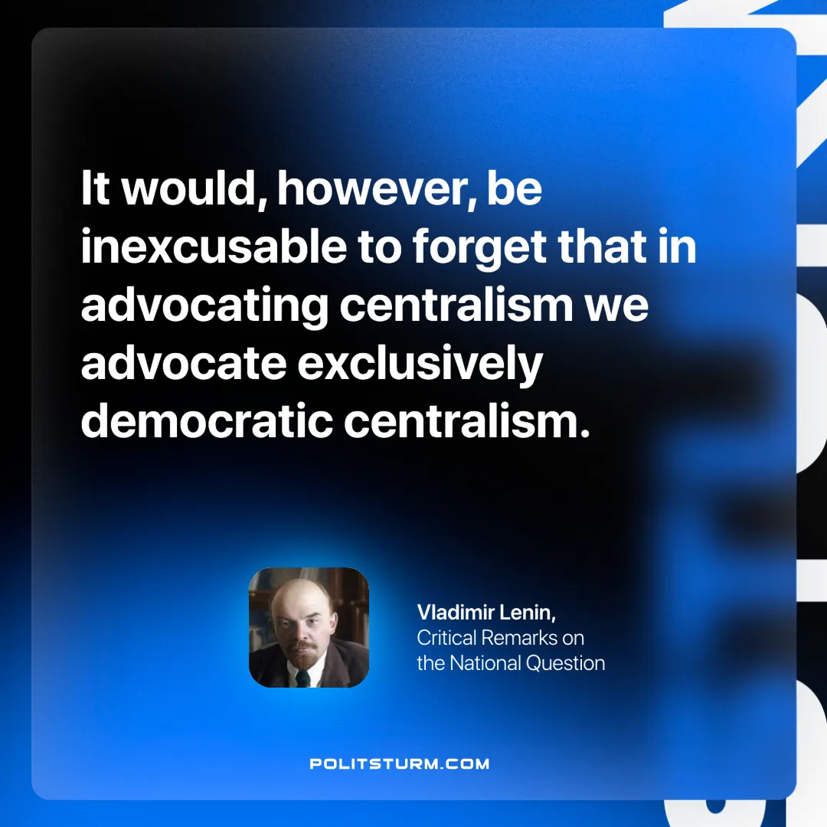

Original article
2025-01-18

“It would, however, be inexcusable to forget that in advocating centralism we advocate exclusively democratic centralism.”
Vladimir Lenin, Critical Remarks on the National Question

Original article

