Lenin on the Defense of One's Own Country
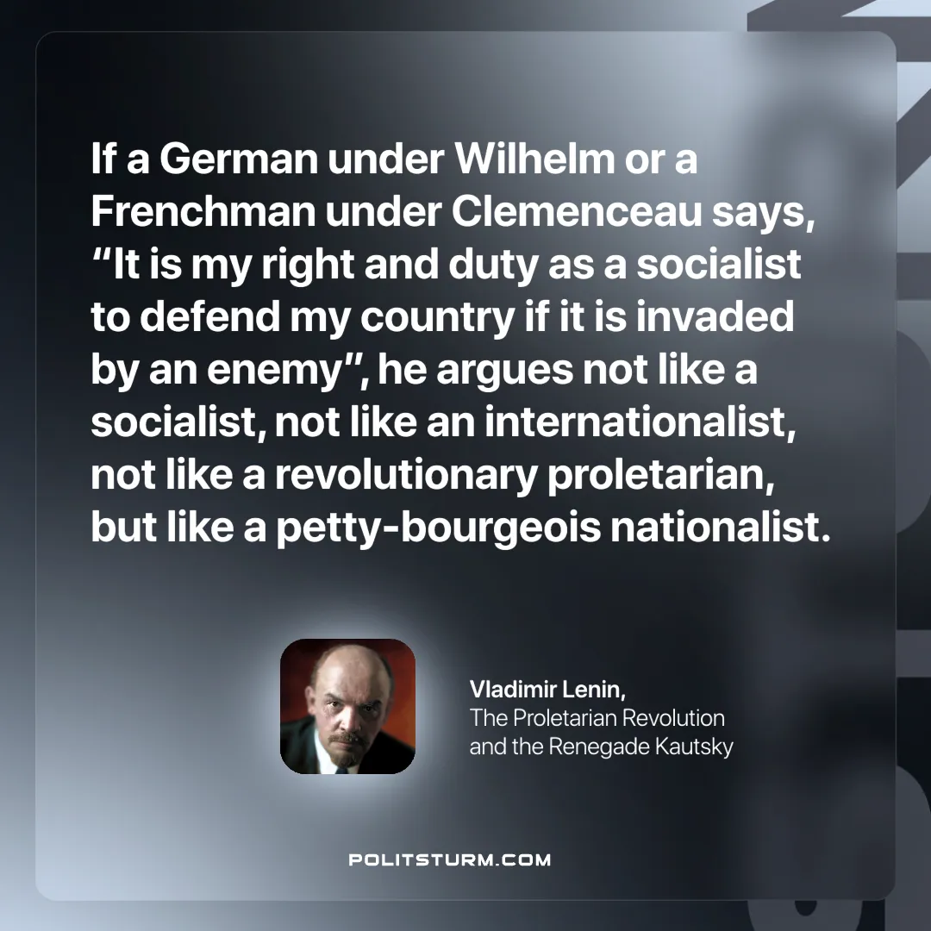

Original article
2024-11-05

“If a German under Wilhelm or a Frenchman under Clemenceau says, “It is my right and duty as a socialist to defend my country if it is invaded by an enemy”, he argues not like a socialist, not like an internationalist, not like a revolutionary proletarian, but like a petty-bourgeois nationalist.”
Vladimir Lenin, The Proletarian Revolution and the Renegade Kautsky

Original article

