Lenin on the General National Culture of the Capitalist
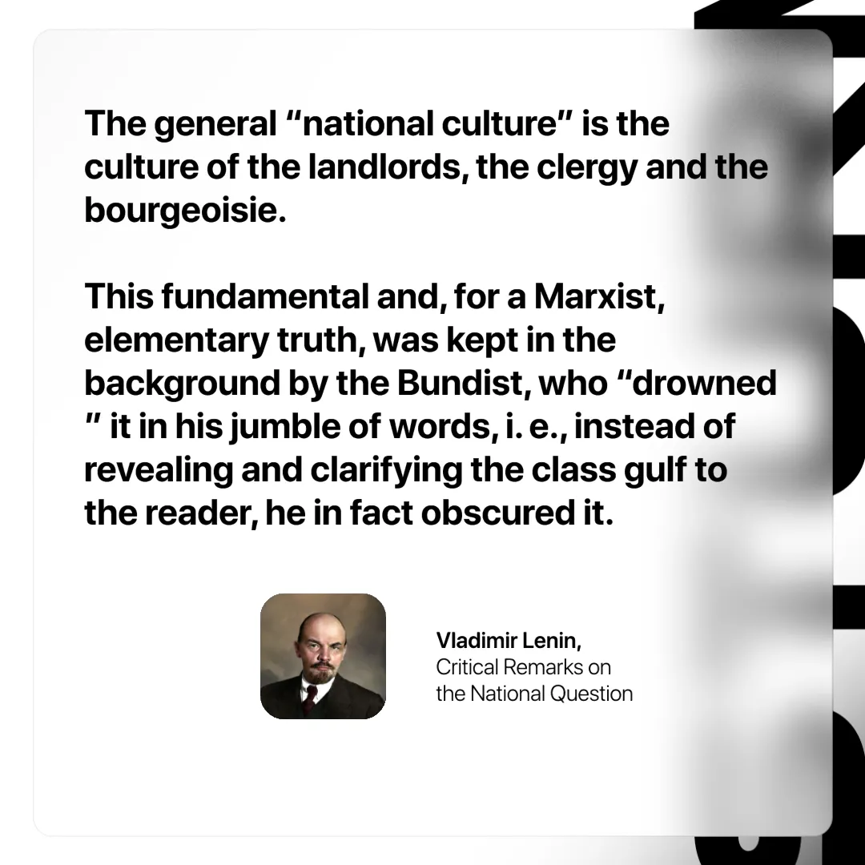

Original article
2024-10-31

“The general “national culture” is the culture of the landlords, the clergy and the bourgeoisie. This fundamental and, for a Marxist, elementary truth, was kept in the background by the Bundist, who “drowned” it in his jumble of words, i. e., instead of revealing and clarifying the class gulf to the reader, he in fact obscured it.”
Vladimir Lenin, Critical Remarks on the National Question

Original article

