Lenin on the Inevitable Battle for the Revolution
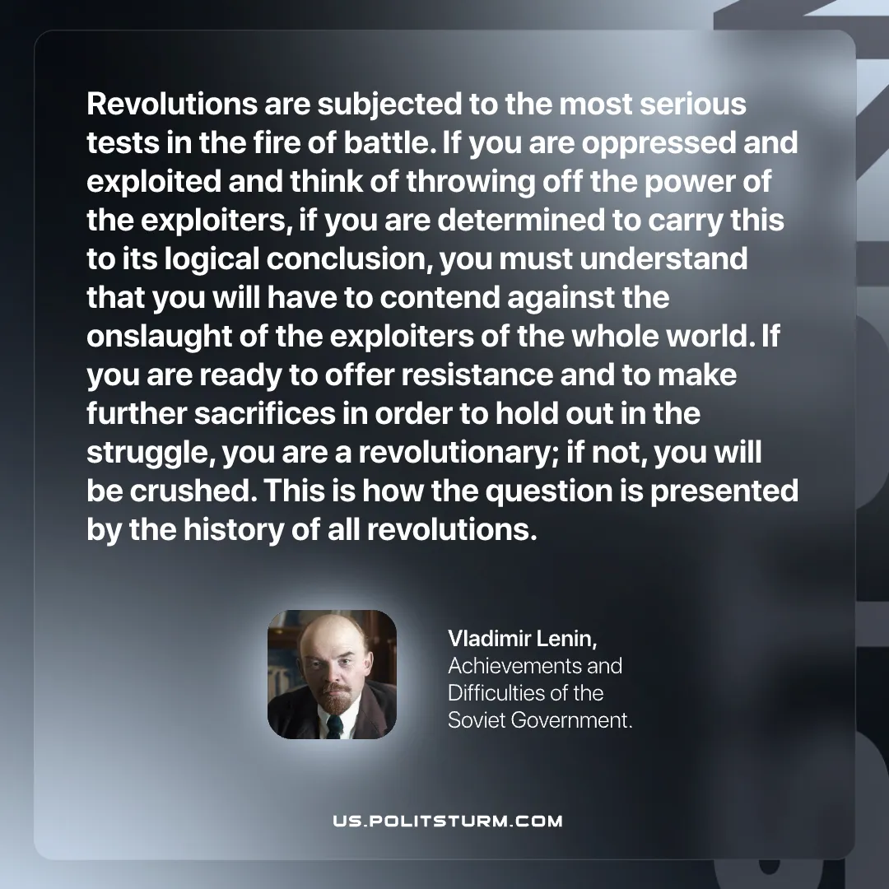

Original article
2026-05-26
1 min read

Revolutions are subjected to the most serious tests in the fire of battle. If you are oppressed and exploited and think of throwing off the power of the exploiters, if you are determined to carry this to its logical conclusion, you must understand that you will have to contend against the onslaught of the exploiters of the whole world. If you are ready to offer resistance and to make further sacrifices in order to hold out in the struggle, you are a revolutionary; if not, you will be crushed. This is how the question is presented by the history of all revolutions.
Vladimir Lenin, Achievements and Difficulties of the Soviet Government.

Original article

