Lenin on the Real Meaning of Unity With the Workers
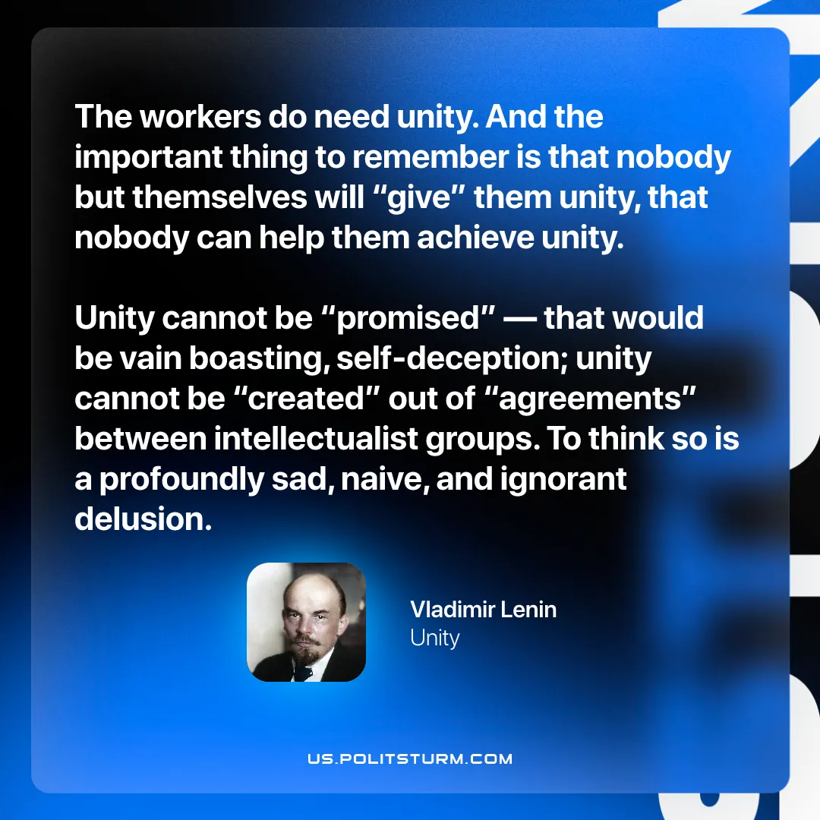

Original article
2026-04-21

“The workers do need unity. And the important thing to remember is that nobody but themselves will “give” them unity, that nobody can help them achieve unity. Unity cannot be “promised”—that would be vain boasting, self-deception; unity cannot be “created” out of “agreements” between intellectualist groups. To think so is a profoundly sad, naive, and ignorant delusion.”
Vladimir Lenin, Unity

Original article

