Stalin on the Inability of Certain Actions Destroying Inequality
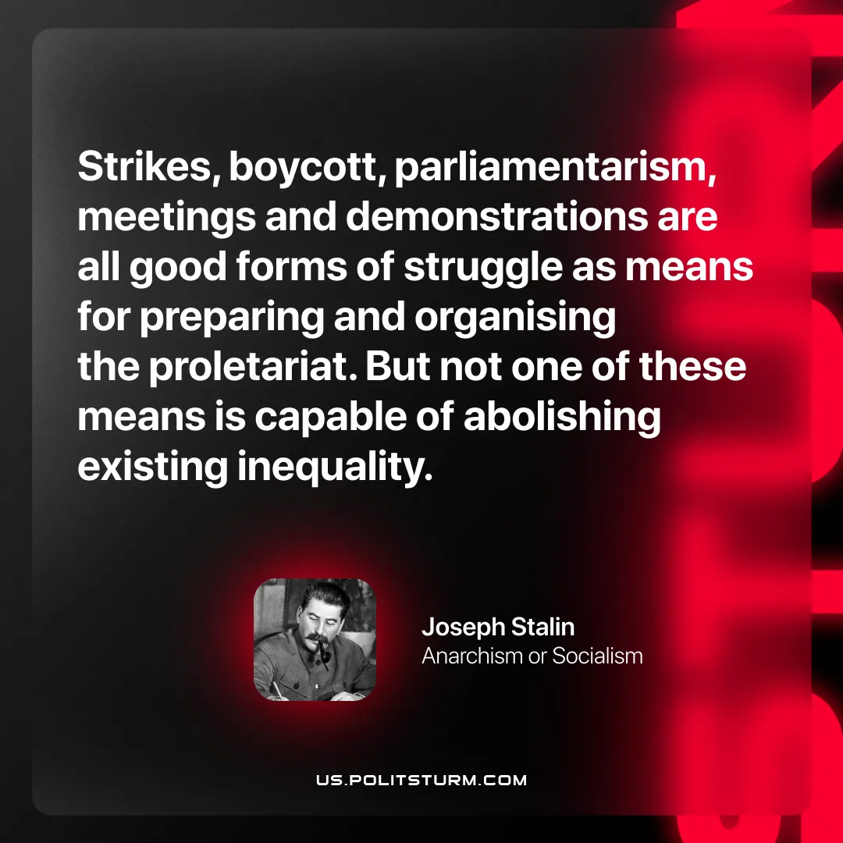

Original article
2026-04-09

“Strikes, boycott, parliamentarism, meetings and demonstrations are all good forms of struggle as means for preparing and organising the proletariat. But not one of these means is capable of abolishing existing inequality."
Joseph Stalin, Anarchism or Socialism

Original article

