Lenin on the Importance of Choosing Actions that Unite the Workers
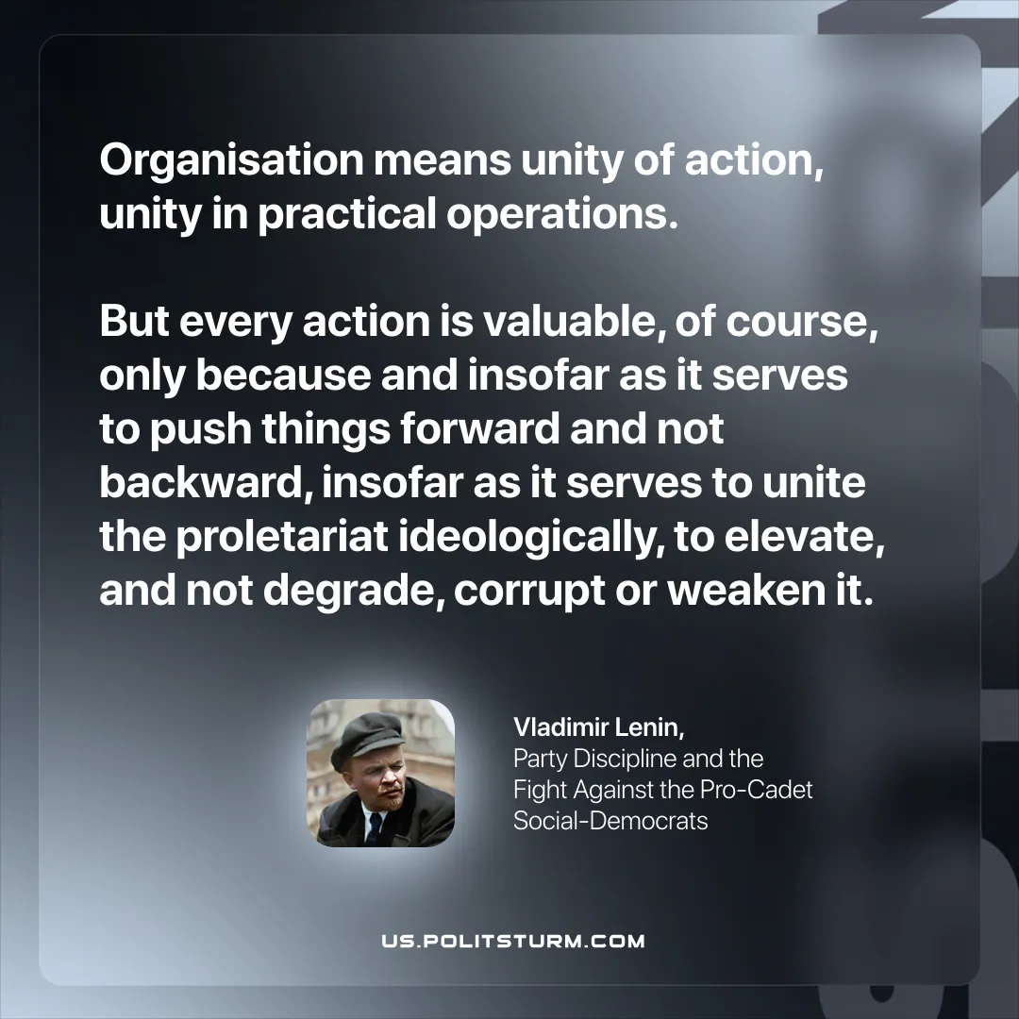

Original article
2025-12-09

“Organisation means unity of action, unity in practical operations. But every action is valuable, of course, only because and insofar as it serves to push things forward and not backward, insofar as it serves to unite the proletariat ideologically, to elevate, and not degrade, corrupt or weaken it.”
Vladimir Lenin, Party Discipline and the Fight Against the Pro-Cadet Social-Democrats

Original article

