Marx on Productiveness Under Capitalism Laying Waste to the Wage Worker
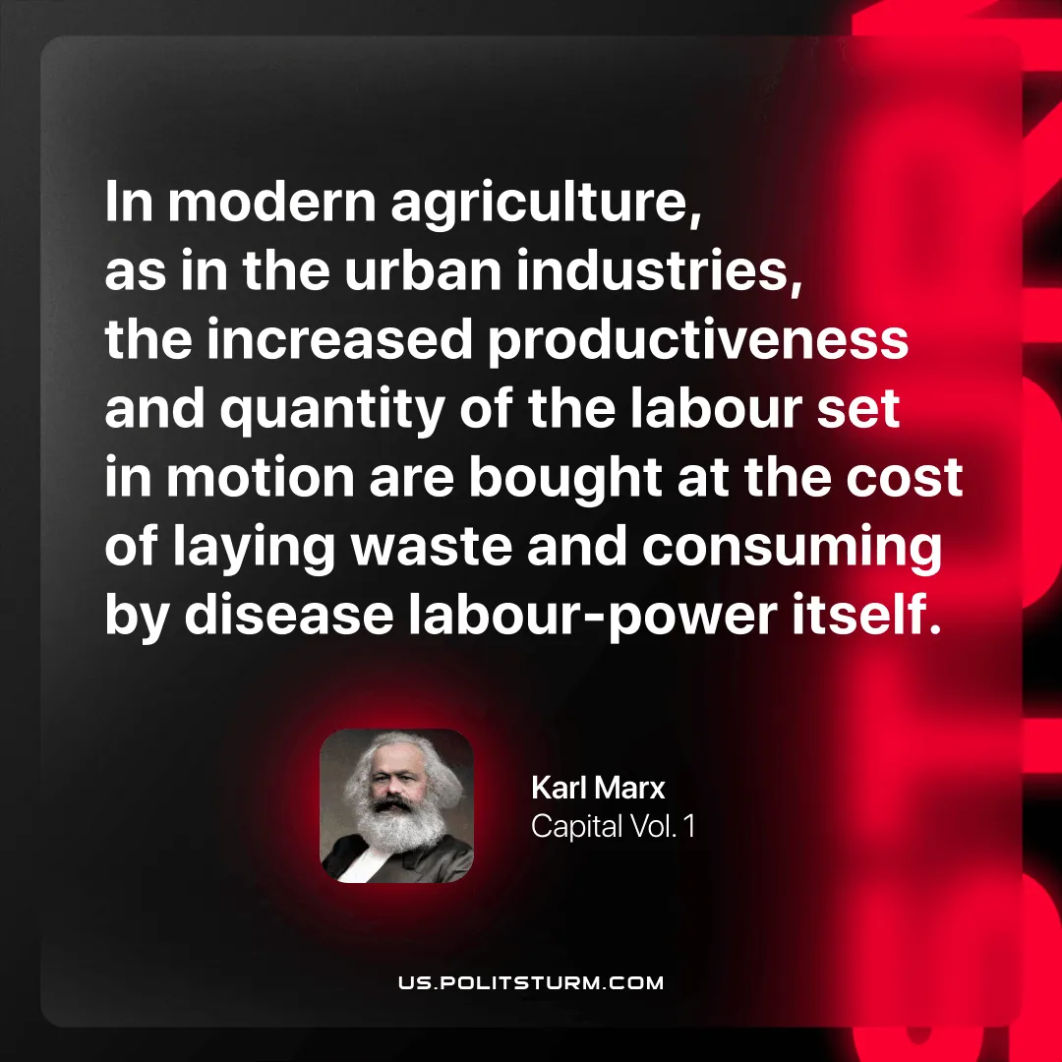

Original article
2025-11-11

“In modern agriculture, as in the urban industries, the increased productiveness and quantity of the labour set in motion are bought at the cost of laying waste and consuming by disease labour-power itself.”
Karl Marx, Capital Vol. 1

Original article

