Lenin on the Limitations of the Liberal Capitalist
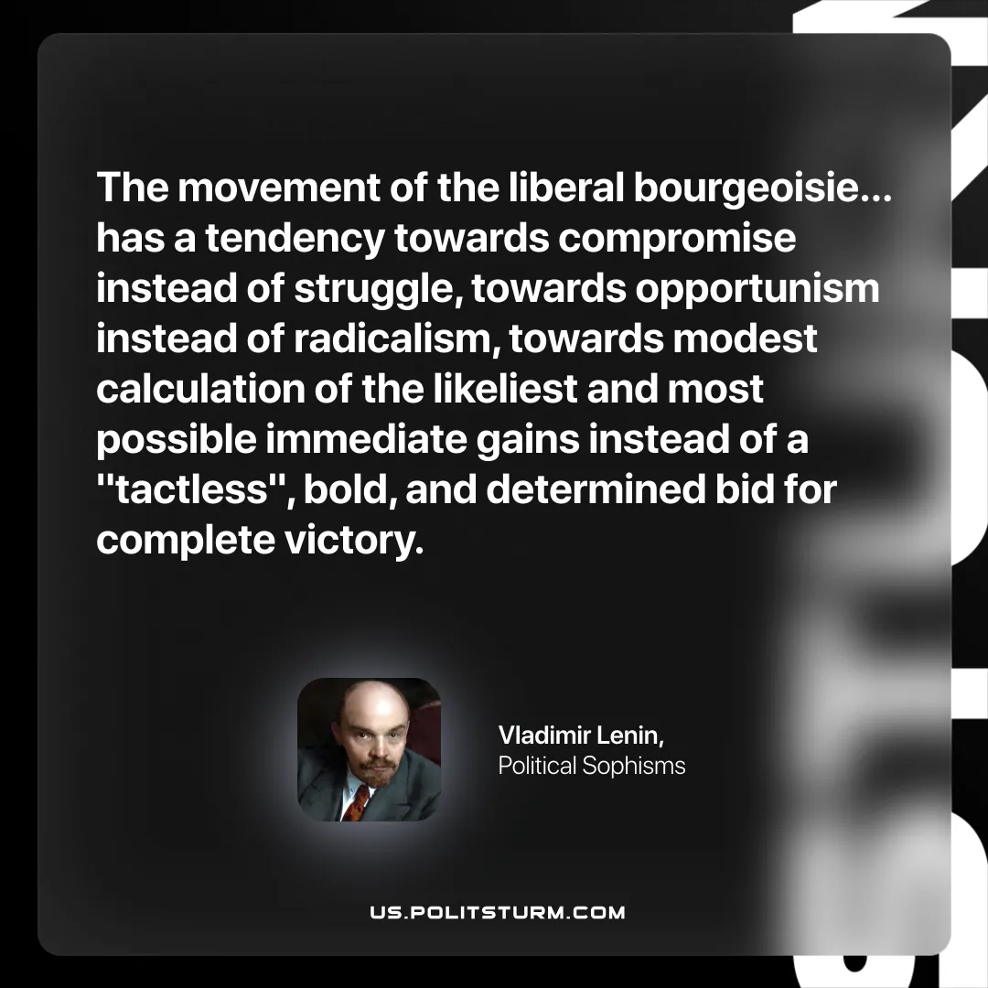

Original article
2025-10-21

“The movement of the liberal bourgeoisie… has a tendency towards compromise instead of struggle, towards opportunism instead of radicalism, towards modest calculation of the likeliest and most possible immediate gains instead of a "tactless", bold, and determined bid for complete victory.”
Vladimir Lenin, Political Sophisms

Original article

