Lenin on the Petty-Bourgeois
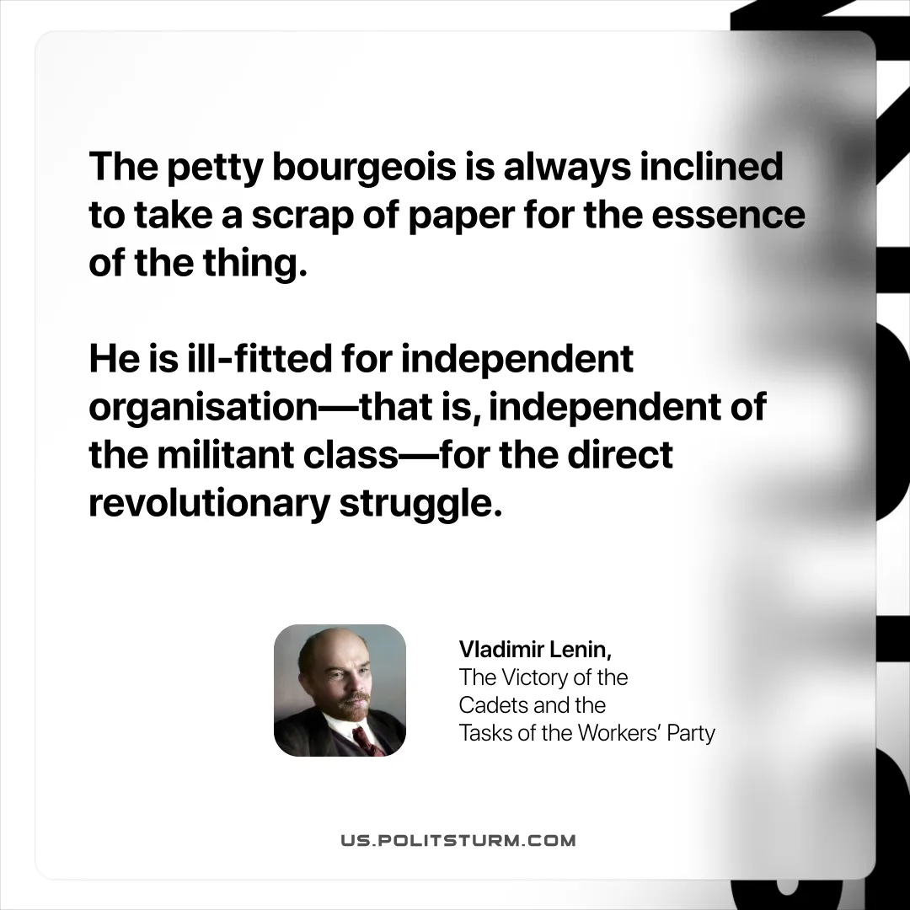

Original article
2025-10-19

“The petty bourgeois is always inclined to take a scrap of paper for the essence of the thing. He is ill-fitted for independent organisation—that is, independent of the militant class—for the direct revolutionary struggle.”
Vladimir Lenin, The Victory of the Cadets and the Tasks of the Workers’ Party

Original article

